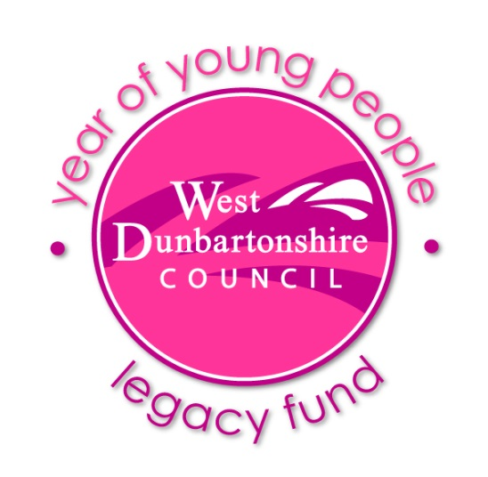

Application Form
The Year of Young People Legacy Fund is available to any not-for-profit properly constituted group providing activities or services to children/young people in West Dunbartonshire.
Grants of up to £10,000 are available and may be spent over a period of up to 4yrs. Applications can be for anything your group wants, including sustaining your group itself (e.g. admin & staff costs), as long as it provides a benefit to children/young people in West Dunbartonshire aged 0 up to 26 years of age.
In applying for this funding, we require you to identify: who you will target, that you will be inclusive to all children and young people, that you will ensure robust safeguarding and financial scrutiny and report upon the impact of your project.
A legacy funding panel of council officers and community representatives will review all application forms to approve or reject and ensure adherence with funding criteria.

Section 1: About You.
Organisation Name:
Confirm that you are a properly constituted and not-for-profit organisation | Yes No (please select)
Charity Number:
(if applies)
Address:

Responsible Person:

Position in Organisation:
(if applies)

Mobile:

Email:

Section 2: Project Information
Project Title:
Total Project Cost: | £
How much funding are you requesting from us?  (please identify which financial year/s this relates to e.g. 2019/20, 2019-2021 etc.) | £
Is project part-funded and by whom?
(please provide details of other funding sources).
Project Description:
(tell us about your project in up to 200 words)

What area/community in West Dunbartonshire will you support?

What do you want to do with the funding? How will this funding help you?

Where will your project take place?
(if applicable provide venue/s address/s)

When will your project take place?
(if applicable provide dates & times)

How will you let people know about your project?
(e.g. social media, flyers, posters) * Please note that any publicity must include acknowledgement of West Dunbartonshire Council’s Year of Young People Legacy Fund.

Who will you help and how?
(e.g. target age group; specific young person’s group - what will the benefit be to your participants?)

What are your targets? How will you know is your project is successful?

Section 3: Project Management
How will you spend this funding if successful?
(explain how this will breakdown e.g. staff, equipment, activities)
What financial monitoring and management will you put in place for this project?
(please note if successful you will require to maintain financial records and be able to evidence spending in your project evaluation report)
Section 4. Finance:
Please provide your organisation’s bank details:
Name of Bank:

Name on Account:

Sort Code:

Account No:

Grant Conditions:
(in signing this grant application you are confirming adherence to the following grant conditions non adherence may result in removal of funding).

- Applications to the Year of Young People Legacy Fund are only open to properly constituted not-for-profit organisations and/or charities, only projects taking place in West Dunbartonshire are eligible.
- Grants of up to £10,000 are available and may be spent over a period of up to 4yrs.
- Any grant monies awarded must only be used for the purposes laid out in your grant application and provide a benefit to children/young people aged 0 up to 26 years of age.
- In applying for this funding, you are agreeing to ensuring you will maintain robust safeguarding and financial scrutiny of your project.
- Any adult working unsupervised with children must be PVG checked.
- Successful applicants are responsible for ensuring than any activities are safely provided in line with current legislation and insured where applicable.
- Proposed projects must not commence until written confirmation of a successful award has been received.
- Successful applicants should aim to provide best value and use good practice in terms of securing supplies and services.
- Visits to funded projects may be made at any time by WDC Officers upon prior notice.
- The support of West Dunbartonshire Council’s Year of Young People Legacy Fund must be acknowledged in any related publicity.
- You require to carry out an evaluation of the impact upon participants/ or where a grant is for the purchase of equipment evaluate improvements resulting from this.
- A final balance of 10% of the grant award will only be issued on receipt of a final written project evaluation and may be retained if the grant conditions have not been met.
- Successful applicants will comply with their obligations under the Data Protection Act 2018 and General Data Protection Regulation ("GDPR") (or its equivalent).

Signed: _________________________________ Date: _________________

Applications should be returned by email to: Year of Young People Legacy Fund
Deadline for submission: 30 September 2019
Further information is available from Gill Graham, Engagement & Involvement Officer, Education, Learning & Attainment, West Dunbartonshire Council 01389 737637

Post Project Evaluation
Please use this form to provide an evaluation of your project. You should complete and return this form within 6 weeks of your project ending. A final balance of 10% of the grant award will only be issued on receipt of a final written project evaluation and may be retained if the grant conditions have not been met.
Organisation Name:
Project Title:
Total Project Cost: | £
Year of Young People Legacy Grant Awarded. | £
What did your Legacy Grant fund?
(please detail in up to 200 words how you spend you grant).
Please detail how for many days/ and where your project took place?
(if applicable)

How many children and young people participated or benefited from your project?
(include age group/s)

How do your project outcomes compare to the targets you provided in your application?
(please explain why you feel you exceeded or didn’t meet these).

Thinking about what you hoped to achieve. Tell us………
What went well? | What could have been better?
What was your total expenditure?  (please note you may be asked to provide evidence of any expenditure) | £
The following only applies if you have underspent your grant.  If your grant hasn’t been spent in full do you wish to return the balance?  or  Do you wish to retain and re-allocate any of the funding to a different project? | Return / Retain* (select)  * If retain please detail below how you wish to spend the balance of your grant.

Signed: _________________________________ Date: _________________
Post project evaluations should be returned by email to: Year of Young People Legacy Fund
Further information is available from Gill Graham, Engagement & Involvement Officer, Education, Learning & Attainment, West Dunbartonshire Council 01389 737637

