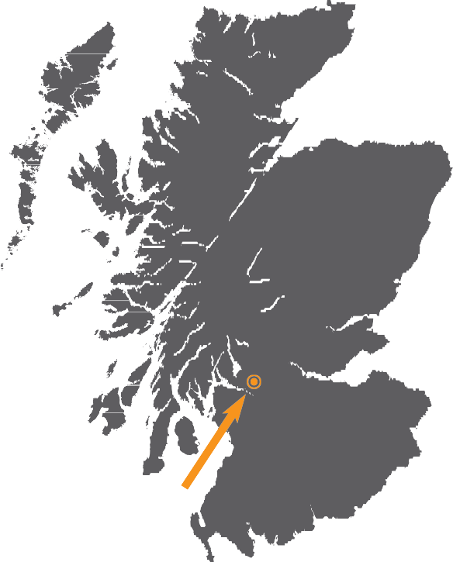

SUSTAINABLE
ECONOMIC
GROWTH FOR ALL

WEST DUNBARTONSHIRE’S
ECONOMIC DEVELOPMENT STRATEGY
2022 – 2027
West Dunbartonshire

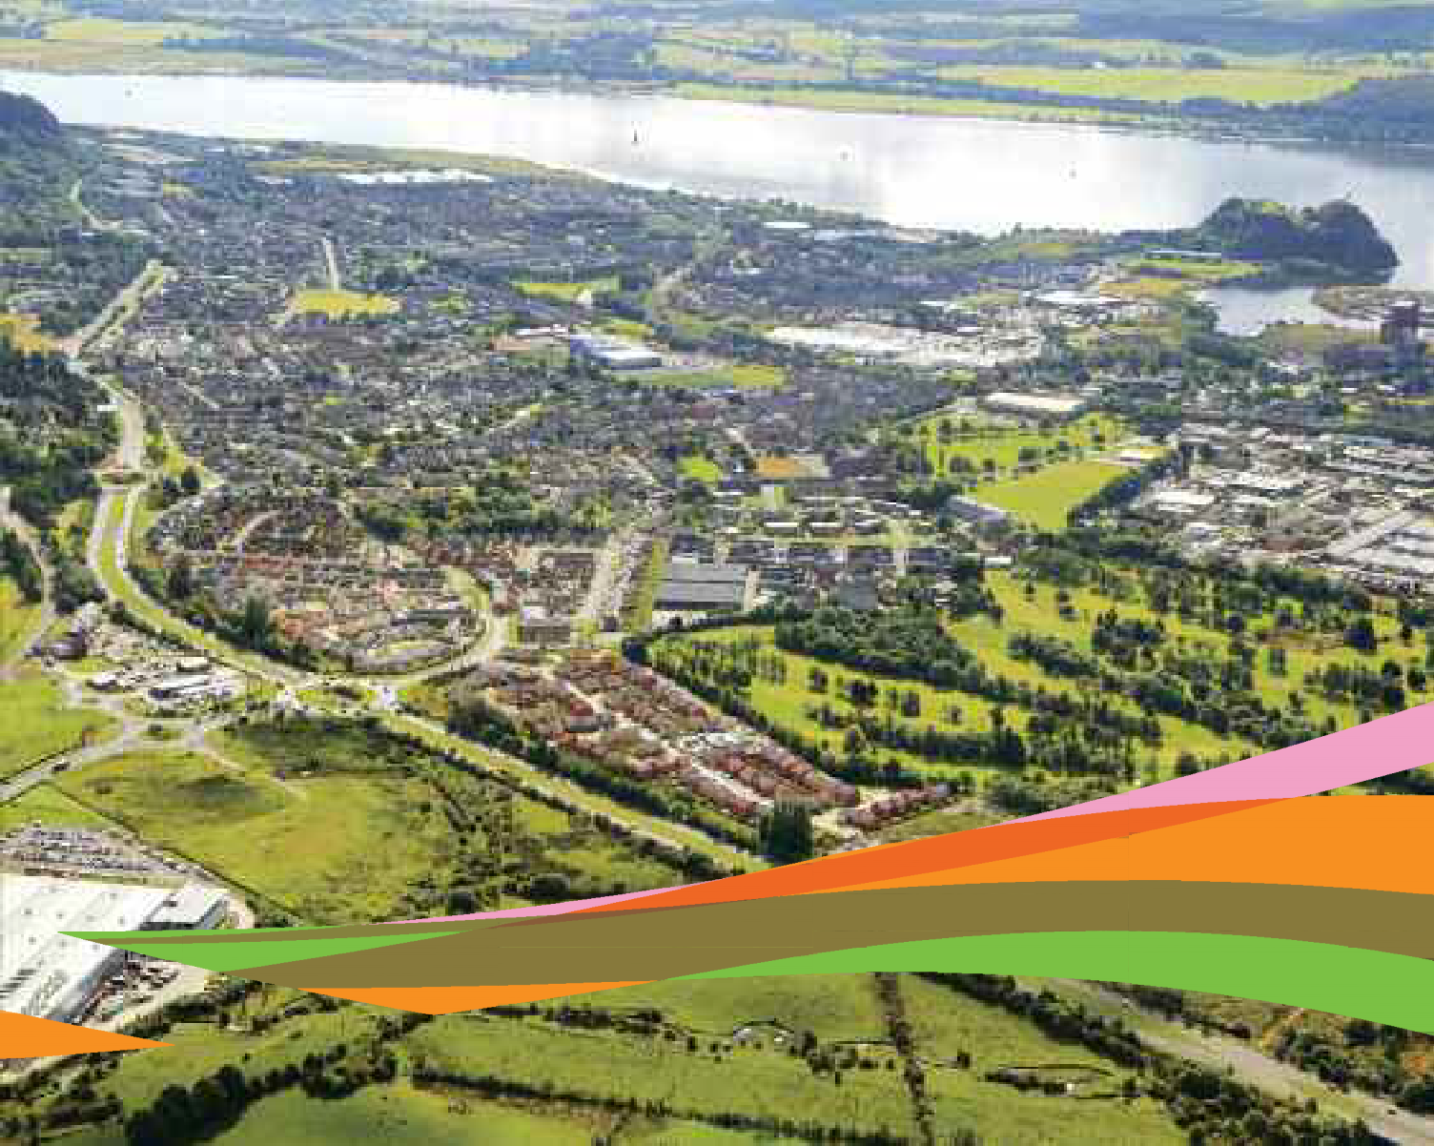

CONTENTS

Our vision and how we will achieve it | 3

Stimulating economic investment and growing the business base | 4

Establishing an inclusive economy by improving the skills  of our people and supporting them into work | 5

Creating a prosperous place where people choose to live, work, visit and invest | 7

Addressing climate change and supporting a green recovery | 11

Building stronger partnerships and new approaches to delivery | 12

OUR VISION AND HOW WE WILL ACHIEVE IT

‘By 2027, West Dunbartonshire will have an inclusive and vibrant economy through the creation of fairer jobs, a drive towards net Zero, and the development of prosperous places in partnership with our communities and businesses’.

The key strategic priorities of the Economic Development Strategy are:

- Stimulating economic investment and growing the business base
- Establishing an inclusive economy by improving the skills of our people and supporting them into work
- Creating a prosperous place where people choose to live, work, visit and invest
- Addressing climate change and supporting a green recovery
- Building stronger partnerships and new approaches to delivery

STIMULATING ECONOMIC INVESTMENT
AND GROWING THE BUSINESS BASE

Increasing the number of new start businesses

Supporting the start-up rate, survival and growth of our local businesses remains a key priority for the Council. We will work to stimulate our business base to ensure we increase the start-up and survival rate of our local businesses. The Council’s Business Support team provides dedicated advice and a range of financial support to encourage entrepreneurship and help to support local businesses to start up and grow.

The Council will focus on:

- Delivering start-up advice and support to all sections of the community;
- Promoting support available to increase the number of new local businesses formed including high growth start-ups and social enterprises;
- Providing potential entrepreneurs with the skills necessary to start and sustain a business;
- Deliver a range of webinars/workshops to provide advice on how to start-up and grow your business.

Assisting our local businesses to recover and grow

The post-Covid pandemic recovery and growth of small and medium businesses is a key objective in growing our local economy. In West Dunbartonshire, the majority of our businesses are either micro or small scale and are often family owned. Many of these businesses provide outstanding services and products to the market place. However too many local businesses either lack ambition to grow or do not have the right skills in place to do this. A key focus of the Strategy going forward is therefore to support the growth of ambitious local SMEs that can offer additional, and preferably greener, higher value, employment opportunities.

- Provision of grant assistance to support innovation & business growth;
- Provision of specialist consultancy assistance through Business Gateway service;
- Referral of businesses to partner organisations that provide relevant financial advice or support;
- Access to financial investment through Business Loans Scotland.

Increasing the adoption of digital technology

The digital connectivity of our local businesses is now of even greater importance due to the COVID pandemic. Embracing digital technology offers many benefits for businesses, including the ability to engage with customers directly, to develop new processes and products, and the ability to sell these products to a global market, 24 hours a day at a relatively low cost. Our Business Advisers provide a range of advice and support to assist businesses to improve their digital presence, which includes:

- Delivery of Digital Boost programme through the Business Gateway;
- Specialist expert help available through Business Gateway service;
- Provision of grants to support business digitalization;
- Access to a range of webinars/workshops to provide advice and support.

Developing the foundational economy

The foundational economy provides those basic goods and services which keep us safe, sound and civilized, such as care and health services, food, housing, energy, construction, tourism and retailers on the high street.

The foundational economy approach offers the chance to reverse the deterioration of employment conditions, reduce the leakage of money from communities (in keeping with the current thinking around Community Wealth Building) and address the environmental cost of extended supply chains.

This new Strategy sets the direction for a broader and more balanced approach to economic development with a shift towards a focus on place and making communities stronger and more resilient. The Strategy places a greater emphasis on tackling inequality and the promotion of inclusive growth through a new focus on the foundational economy, this approach sits alongside some of the other priorities of our Economic Strategy; supporting business growth that future-proofs the economy; investing in the skills people need to enter, remain and progress in work; and investing in the infrastructure communities need to be connected and vibrant.

Supporting sustainable tourism

West Dunbartonshire links the City Region with Loch Lomond and offers a mix of rich history along with natural landscapes which creates a distinctive Scottish visitor experience. Tourism is an important contributor to West Dunbartonshire’s overall economic growth. It is therefore important that we continue to develop sustainable tourism in West Dunbartonshire to support national and local strategies seeking to grow this sector and create employment. We will achieve this by working closely with tourism partners and businesses to

- encourage and assist the adoption of sustainable and green practices;
- improve their use of digital technologies;
- upskill and create employment in tourism and hospitality;
- encourage visitors and businesses to use sustainable transport.

ESTABLISHING AN INCLUSIVE ECONOMY
BY IMPROVING THE SKILLS OF OUR PEOPLE
AND SUPPORTING THEM INTO WORK

Assisting people back into work

A key priority in West Dunbartonshire is to support people back into work and assisting them to progress in the labour market. This will be achieved by adopting innovative approaches that support people into ‘Fair Work’ and the best quality jobs possible. We will do this by fully engaging with West Dunbartonshire employers and residents; providing good quality advice about employment and training options; and helping them to develop their skills and overcome barriers to opportunity. Activities will include:

- Further development of West Dunbartonshire’s approach to local employability service provision, ensuring the principles of No One Left Behind are addressed and using a service design approach that will continue to deepen partnership working amongst community planning agencies;
- Develop the West Dunbartonshire Apprenticeship Pathway, extending opportunities to school pupils through access to Foundation opportunities and developing Modern Apprenticeships to reflect the opportunities within the council and wider economy;
- Support local employers by incentivising them to recruit and upskill staff, including apprentices, through the range of available Employer Recruitment Incentives and emerging grant funding;
- Working in partnership through the No One Left Behind Approach to reinforce approaches that will further develop employment opportunities within the Third Sector;
- Maximise funding opportunities available through replacements to European and Government funding streams and increase employability support for local people e.g. Future Prosperity Fund, No One Left Behind, Parental Employability Support and Young Persons Guarantee;
- Inclusion of Community/Social Benefit clauses in contracts that the Council puts out to tender.

Meeting the skills needs for growth businesses

West Dunbartonshire Council supports the skills development needs of growing businesses and has developed a range of business support mechanisms which can provide local businesses with a free business skills review to identify any training needs. Any eligible training requirements identified can also be supported through the Council’s business training grant. The Council will continue to meet the skills needs for growth businesses through:

- Collation of intelligence on the skills needs of growth industries;
- Development of tailored skills interventions to support growing businesses;
- Provision of a range of mechanisms that encourage employers to recruit new staff and up-skill existing employees;
- Maximisation of community benefits to create training and employment opportunities through major capital projects.

Supporting young people in their transition to work

It is vital to the future success of the West Dunbartonshire economy that the Council maximises the opportunities available to our young people and ensures that they are equipped to take advantage of these opportunities.

Support for young people in their transition will include:

- Supporting entrepreneurship within educational establishments;
- Providing work experience placements which challenge stereotypes for school pupils;
- Working with partners to support young people to enter training or employment through both national and local programmes;
- Supporting young people to enter employment;
- Supporting graduates to enter employment within growth sectors.

Improving core employability skills

At present, low workforce qualifications act as a constraint to economic growth. In addition, the demographic challenges facing the area mean that getting more people engaged in economic activity is a key priority.

This requires us to help individuals to improve core employability skills and attitudes that will allow them to access job opportunities. We will provide support through:

- Building on strong partnership working activities between the Council’s employability service ‘Working4U’, Department of Work and Pensions, Skills Development Scotland, West College Scotland and the Council’s schools to improve core employability skills;
- Widening opportunities for engaging those without work in purposeful activities which will move them towards training and employment;
- Providing employability support to local people as outlined above.

CREATING A PROSPEROUS PLACE WHERE PEOPLE CHOOSE TO LIVE,
WORK, VISIT AND INVEST

Placemaking

A place-based approach to developing the urban and rural environment puts the needs of communities at the centre of decision making. It is therefore best achieved through a collaborative and inclusive process where public bodies, the community, businesses and other organisations work alongside each other and are resourced to support local residents and community groups to understand and deliver on their needs.

There is much evidence that draws a correlation between our health and wellbeing and where we live and the opportunities to positively interact with our environment. Easy access to parks and greenspace contributes to wellbeing. Where access is less easy, greening programmes and regeneration of vacant land will be explored. Connecting Clydebank and Connecting Dumbarton projects will provide infrastructure for active and sustainable travel. Redesigning our roads and streets to create safe routes for pedestrians and cyclists must be integral to placemaking, not just for health reasons but to reduce our carbon impact.

Placemaking provides West Dunbartonshire Council with the opportunity to align its resources to create successful places. Success will be achieved by taking a collaborative approach that is ambitious and where necessary challenges established practices, for example car dominance in town centres and repurposing obsolete retail premises to create vibrant town centres and high streets. West Dunbartonshire Council has already taken a placemaking approach to regeneration and development and will continue to prioritise:

- Clydebank town centre and Queens Quay;
- Dumbarton town centre and waterfront;
- Alexandria town centre;
- Balloch Village;
- North Clyde Riverbank including the former Exxon site and Bowling Harbour;
- Redevelopment of the former Carless site in Old Kilpatrick.

20 Minute neighbourhoods

20 minute neighbourhoods are places in which residents can meet almost all of their essential needs including employment, education, health care, shopping and leisure within comfortable walking, cycling or wheeling distance from their home. The principle of living more locally and enhancing place is not new but has been given more emphasis in response to the Covid-19 pandemic and the need to reduce carbon emissions. The Programme for Government 2020-21 ‘A Fairer, Greener Scotland’ commits to work with local authorities to take forward the Scottish Government’s ambition for 20 minute neighbourhoods. This is echoed in the new spatial plan for Scotland to 2050 (NPF4) and the aims around active travel and public transport align with Scotland’s National Transport Strategy.

We are aware of and support the Scottish Government’s Town Centre First approach and are working to make our town centres attractive places for people to live. In recent years WDC have placed a significant emphasis on town centre regeneration i.e. investing in and changing underutilised or tired town centres with the aim of giving them a new lease of life.

Like town centre regeneration, the 20 minute neighbourhood concept adopts a place-based approach but stresses the benefits living locally can bring to a place whilst also reducing inequality and meeting net zero carbon emission targets. Much of the work the Council is already doing is in line with the 20 minute neighbourhood concept but we now need to take that further and apply it to achieving West Dunbartonshire’s Mission i.e. ‘ By 2030, West Dunbartonshire will create fairer jobs, drive towards net Zero, and create vibrant places in partnership with our communities and businesses’.

The 20 minute neighbourhood concept links with the Council’s four Strategic Themes which sit below this mission but is most relevant to the theme of Placemaking – make places that fulfil the needs of the local community.

In delivering 20 minute neighbourhoods, the Council will need to take a proactive and joined up approach across a number of areas including planning, housing, regeneration and transport and also work with partner organisations to support the concept, with an emphasis on the following areas:

- Delivery of Alexandria Masterplan;
- Development and delivery of Clydebank Town Centre Framework;
- Railway to Rock Connectivity opportunity in Dumbarton;
- Development options and interventions for the obsolete Artizan Centre;
- Meeting the aspirations of the Balloch Village Charrette;
- Delivery of actions of the Active and Sustainable Travel

Strategic sites

At 0.8% of total land area, West Dunbartonshire has a higher percentage of vacant and derelict land than Glasgow City Region at 0.7% and Scotland at 0.1%. Scottish Government Vacant & Derelict Land Survey
Much of the vacant land is on the Clyde Riverside where traditional industry such as shipbuilding was once located. In recent years many of these former brownfield sites have been brought back into productive use. Queens Quay is a £250 million mixed-use regeneration project on the site of the former John Brown’s shipyard in Clydebank and with energy provided by the District Heating Centre, Queens Quay will transform Clydebank into one of the UK’s greenest town. Dumbarton Waterfront is being transformed with new housing and retail development, and the creation of a walkway on the Leven riverside between Dumbarton town and the Rock and Castle.

Looking to the future, the Malin Group is creating a new Scottish Marine Technology Park at the former Carless oil refinery site in Old Kilpatrick with the potential to create 1,000 new jobs and substantially develop marine engineering in the area. The Clyde Riverbank will also benefit from investment of £28m from the Glasgow City Region City Deal, which will create a new mixed use location at the former Exxon site at Bowling, with the potential to create a new enterprise zone to attract further investment and create new employment opportunities. There are further opportunities along North Clyde Riverbank to deliver mixed use developments that will create places where people choose to work, live or spend their leisure time, and the Council will work in partnership with relevant stakeholders to realise these opportunities.

The regeneration of brownfield sites continues to offer opportunities for inward investment, economic growth and jobs but can also fulfil social and community needs. Vacant and derelict sites have the potential to become local community assets to provide access to greenspace, growing areas, community facilities, access to the river, recreation, carbon reduction or to meet local housing needs. With the support of the European Regional Development Fund/Scottish Government’s Green Infrastructure Fund, Melfort Park in Clydebank has transformed a contaminated urban site into a local park with much sought after community growing areas.

57.3% of the population of West Dunbartonshire live within 500 metres of vacant or derelict land. People and environment must be at the heart of all decisions however the choice to promote regeneration of strategic sites and vacant and derelict land for employment uses, community facilities or greenspace need not be a mutually exclusive one. In line with the principles of placemaking and 20 minute neighbourhoods advocated in this Strategy, a mixed use approach to the development of strategic sites to deliver sustainable urban development must continue to happen.

Development options must be considered in the widest possible context that takes account of economic opportunities, development planning, community needs and aspirations and social impact, including:

- The ongoing development of Queens Quay and strengthening its connection with Clydebank town centre;
- Infrastructure delivery on the Exxon site, and exploration of further opportunities along the North Clyde Riverbank including Bowling Harbour and Scotts Yard;
- Supporting the development of advanced manufacturing and research, development and technology businesses on the former Carless site in Old Kilpatrick;
- Redevelopment or reuse of brownfield sites within our town centres to support placemaking and the creation of 20 minute neighbourhoods.

Delivering homes for the future

Availability of good quality homes and a choice of tenures is a fundamental component of placemaking. The home environment has a significant impact on the wellbeing of an individual, and well designed housing that is close to services plays a significant role in the creation of 20 minute neighbourhoods. New homes are important because they deliver high quality, energy efficient properties into our housing stock. They are designed to suit a variety of needs and our design standard requires the inclusion of 10% accessible properties in any affordable development. The latest draft Strategic Housing Investment Programme 2022-27 (SHIP) identifies 755 homes to be developed by ourselves and our Registered Social Landlord partners leveraging an estimated £55.8million of grant funding from the Scottish Government over the five years of the plan. Investing in new homes is vital for meeting housing need in our communities. We will continue to work with our colleagues to review the private housing market and ensure there is an adequate supply of private housing sites.

We have high levels of housing need in West Dunbartonshire. Therefore we will work closely with colleagues in other teams to deliver more housing of all tenures and ensure that our housing is the best it can be across the council area. Any investment in housing reaps rewards beyond the home itself and in addition provides significant community benefits through our procurement processes. These include apprenticeships, school engagement and investment in community spaces such as gardens.

West Dunbartonshire Council and our strategic housing partners continue to invest considerably in our homes to ensure that they meet the Scottish Quality Housing Standard (SQHS) and the recently introduced Energy Efficiency Standard for Social Housing 2 (EESSH2).

New homes can only add a comparatively small number of homes to the overall housing stock and therefore it is also important that our existing homes benefit from investment too. We have a budget of around £20 million per year to invest in our own homes over the next five years. This includes a budget for energy efficiency works to help us reach EESSH2 requirements and those ambitions set out in WDC’s climate change strategy. We will also support private owners and landlords to invest in their properties through our energy advice service and including them in grant funded area based investment programmes such as the Home Energy Efficiency Programmes for Scotland Area Based Schemes(HEEPS ABS) where appropriate.

Empowering and engaging with our communities

West Dunbartonshire Council is committed to empowering its communities, and delivery of the Economic Development Strategy must respond to the opportunities set out in the West Dunbartonshire Community Empowerment Strategy, Action Plan and subsequent Delivery Plan. In recent years regeneration and placemaking in West Dunbartonshire has been influenced and often shaped by the involvement of local community groups and residents.

The Alexandria Masterplan (2021) was produced following extensive and diverse community engagement based on the principles of community-led Place conversations that took place in 2019. The Clydebank Town Centre Development Framework has evolved from the community aspirations and needs expressed in the Clydebank charrettes.

The extensive development and improvement of Dumbarton’s Waterfront including the Waterfront Path follows the successful Dumbarton Rock and Castle Charrette. As we develop projects and programmes of work from the Economic Development Strategy, we will ensure that communication and engagement with our communities continues. Projects will be developed in collaboration with the communities involved through Locality plans and the development of Neighbourhood plans which will be supported by the Communities team and provide the opportunity for community groups; schools, interest groups and a range of other local organisations to have their voices heard. This will include but not be limited to:

- Delivery of Alexandria Masterplan and Clydebank Town Centre Development Framework;
- Further improvements to Dumbarton Town Centre, including the potential redevelopment of the Artizan Centre and the Rail to Rock connectivity project;
- Ongoing regeneration of Bowling Harbour and North Clyde Riverbank;
- Ongoing investment in Exxon and Queens Quay.

ADDRESSING CLIMATE CHANGE AND SUPPORTING A GREEN ECONOMY

Addressing climate change

In January 2021 the Council launched a new Climate Change Strategy and Action Plan in response to the global climate emergency, setting a long term target for West Dunbartonshire becoming net zero by 2045, following a similar trajectory to the national target set for Scotland as a whole. To deliver on this, our action plan sets out the immediate and longer term actions the Council will need to take to respond to the climate emergency, both in relation to mitigating and adapting to climate change.

Our climate strategy and action plan will support the Economic Development Strategy by ensuring any major projects or developments developed and implemented by the Council will consider mitigation, adaptation and sustainability measures in order to tackle Climate Change and support our ambitions to be a net zero by 2045.

Supporting the wider green economy

The Council aims to maximise the opportunities available to secure investment and jobs from the growing green economy and to ensure that the benefits of this are shared across our local area and our local community. The Council will work to ensure that planning and regeneration policies and projects directly or indirectly consider the current and future long-term impacts of Climate Change.

This can be achieved by better supporting a Just Transition for Scotland - a fairer, greener future for all – and by using the Green Recovery as a foundation for ensuring regeneration helps to better create jobs in the environmental sector. This can be achieved by upskilling and reskilling, and helping to both support and develop businesses to reduce emissions, increasing resilience against extreme weather events and better adapting to the impacts of Climate Change. Therefore, it supports a net zero and climate resilient economy in a way that delivers fairness and generates jobs in the Green Economy.

Actions include but are not limited to:

- Creating the necessary conditions and support for a more local, sustainable, low carbon or net zero economy;
- Support businesses in becoming net zero;
- Support businesses in becoming more resilient to extreme weather events by being more prepared for adapting to the impacts of Climate Change;
- Support businesses in transitioning towards a ‘Circular Economy’;
- Encourage wider investment in and opportunities for low carbon and renewable heat technologies (e.g. The Queens Quay District Heating Network (DHN)), therefore tackling fuel poverty and supporting the transition away from a fossil fuel economy;
- The potential creation of additional jobs from projects such as the Queens Quay District Heating Network, Clydebank. For example, works for carrying out current and future connections, including (but not limited to) the manufacturing of products, transportation of products, and construction, etc. This would be through the heat network expansion and Housing energy efficiency retrofit programmes;
- Invest in further improving the quality of housing stock, including initiatives to improve energy efficiency and to tackle fuel poverty.

BUILDING STRONGER PARTNERSHIPS
AND NEW APPROACHES TO DELIVERY

West Dunbartonshire Community Planning Partnership

The Council recognises that this Strategy can only be delivered through effective partnership working between key stakeholders and local communities. In the current economic climate it is vital that the Council works harder than ever to strengthen partnerships and collaborative working to achieve more with less and deliver better outcomes for all.

The Community Planning Partnership have developed a ‘West Dunbartonshire Plan for Place’ which builds on the previous Single Outcome Agreements. Delivery of the aspirations and priorities set out in this plan falls to the five Delivery & Improvement Groups (DIGs), which report in to CPWD on action plans and activity to improve outcomes for all residents. The five Delivery Improvement Groups (DIGs) are:
- A flourishing West Dunbartonshire;
- An independent West Dunbartonshire;
- A nurtured West Dunbartonshire;
- An empowered West Dunbartonshire;
- A safe West Dunbartonshire.
Glasgow City Region and Clyde Mission

The Glasgow City region was established in 2015 and was driven by the initial £1.13bn City Deal investment. The Council city deal project is the regeneration of the former Exxon site at Bowling which is progressing with final business case for this £34.05m project due in November 2022 with works due for completion by 2026. The Glasgow City Region regional economic strategy has prioritised the themes of creating an inclusive economy, enhancing productivity, and addressing the climate emergency, with the Council Economic strategy directly aligned to these. In addition the opportunities through Clyde Mission with a focus on maritime opportunities and green jobs for our communities are being pursued. The UK Shared Prosperity Fund and the role of the City Region will continue to be a focus through this strategic period.

Green Freeport

The Council, through its membership of the Glasgow City Region, is involved in the process of attempting to win a Green Freeport partially located in West Dunbartonshire. Green Freeports are free economic zones that include rail, sea or air. Organisations within the Green Freeport zone can benefit from tax breaks and lower business tariffs, forming part of the UK Government’s Levelling Up agenda and the Scottish Government’s Economic Strategy 2022. The joint government objectives for Green Freeports in Scotland are:

• To promote regeneration and high-quality job creation
• To promote decarbonisation and a just transition to a net zero economy
• To establish hubs for global trade and investment
• To foster an innovative environment

The Glasgow City region bid is a partnership between the public and private sector. In West Dunbartonshire the sites included in the bid are adjacent to Bowling Basin and Rothesay Dock in Clydebank. Securing a Green Freeport in West Dunbartonshire could lead to the creation of many jobs and opportunities for our local businesses, as well as attracting new employers to the area.

Partnership Working

In West Dunbartonshire, the Council has developed strong partnerships with national and local agencies. These partnerships have been strengthened through ‘working4business’, our single point of contact for business support services and ‘working4U’, our employability service. Both provide a partnership approach from public sector partner agencies and external partners to successfully grow the local economy and create new employment opportunities. Examples of partnership working include:

- Service level agreements with key partner organisations such as East Dunbartonshire Council and the Dunbartonshire Chamber of Commerce;
- Working in partnership with other local authorities, in particular the Glasgow City Region through City Deal;
- Joint programme delivery with key partner organisations;
- Continued development of key projects through the Community Planning Partnership Delivery and Improvement Group.

Maximising external funding opportunities

We will seek external funding to help us deliver on this strategy. West Dunbartonshire Council has a strong track record of attracting external funding for Economic Development, Regeneration, Infrastructure and Employability projects. Recent examples include £2m of funding from the Scottish Government’s Clyde Mission Fund to enable construction of the Scottish Marine Technology Park, £20m from the UK Government’s Levelling Up Fund for our Town Centres regeneration projects and various grants from the Scottish Government’s Regeneration Capital Grant Fund. We are a partner to the Glasgow City Region and are developing a multi-million pound project to create new industrial premises and associated infrastructure at the former Exxon site near Dumbarton.

We secured funding almost £7m of funding from the European Regional Development Fund/Scottish Government Low Carbon Infrastructure Transition Programme for our pioneering Clyde Energy Centre at Queens Quay, the site of the former John Brown shipyards. This project involves a water source heat pump and associated district heating network which will provide low cost energy to the Queens Quay development site as well as adjoining sites such as the Clydebank Leisure Centre, the new Clydebank Health Centre, the Golden Jubilee Hospital complex, West College Scotland and potentially beyond to other local homes.

We have also secured funding from the former European Structural Funds to help our local businesses to start up and grow, and we manage other business support funding in the form of Business Gateway and associated funds such as the Digital Boost programme.

Our Employability section have secured funding from the former European Social Fund to deliver a wide range of employability support. Both they and our Economic Development section have applied for funding from the UK Shared Prosperity Fund to ensure continuity of these employability and business support programmes in the wake of Brexit and the loss of access to European funding. Our Employability section will also seek to maximise funding opportunities available through replacements to European and Government funding streams and increase employability support for local people e.g. Future Prosperity Fund, No One Left Behind, Parental Employability Support and Young Persons Guarantee. Potential future sources of external funding include:

- United Kingdom Shared Prosperity Fund;
- Levelling Up Fund;
- Scottish Government Clyde Mission Fund;
- Scottish Government Regeneration Capital Grant Fund;
- Scottish Government Vacant & Derelict Land Investment Programme.

Improving Procurement opportunities

We recognise the importance of procurement opportunities for our local economy. The Council procured £167m worth of supplies, services and works in the year 2020/21. Our Procurement section has committed to working to ensure that local businesses can compete effectively for Council contracts. This can be seen in targets set in our Sustainable Procurement & Commercial Improvement Strategy.

In financial year 2020/21 31.6% of Council procurement was spent on local enterprises and/or who have a presence in West Dunbartonshire. We aim to increase this figure to 38% by financial year 2021/22. In financial year 2019/20 8.23% of Council procurement was spent on local small/medium-sized enterprises (LGBF measure) The Council aims to increase this figure to 14%.

We will work with our local SMEs to help them prepare to bid for Council and other contracts. We will do this through our experienced Business Gateway team and through external agencies such as the Supplier Development Programme.

Supporting Social Enterprises

We recognise the importance of Social Enterprise as part of the economy of West Dunbartonshire and Scotland in general and will continue to work with and support their start up and growth. The importance of procurement has been referenced above and this can also be seen in relation to Social Enterprise. The Council awarded approximately £14.5m of procured spend to Social Enterprises in 2020/21.

Community Wealth Building

Community wealth building (CWB) is a people-centred approach to local economic development, which redirects wealth back into the local economy, and places control and benefits into the hands of local people. This new strategy recognises the importance and responds to the Community Wealth Building principles. Examples of this include:

- Plural ownership of the economy – through providing support to social enterprises to start up and grow;
- Making financial power work for local places – we have supported the Scotland Loves Local scheme which encourages people to think local first and support their high street businesses;
- Fair employment and just labour markets – our employability service Working4U works with “ harder to reach” groups to move them toward employment;
- Progressive procurement of goods and services – this is illustrated by the detail above on procurement by the Council;
- Socially productive use of land and property – our Asset Management and Communities services have, through the community asset transfer process, transferred under-utilised assets to community groups.

COSLA Leaders committed to the 1% Framework Agreement in October 2017 which stated that at least 1% of local authority budgets (excluding council tax) will be subject to Participatory Budgeting (PB) by the end of 2020-21. Since then significant PB activity supported by the Communities Team has taken place across West Dunbartonshire Council, in a small grants/grant giving model and as tests of ‘mainstreaming’ PB with specific service areas and budgets. The focus on developing a corporate approach will continue: embedding a culture of participation; encouraging more active citizenship and participation; directing priorities and spend to community need. PB and participatory processes more generally, enhance local democracy by bringing together those who have traditionally held operational decision-making power with people living in communities impacted by those decisions.

Tackling inequalities

We believe that creating a prosperous economy will have a positive impact on equalities.
Our aim through this strategy is to create an inclusive economy where our community is thriving economically, socially and environmentally, and in which we deliver prosperity for all. Our strategic priorities aim to deliver higher rates of employment and wage growth, to reduce poverty - particularly child poverty - and improve health and quality of life for disadvantaged families and communities. Some of the key issues this Strategy will tackle include:

Disability

Disabled entrepreneurs are an essential part of the UK economy, with disabled-owned small businesses accounting for 8.6 per cent of the turnover of all UK businesses. 41 per cent of disabled business owners have used no business support, compared with 35 per cent of non-disabled business owners. (Federation of Small Businesses).

Age

Young people need support to start up and grow businesses. Around 60,000 young people in Scotland, or 13% of 18-24 year olds, were early-stage entrepreneurs, the highest rate among the home nations. Entrepreneurship among people under 30 years old in Scotland has steadily grown from being the lowest in the UK at 3.5% in the 2007/09 period.). We will provide support for young entrepreneurs to start up and grow businesses. University of Strathclyde Hunter Centre for Entrepreneurship

Race

While it is widely recognised that Ethnic Minority-led Businesses (EMBs) make a variety of economic and social contributions to their communities and the wider society in Scotland, there are longstanding concerns that Ethnic Minority Entrepreneurs (EMEs) do still experience relative disadvantage in a number of areas. (University of Strathclyde Business School, Hunter Centre for Entrepreneurship).

Gender

Men are still almost twice as likely to start businesses as women. The scale of Scotland's enterprise 'gap' is illustrated by estimates suggesting that Scotland would have an additional 108,480 businesses if women's business ownership rates equalled those of men. This would equate to a 32% increase in Scotland's business base.
(Business Gateway Women in Business)

Unemployment

West Dunbartonshire experiences higher levels of unemployment than both Scotland and the rest of Great Britain. In terms of Economic Activity 73.8% are Economically Active compared with 76.2% in Scotland and 78.4% in Great Britain.
Workless Households are higher in West Dunbartonshire too at 19% compared with 18.1% in Scotland and 13.6% in Great Britain. Claimant Count unemployment is also higher at 4.5% compared with 3.2% in Scotland and 3.8% in Great Britain.

Wages

Average earnings for workers based in West Dunbartonshire are £574 per week, compared with £622 in Scotland and £612 in Great Britain.
(All NOMIS Local Area Profile West Dunbartonshire June 2022)

Businesses

There are fewer businesses in West Dunbartonshire at 343.8 per 10,000 of the working age population. This compares with 508.7 in Scotland and 657.1 in the United Kingdom. (NOMIS - UK Business Count)

Other Formats

This document can be provided in large print, Braille or on audio cassette and can be translated into different community languages.

Please contact:
West Dunbartonshire Council
Corporate Communications
Church Street
Dumbarton, G82 1QL
Tel: 01389 737000

For further information, please contact:
West Dunbartonshire Council
Economic Development
Church Street
Dumbarton, G82 1QL
Tel: 01389 737777
www.west-dunbarton.gov.uk

