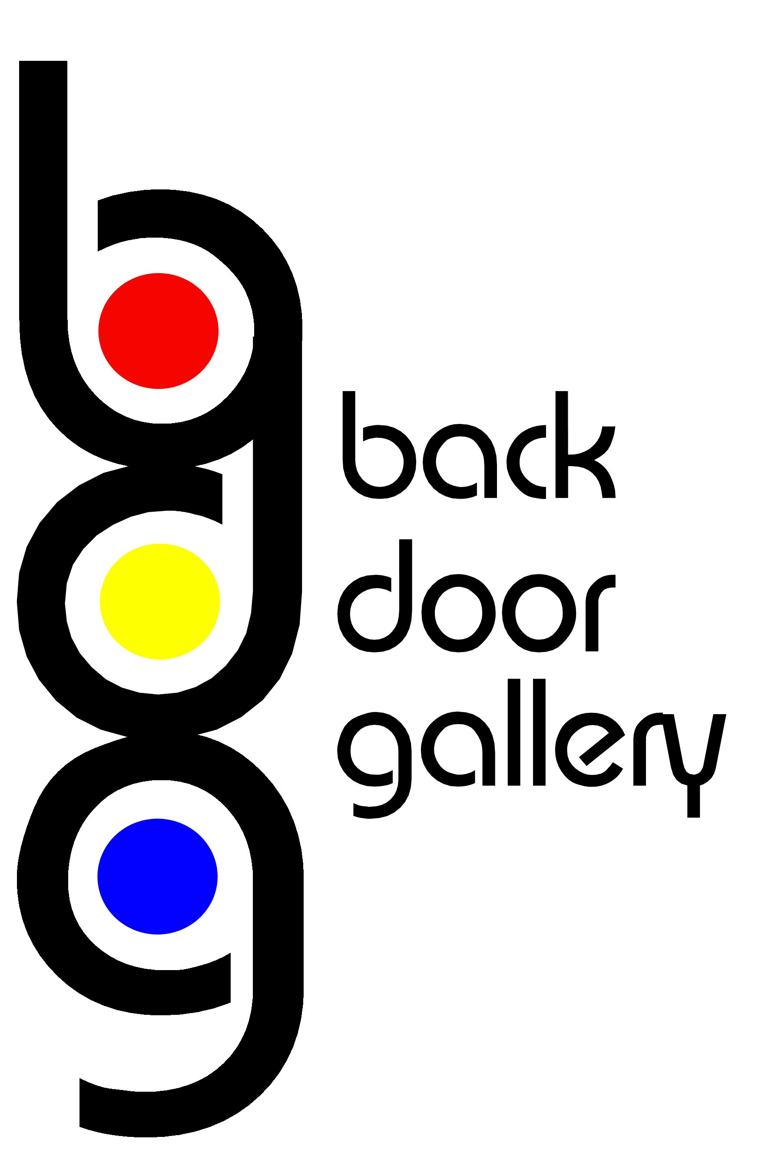
PROPOSAL FORM:
BACKDOOR GALLERY
Name |  | Phone
Address |  | Website
Address |  | Email

Proposal (Max 300 words, include dimensions & medium if known)

Technical Requirements

Please attach selection of up to 5 images with proposal via:
EMAIL: | Trish Robbins | Trish.Robbins@west-dunbarton.gov.uk
FORMAT: | Individual .JPEG files at 300dpi / in compressed zip file / as PDF

Post: | Proposal for Backdoor Gallery
 | Trish Robbins
 | Libraries and Cultural Services
 | 19 Poplar Road
 | Broadmeadow Industrial Estate
 | Museums Galleries Scotland Recognition
 | G82 2RJ
FORMAT: | Photographic prints / .JPEG files on CD

If you have any questions please do not hesitate to contact us via email or call 01389 772011



