**West Dunbartonshire Tenants & Residents Organisation (WDTRO)**

**Climate Change & Net Zero Housing**

**Summary Brief**

**Climate Change in Scotland**

The global climate is changing at a considerable rate. The Met Office detailed how since 1884, the 10 warmest years recorded have occurred since 2002, whereas the top 10 coldest years were recorded before 1970.

In Scotland, climate averages between 2009-2018 compared to averages for 1981-2010 show that:

* Temperatures have increased by 0.3°C; and
* Summers have been on average 11% wetter and winters 5% wetter.

Overall, in Scotland:

* Changes in our climate will accelerate, with winters becoming warmer and wetter; and hotter summers with changing patterns and intensities of rainfall;
* By the 2050’s Scotland could see summer temperatures increased by 4-5 degrees Celsius, with 40-60% more winter rainfall in places if no action is taken to reduce carbon emissions;
* Rates of sea-level rise are predicted to increase at an accelerated rate, with a global sea level increase of between 0.56 -1.12 metres by 2100 under a high emissions scenario; and
* Weather extremes will become increasingly the norm.
* Overall average temperatures will continue to increase (Figure 1.)

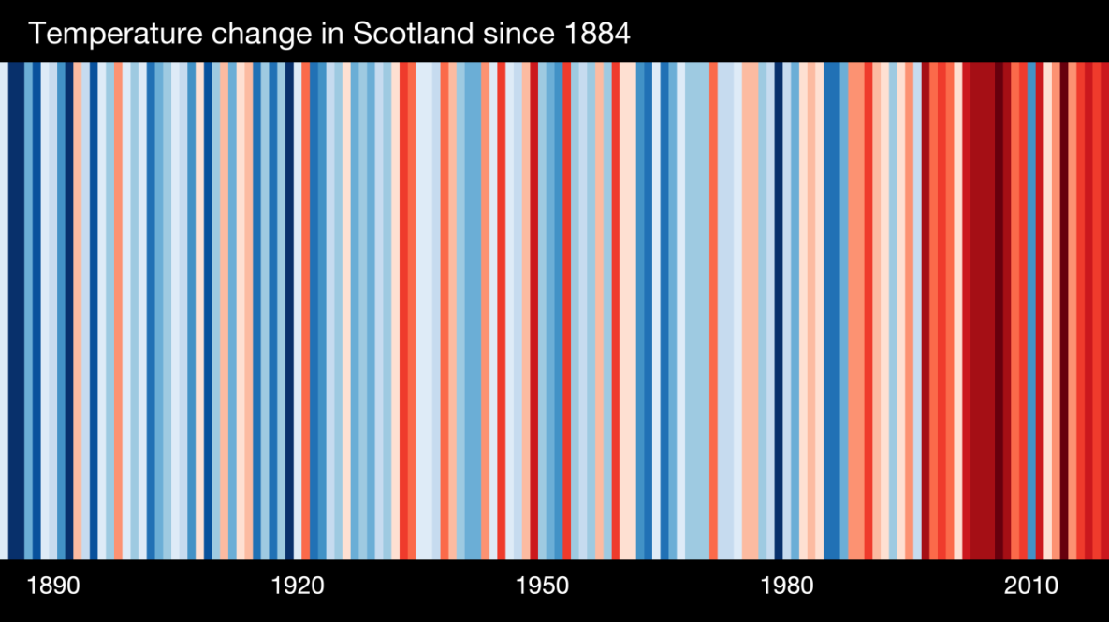

*Figure 1. Overall temperature change in Scotland from 1890 until 2019. Note the significant increase in temperature from the mid 1980’s until now.*

**Legal and policy drivers**

In a drive towards a low carbon economy, the Scottish Government set world leading Climate Change targets to reduce Scotland’s carbon emissions by 80% by 2050, with an interim reduction of 42% by 2020. In 2014 this interim target was met and exceeded (45.8%), leading to a new target set for a reduction of 50% for 2020. These targets present Scotland with significant social and economic opportunities, as well as challenges, and required a range of actions across society and the economy. The [Climate Change (Scotland) Act 2009](http://www.legislation.gov.uk/asp/2009/12/contents), which details these targets, is unanimously regarded as the most ambitious Climate Change legislation anywhere in the world.

In Scotland’s latest climate plan - ‘[Climate Change Plan: third report on proposals and policies 2018-2032 (RPP3)](https://www.gov.scot/publications/scottish-governments-climate-change-plan-third-report-proposals-policies-2018/)’, further expectations are placed on the public sector to increasingly demonstrate how its own operations are driving down emissions. RPP3 sets out the path to a low carbon economy while helping to deliver sustainable economic growth and secure the wider benefits to a greener, fairer and healthier Scotland in 2032. Since the publication of RPP3, a Climate Emergency has been announced by Scotland’s First Minister, followed by new national emissions reduction targets and the ‘[Climate Change (Emissions Reduction Targets) (Scotland) Act 2019’](http://www.legislation.gov.uk/asp/2019/15/enacted) which details new emission reduction targets for Scotland. These are:

* 56% reduction by 2020;
* 75% reduction by 2030;
* 90% reduction by 2040; and
* ‘Net Zero’ emissions by 2045.

To achieve this, the decarbonisation of the domestic housing and non-domestic building sectors will be key to achieving a net zero Scotland by 2045. This ambition is matched by the following policy and strategy documents, providing guidance on what we should be doing with all Scotland’s building stock starting immediately:

* [Climate Change (Scotland) Act 2009.](http://www.legislation.gov.uk/asp/2009/12/contents)
* [Climate Change (Duties of Public Bodies: Reporting Requirements) (Scotland) Order 2015.](https://www.legislation.gov.uk/ssi/2015/347/contents/made)
* [Climate Change (Emissions Reduction Targets) (Scotland) Act 2019.](http://www.legislation.gov.uk/asp/2019/15/enacted)
* [Scottish Government’s RPP3 (Low Carbon Scotland – Meeting our Emissions Reduction Targets 2018-2032).](https://www.gov.scot/publications/scottish-governments-climate-change-plan-third-report-proposals-policies-2018/)
* [Scotland’s Energy Strategy: The Future of Energy in Scotland (2017).](https://www.gov.scot/publications/scottish-energy-strategy-future-energy-scotland-9781788515276/)
* [Committee on Climate Change (CCC): Reducing UK Emissions – 2020 Progress Report to Parliament.](https://www.theccc.org.uk/publication/reducing-uk-emissions-2020-progress-report-to-parliament/)
* [Energy Efficient Scotland Programme](https://www.gov.scot/publications/energy-efficient-scotland-route-map/)

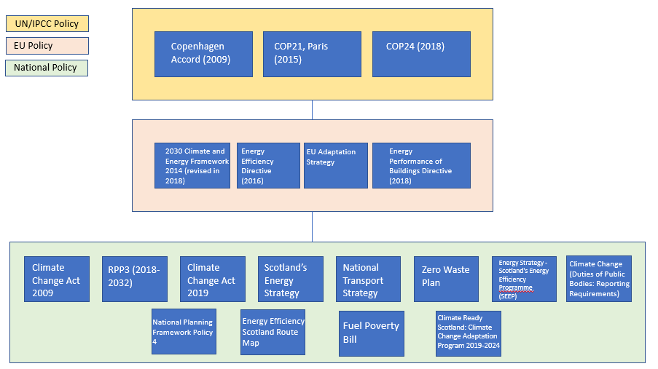

**What is Net Zero?**

**‘**Net zero’ refers to achieving an overall balance between emissions produced and emissions taken out of the atmosphere. Simply, this means that for all the emissions produced there must be mitigating actions in place to remove the same level of emissions from the atmosphere. Net zero does not mean that there should be no emissions, just that they must be balanced through emission reduction interventions. This is illustrated in the diagram below. The interventions range from land-use change methods, tree-planting, peatland restoration, investing in carbon-offsetting charities, technical solutions that draw carbon from the air, or Bioenergy with Carbon Capture and Storage (BECCS).

Pictures showing that emissions from cars, electricity, people and waste leads to CO2. this is balanced by CO2 being reduced by sequestration through trees. 

**What this means for WDC and the wider domestic sector in Scotland?**

**Committee on Climate Change (CCC): Reducing UK Emissions – 2020 Progress Report to Parliament**

* A switch to low-carbon heating. From **2025**, all new build homes will need to be built with low-carbon heating. The UK's 29m existing residential dwellings, and all commercial and public buildings, will need to switch away from fossil fuelled boilers towards low-carbon heating sources.
* Furthermore, we must phase out the installation of all new gas boilers by **2035 at the latest.** This means that any decision we make or any projects we are planning should already be including low-carbon heating as a replacement of gas or other fossil fuel heating types.

**The ‘Energy Efficient Scotland Programme’**

Energy Efficient Scotland is a 20 year programme containing a set of actions aimed at making Scotland’s existing buildings near zero carbon wherever feasible by 2050, and in a way that is socially and economically sustainable. It has two main objectives:

* Removing poor energy efficiency as a driver for fuel poverty
* Reducing greenhouse gas emissions through more energy efficient buildings and decarbonising our heat supply.

It’s vision is, by **2040**, Scotland’s homes and buildings are warmer, greener and more efficient. To achieve this they have set the following targets:

* **Domestic sector** - By **2040**, all Scottish homes are EPC C (where technically feasible and cost effective).
* **Non-Domestic Sector** – Our non-domestic buildings will be assessed and improved to the extent this is technically feasible and cost effective by 2040.

These overall targets can only be achieved if we are to quickly and radically change the way we approach energy efficiency in our homes and all other buildings. It must be set at the core of what we do when carrying out retrofit and new builds. The following table highlights the targets we must achieve.

**EPC standards**

|  |  |  |  |
| --- | --- | --- | --- |
| Social Housing | Private Rented | Owner Occupied | Fuel Poor Households |
| * Maximise the number of social rented homes achieving EPC B by 2032, and to include air quality and environmental impact requirements. * No social housing should be let if the energy efficiency rating is lower than EPC D. | Private rented homes to be:   * EPC E by 2022; * EPC D by 2025; and * EPC C by 2030   (where technically feasible and cost effective.) | * All owner occupied homes to reach EPC C by 2040 (where technically feasible and cost effective). | * All homes with households in fuel poverty to reach EPC C by 2030 and EPC B by 2040 (where technically feasible and cost effective). |
| Homes in the social rented sector are some of the most energy efficient in Scotland, with over 90% already achieving an EPC D or above. We want to continue the excellent progress that has been made. | People living in private rented accommodation generally live in homes that have poorer energy efficiency than elsewhere in the domestic sector. | Owner occupied homes account for 61% of domestic housing and around 34% of these are EPC C or above. | There were around 649,000 households living in fuel poverty in 2016, of which 79% lived in homes rated below an EPC C. These are our most vulnerable households and improving the energy efficiency of their homes will have a significant impact on their heating bills. |

**Building standards**

* Strive towards a higher energy efficiency and sustainability standard for our homes and buildings. This will require moving towards the highest sustainability standard as set out by the [Scottish Domestic Sustainability Building Handbook](https://www.gov.scot/publications/building-standards-technical-handbook-2019-domestic/about/).
* Look to prioritise retrofit of existing dwellings and buildings over new build. Ensure that retrofit strives towards the highest sustainability standard set out in the Scottish Sustainability Building Handbook; or similar retrofit standard such as ‘EnerPHit’ **\*1**.
* When new build is necessary, strive towards the highest sustainability standard set out in the Scottish Sustainability Building Handbook; a net zero building standard; or similar building standard such as ‘Passivhaus’ **\*2** (where technically feasible and cost effective).

**\*1** *A standard for an economically and ecologically optimal energy retrofit, for old buildings that cannot achieve Passive House Standard with reasonable effort. (PHI).*

**\*2** *A voluntary standard for energy efficiency in a building, which reduces the building's ecological footprint. It results in ultra-low energy buildings that require little energy for space heating or cooling.*

**Challenges**

* **Fuel poverty –** if we are to convert our heating to electricity, costs of electricity must be reduced to prevent increased fuel poverty as a result of more expensive electricity bills. The cost of gas is still too low and this must be considered going forward.
* **Nationwide shift towards alternative ‘greener’ fuels for heating** – decisions still must be made at a national or international level on the feasibility of retrofitting and converting the gas network to include greener alternatives such as hydrogen and biogas. Both of which have their own challenges.
* **Holistic approach** – Local Authorities and many other organisations must take a holistic approach to energy efficiency in the domestic and non-domestic sector. There is no ‘silver bullet’ that can help us with this, it most definitely will be a ‘mix’ of various technologies and interventions including building fabric improvements, renewables, District Heating, electricity and hydrogen. This will vary depending on the project, area and/or approach we take as a Local Authority.
* **Capital costs** – Local Authorities will likely need to invest more money in higher energy efficiency standards, low/no carbon heating systems and more sustainable building materials and construction practices. More funding will become more available from UK and Scottish Governments to help, but it still requires more investment from councils .
* A better understanding of **Whole-Life Costs (WLC) and avoidable environmental impacts** of purchasing and construction. This will include (but not limited to):
  + Understanding where materials are sourced;
  + Measuring the environmental impacts of their extraction and development;
  + Avoiding carbon emissions from transport and supply chain;
  + Reducing the environmental impacts of Land Use Change (LUC) if the development is new-build;
  + Avoiding construction materials that may have additional pollutants and off-gases;
  + Measuring and avoiding the environmental impacts of disposing or recycling construction waste;
  + Reusing existing construction materials from other projects or demolitions; and
  + Measuring the ‘embodied’ carbon of existing buildings over new builds.

**Tenant’s**

## Financial support for tenants

* [HEEPS: Warmer Homes Scotland scheme](https://energysavingtrust.org.uk/scotland/grants-loans/heeps/heeps-warmer-homes-scotland-scheme)– assistance from the Scottish Government to help private sector tenants and homeowners struggling to heat their home and who meet the qualifying criteria.
* [Energy Company Obligation](https://energysavingtrust.org.uk/scotland/grants-and-loans/energy-company-obligation)**(ECO)**- Low income and vulnerable households could be eligible for support with insulation and heating through the Energy Company Obligation.

## Contact Home Energy Scotland

* If you would like help, please **call 0808 808 2282** to speak to their advisors at [Home Energy Scotland](https://energysavingtrust.org.uk/scotland/home-energy/home-energy-scotland).
* Their trained advisors can carry out a Home Energy Check over the phone and give you practical advice on how to save energy and reduce your energy bills They can also let you know if there are benefits, credits or funding you may be eligible for but may not know about. And they could also advise you if you are eligible for discounted energy rates.

## Write to your landlord

* As a tenant you can also write to your landlord and ask them to consider helping make the property you are renting more energy efficient. Energy saving measures don’t have to be costly as there is funding and free impartial advice available to [landlords](https://www.homeenergyscotland.org/energy-efficiency-support-for-landlords/) too.

## Quick fixes

* In the meantime, there are lots of ways you can improve the energy efficiency of your home which don’t involve major changes to the property. Learn more about our quick fixes for [improving your home](https://energysavingtrust.org.uk/home-energy-efficiency) and saving money on fuel bills.

**Residents**

## Financial support for residents

* Contact Home Energy Scotland directly or go on the [grants and loans](https://energysavingtrust.org.uk/scotland/grants-loans) section of their website to find out what financial support can be provided for you to improve energy efficiency at your home. As a resident or home owner there are more grants or funding options available to you.
* [HEEPS: Warmer Homes Scotland scheme](https://energysavingtrust.org.uk/scotland/grants-loans/heeps/heeps-warmer-homes-scotland-scheme)– assistance from the Scottish Government to help private sector tenants and homeowners struggling to heat their home and who meet the qualifying criteria.
* [Energy Company Obligation](https://energysavingtrust.org.uk/scotland/grants-and-loans/energy-company-obligation)**(ECO)**- Low income and vulnerable households could be eligible for support with insulation and heating through the Energy Company Obligation.

## Contact Home Energy Scotland

* If you would like help, please **call 0808 808 2282** to speak to their advisors at [Home Energy Scotland](https://energysavingtrust.org.uk/scotland/home-energy/home-energy-scotland).
* Their trained advisors can carry out a Home Energy Check over the phone and give you practical advice on how to save energy and reduce your energy bills They can also let you know if there are benefits, credits or funding you may be eligible for but may not know about. And they could also advise you if you are eligible for discounted energy rates.

## Quick fixes

* In the meantime, there are lots of ways you can improve the energy efficiency of your home which don’t involve major changes to the property. Learn more about our quick fixes for [improving your home](https://energysavingtrust.org.uk/home-energy-efficiency) and saving money on fuel bills

**Queens Quay DHN;**

The Queens Quay district heating system is nearing the completion of the fit out portion of the Energy Centre. The fit out in principally complete with the commissioning of the system and its individual components almost complete. The Water Source Heat Pumps are now operational and last week were run to full operating temperature and tested. The network and thermal store has since been charged with hot water and heat was supplied to the Clydebank Care home last Friday. This week we are aiming to get heat on to Titan Enterprise Centre and Aroura House with Clydebank Leisure Centre to follow shortly thereafter. We are currently investigating the comparison cost of doing a gas boiler replacement in the town hall and library against the installation for the district heating but stress gas is not the future. We are in negotiation with Clydebank College and The Golden Jubilee Hospital regarding connecting both of them to the network.

We are currently developing a pilot Local Heat and Energy Efficiency strategy (LHEES)

The project will seek to identify local solutions to reduce emissions from buildings and tackle fuel poverty across all building types within the town of Clydebank. It is proposed that the project will identify opportunities for expansion of the Queens Quay District Heating network which is currently being developed centrally within this area. The project will also explore the feasibility and costs of other energy efficiency measures across this area and build on existing EWI programmes, explore alternative heating solutions and opportunities with a focus on solutions and technologies around energy efficiency and heat decarbonisation.

The 20 strategy will strive towards achieving net zero emissions from buildings by 2045 and removing poor energy efficiency as a driver for fuel poverty.

All analysis on fuel poverty will use the latest poverty definition as laid out in the Fuel Poverty (Scotland) Act 2019.