WEST DUNBARTONSHIRE LICENSING BOARD

LICENSING (SCOTLAND) ACT 2005

STATEMENT OF LICENSING POLICY

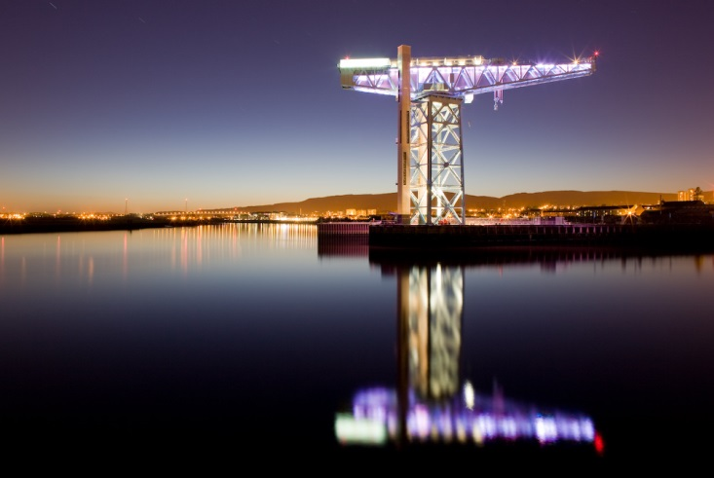

November 2018 to November 2023
Came into effect 4 November 2018

INDEX

Section Page

Foreword 4

PART 1 INTRODUCTION

1. Legal Background 5
2. West Dunbartonshire Licensing Board 5
3. Licensing Objectives 5
4. Licensing Board Functions 6
5. Declaration 6
6. Licensing Policy Statement and
Individual Applications 7
7. Relationship with other Strategies 7
8. Tourism 7
9. Duplication 7
10. Equalities 8

PART 2 THE LICENSING OBJECTIVES

11. The Licensing Objectives 9
12. Preventing Crime and Disorder 9
13. Securing Public Safety 10
14 Prevention of Public Nuisance 10
15. Protecting and Improving Public Health 11
16. Protecting Children & Young Persons from Harm 12

PART 3 LICENCES

17. Licences 14
18. Premises Licence 14
18.2 Access to Premises by Children and
Young Persons 14
18.5 Garages 15
18.6 Home Deliveries 15
18.7 Outside Drinking 16
18.14 Plastic Glasses 17
18.15 Smoking 17
18.16 Race Nights 17
18.17 Capacity 17
19. Personal Licence 18
19.1 Training 18 19.2 Renewal 18

INDEX Cont …

Section Page

PART 3 LICENCES Cont …

20. Occasional Licence 18
20.2 Occasional Licence – Repeated applications in lieu of a Premises Licence 18
20.3 Hours 19 20.5 Recommended Training Requirements 19
21. Extended Hours Applications 19
21.1 Special Events 19
21.2 National and International Events and
Festivals 20
21.3 Hours 20
22. Premises that are Tenanted Out and the
Premises Licence Holder is the Landlord. 20

PART 4 OVERPROVISION

23. Overprovision 22

PART 5 LICENSED HOURS/HOURS OF TRADING

24. Off-Sales 25
25. On-Sales 25
26. Festive Period 27
27. Late Opening 27
28. Early Opening 27
29. British Summer Time 28

PART 6 BOARD PROCEDURE

30. General 28
31. Delegation of Functions 28
32. Enforcement 29
33. Licensing Standards Officers 29
34. West Dunbartonshire Local Licensing Forum 30

Addendum Summary of Evidence Considered by the
Board in Consideration of its Statement of
Licensing Policy. 31

APPENDIX Overprovision Localities Maps 33

Foreword

Welcome to West Dunbartonshire Licensing Board’s fifth Licensing Policy Statement, which will be in operation from November 2018.

The Board in this Policy Statement has continued its established approach to the formation of its Policy. The Board is thankful to all parties who contributed to this process.

Since the last Statement of Licensing Policy the issues with regard to West Dunbartonshire’s relationship with the harm caused by the misuse of alcohol sadly remain. The statistics and figures show that West Dunbartonshire fairs poorly against the Scottish standard in relation to alcohol related admissions/discharges, alcohol related deaths and alcohol related brain damage admissions/discharges.

Against this background, the Board has continued its approach to the assessment of overprovision, and has declared that 16 out of 18 areas within the West Dunbartonshire are overprovided with certain types of licensed premises.

The Licensing Board is committed to ongoing consultation with West Dunbartonshire Licensing Forum and all other interested parties on the content of this document and will continue to monitor the effectiveness of the Statement of Licensing Policy throughout the duration of the policy and implement any supplementary statements as required. The Board is pleased to note the contribution of the Local Licensing Forum and partner agencies to the local community, and fostering and maintaining a good working relationship with the licensed trade.

Councillor Jim Brown
Chair of West Dunbartonshire Licensing Board

PART 1

INTRODUCTION

1. Legal Background

1.1 The Licensing (Scotland) Act 2005 (“the Act”) makes provision for the sale of alcohol and for regulating licensed premises and other premises on which alcohol is sold.

1.2 Section 6 of the Act places a requirement on every Licensing Board to publish a Statement of their Policy in respect of their functions under the Act. Section 6 has been amended to require a Licensing Board’s policy to be in place within 18 months of the Board Members being elected into office. Section 7 of the Act provides that the Board’s Licensing Policy Statement (“the Policy”) will include a statement as to the extent to which the Board considers there to be overprovision of (a) licensed premises or (b) licensed premises of a particular description in any locality within the Board’s area. In considering whether there is overprovision of licensed premises the Board must take into account the number and capacity of licensed premises and may have regard to such other matters as the Board thinks fit including, in particular, the licensed hours of licensed premises in the locality. This statement fulfils these statutory requirements for West Dunbartonshire Licensing Board. The Board is committed to ongoing consultation with West Dunbartonshire Licensing Forum and all other interested parties on the content of this document.

2. West Dunbartonshire Licensing Board

2.1 West Dunbartonshire Licensing Board (referred to in this Statement of Licensing Policy as “the Board”) is the licensing authority for the West Dunbartonshire Council area for the purposes of the Licensing (Scotland) Act 2005 and any subsequent regulations and guidance. Located in the West of Scotland and stretching from the outskirts of Glasgow to the Banks of Loch Lomond, According to the National Records for Scotland, the most recent population figure for West Dunbartonshire is 89,860, concentrated in the main settlements of Clydebank, Dumbarton and Alexandria. A map of the Council area is appended to this Statement of Licensing Policy.

3. Licensing Objectives

3.1 In exercising their functions under the Act and in preparing their Licensing Policy Statements, licensing authorities must have regard to the licensing objectives, as set out in Section 4 of the Act. The licensing objectives are:-

- preventing crime and disorder
- securing public safety
- preventing public nuisance
- protecting and improving public health
- protecting children and young persons from harm

Further details of how the Board will seek to promote these objectives are set out in Part 2.

4. Licensing Board Functions

4.1 The Board is responsible for various functions under the Act including, for example granting:-

- Premises Licences
- Personal Licences
- Occasional Licences
- Provisional Licences
- Temporary Licences
- Extension to Licensing Hours
- Transfers of Licences
- Variations of Licences

In respect of the sale of alcohol for retail consumption on or off the premises.

The Licensing Board is now required to prepare an annual report detailing its functions. This report, referred to as the annual functions report is a summary of the Boards’ business and can be viewed here:

https://www.west-dunbarton.gov.uk/media/4314861/final-licensing-board-functions-report-v3-with-appendices-1-and-2.pdf

4.2 The Board is also responsible for certain gambling licensing functions. The Board’s Gambling Policy is contained in a separate document available at https://www.west-dunbarton.gov.uk/media/4309575/statement-of-principles-gambling-act.pdf.

5. Declaration

5.1 In producing this Statement, the Licensing Board declares that it has had regard to the licensing objectives set out in the Act, to the guidance issued by the Scottish Government and the responses from those consulted on the Policy Statement, the Statement of Overprovision and on the Licensing Policy Statement generally. At the time this statement of licensing policy was being prepared the Scottish Government guidance was under review. Sections of this guidance were subsequently released in draft, and this draft guidance was considered in the writing of this policy.

5.2 This policy covers a wide variety of issues including procedural matters, licensed hours and the protection of children. It cannot provide for every eventuality but the intention is to outline the general policy that will be followed by the Board. If issues arise which are not fully covered by this policy the Board may issue guidance and may also publish a supplementary Policy Statement during the licensing policy period, in terms of Section 6 of the Act.

6. The Licensing Policy Statement and Individual Applications

6.1 A clear policy has a number of advantages. It promotes consistency of decision and gives advance notice to applicants as to the Board’s likely approach to certain decisions. When dealing with individual applications there is a presumption that the Board will follow the terms of its Policy Statement. However it is perfectly open to applicants to seek decisions which are contrary to the Board’s Policy. Similarly the Statement of Policy does not override the right of any person to make objections or representations on an application or to seek the review of a licence. However where applicants, objectors or representees wish the Board to make a decision which is inconsistent with the terms of this Statement of Policy, the Board expects such persons to fully address the Board on why the Statement of Policy should not be followed. In particular it would be helpful if such persons addressed the Board on the benefit to the licensing objectives of the decision which they seek.

7. Relationships with other Strategies

7.1 The Board may have regard to and work in partnership with other national strategies or local policies insofar as they impact on the licensing objectives or the licensing function. These include the Changing Scotland’s Relationship with Alcohol: A Framework for Action (2009), the West Dunbartonshire Development Plan, Community Planning West Dunbartonshire Local Outcome Improvement Plan 2017-2027, West Dunbartonshire Alcohol and Drug Partnership Delivery Plan, West Dunbartonshire Community Health & Social Care Partnership Strategic Plan, West Dunbartonshire Joint Health Improvement Plan and the West Dunbartonshire Integrated Children’s Services Plan.

8. Tourism

8.1 Tourism is a major contributor to parts of the Board’s area, particularly in the Loch Lomond area. The Board’s Licensing Policy Statement tries to recognise the particular needs of the tourist area. Arrangements will be made for the Board to receive, when appropriate, reports on the needs of the local tourist economy for the area to ensure that these are reflected in their consideration.

9. Duplication

9.1 Insofar as possible the Board shall avoid duplication with other regulatory regimes. Where other legislation or powers exist, the Board will endeavour, as far as reasonably possible, to avoid using the powers under the Licensing Act to achieve that same outcome. Where there is a duplication of powers between those of the Board and another regulatory agency, the Board’s decision on who should exercise the regulatory powers will be based on which body is best placed to promote the licensing objectives.

9.2 It is recognised that the Planning, Building Standards and Licensing regimes require to be kept separate and are dealt with in accordance with their own statutory provisions. In particular it is recognised that the planning system deals with the suitability of land for a particular use and tests for the granting of planning permission are different from those relating to the grant of a licensing application.

10. Equalities

10.1 The Board is committed to the fulfilling the three key elements of the general equality duty as defined in the Equality Act 2010:-

- Eliminating discrimination, harassment and victimisation

- Advancing equality of opportunity between people who share a protected characteristic and those who do not

- Fostering good relations between people who share a protected characteristic and those who do not.

10.2 The protected characteristics are; age, disability, gender reassignment, pregnancy and maternity, race - this includes ethnicity, colour and national origin, religion or belief, sex, sexual orientation, and marriage/civil partnership.

10.3 The Board recognises the links between Equality, Human Rights and fairness;
and seeks to help improve the quality of life for everyone in West Dunbartonshire by working with Community partners and the way in which it grants and regulates licences.

10.4 The Board also expects licence holders to be aware of and address equality issues during the operation of their business.

10.5 More on the Licensing Board and Equalities is available at http://www.west-dunbarton.gov.uk/media/4312487/appendix-eq-mainstreaming-report-2017.pdf

PART 2

THE LICENSING OBJECTIVES

11. The following sub-sections set out the Board’s general approach to how it will seek to promote each of the licensing objectives. The Board expects applicants to be able to demonstrate that they have addressed these issues and measures set out in this part. Similarly the Board expects existing licence holders to be able to demonstrate that they have addressed these issues and measures in their operation of premises. Failure to do so may be taken into consideration by the Board in any Review Hearing. Measures and steps detailed in this part are not an exhaustive list of best practice and part of the education role of the Board’s Licensing Standards Officers will be to encourage and share areas of best practice throughout the licensed trade. It is encouraged that applicants and Licence Holder’s view the statements below as not exhaustive and are encouraged to come up with new and imaginative ways to promote the licensing objectives.

12. Preventing Crime and Disorder

12.1 In carrying out the functions under the Act the Board will have regard to the impact licensed activities may have on crime and disorder in the area. In particular, the Board has, as one of its objectives, making the Board’s area a safe environment for residents and visitors.

12.2 The Board encourages licence holders to demonstrate both within their Operating Plan and in everyday practice the measures which will be put in place to promote the prevention of crime and disorder. These include addressing problems associated with:-

- Underage drinking including agent purchases;
- Public disorder or violent behaviour;
- Drink driving;
- Anti-social behaviour and illegal possession, supply and/or use of drugs; and
- The sale of illegal, stolen or counterfeit goods on the premises.

12.3 Suggested control measures might include:-

- Appropriate training of staff members;
- Installation of CCTV equipment;
- Effective and responsible management and supervision of the premises;
- Suitable internal and external lighting;
- Employment of SIA licensed door supervisors;
- Membership of Pubwatch or another similar scheme where such a scheme is in operation;
- Display of prominent notices which set out the management’s policy on illegal substances;
- Ensuring displays of alcohol in off-sales premises are situated in areas which can be monitored by a member of staff;
- Promoting awareness of schemes such as the designated driver scheme;
- Training staff members on the correct way to pour a measure by hand as required under the Weights and Measures Act 1985.
- Premises instigate test purchases themselves as part of staff training where appropriate.
- Toughened glass.
- Taking advantage of the drugs awareness training provided by the Licensing Standards Officer.
- The operation of an incident book on the premises

13. Securing Public Safety

13.1 One of the Board’s priorities is ensuring that the licensed premise is a safe environment for members of the public.

13.2 The Board encourages licence holders to demonstrate both within their Operating Plan and in their everyday practice the measures which will be put in place to ensure public safety on the premises. Such measures should take account of the following:-

- the occupancy capacity of the premises;
- the design and layout of the premises;
- the hours of operation; and
- the profile of the customer at the premises.
- Evacuation policy.

13.3 Suggested control measures might include:-

- Carrying out risk assessments;
- Installation of CCTV equipment and images retained as long as possible in terms of data protection legislation;
- Membership of Pubwatch or another similar scheme where such a scheme is in operation;
- Employment of adequate numbers of suitably trained staff; and
- Proof of regular testing of procedures or equipment which are in place.

14. Prevention of Public Nuisance

14.1 The Board recognises that licensed premises can have an impact on the amenity of the local area. The Board intends to protect local communities from any negative impact from the operation of licensed premises. The Board will take a wide view of the phrase “public nuisance” to include noise, light, odour, amenity of area and anti-social behaviour where they impact adversely on the local community. Note that in line with Section 9. Duplication, the Board will take cognisance of other regulatory regimes. Regarding the Prevention of Public Nuisance, Licensing Standards Officers may be directed by the Board to work in conjunction with Environmental Health to ensure speedy resolution of instances of public nuisance.

14.2 The Board encourages licence holders to demonstrate both within their Operating Plan and in their everyday practice the measures which will be put in place to prevent public nuisance. Such measures should take account of the following:-

- Any proposed curfew times;
- The location of the premises;
- The type of neighbouring properties in the vicinity;
- The nature of the activity to be carried out on the premises;
- The licensed hours; and
- The occupancy capacity of the premises.
- The provision of outdoor drinking and measures in place to minimise the impact of noise emanating from such areas.

14.3 Suggested control measures include:-

- Appropriate management of people entering and leaving the premises;
- The installation of sound-proofing and sound-limiting devices following, engagement with Environmental Health;
- The control of operating hours for different parts of the premises;
- Restricting use of outside areas (e.g. beer gardens) at night;
- Supporting local schemes which encourage safe dispersal of patrons at closing time, for example, taxi marshalling;
- Liaising with the providers of public transport; and
- Additional training of staff members.

15. Protecting and Improving Public Health

15.1 The Board has, as a priority, the health and well-being of patrons of the licensed premises. The Board will have regard to the views of any other bodies responsible for or having an interest in public health.

15.2 The Board encourages licence holders to demonstrate both within their Operating Plan and in their everyday practice the measures which will be put in place to protect public health. The Board commends to Licence Holders the examples of good practice detailed in documents published by Alcohol Focus Scotland and the Scottish Health Action on Alcohol Problems.

15.3 Suggested measures might include:-

- Making available information which promotes moderate drinking along with awareness of units of alcohol and recommended guidelines;
- Clearly displaying the alcoholic content of products at the point of sale and on price lists.
- Providing information on contact details where assistance for alcohol related problems may be sought;
- Displaying anti drink driving materials and promoting awareness of campaigns such as designated driver schemes;
- Having in place a policy to deal with patrons who have consumed excessive alcohol;
- Providing tap water fit for drinking, free of charge, and a wide selection of non-alcoholic drinks at reasonable prices at all times whilst the licensed premises are open; and
- Additional training of staff members.

15.4 There is evidence that those involved in the licensed trade can be more likely to suffer from an alcohol related problem than those in other professions. Therefore the Board would like to see businesses in the licensed trade having in place a workplace alcohol policy in order to raise awareness, minimise harm and ensure that staff are able to access help (without fear of a job loss) when an alcohol related problem arises.

15.5 Licence holders especially are reminded of the offences relating to the sale of alcohol; especially the offences of sale of alcohol to a drunk person and allowing drunkenness to take place on the premises.

16. Protecting Children and Young Persons from Harm

16.1 The Board welcomes applications from licensed premises which will accommodate children and young people. However, the Board recognises the additional responsibilities placed upon such premises and the importance that such premises have in place appropriate measures to protect children and young people from harm.

16.2 The Board encourages licence holders to demonstrate both within their Operating Plan and in their everyday practice the measures which will be put in place to protect children and young people from harm. The Plan should also set out the terms on which children and young people are permitted access to the licensed premises.

16.3 Suggested control measures may include:-

- Appropriate measures to ensure children or young people do not purchase or consume alcohol on the premises (unless such consumption is permitted by a young person in terms of the restricted provisions of Section 105(5) of the Act);
- Appropriate checks for staff who will be working in premises where children or young people are present;
- Acceptance of accredited proof of age schemes and training in spotting counterfeit or forged identity documents;
- Means to ensure that children and young people are not exposed to strong language, violence or disorder; and
- Additional training of staff members.

16.4 In addition the Board recommends the following:-

a) The part or parts of the licensed premises where children and young people are permitted should be free of gaming and/or amusements with prizes machines and pool tables;

b) Gaming and amusements with prizes machines preferably should not be located in walkway areas of the parts of the premises which children or young people will have access to;

c) Premises should exercise their discretion reasonably when live entertainment is in place and children are present on the premises in respect of the suitability of such for families with children. It is the case however, that no use of karaoke is permitted in the part or parts of the premises where children or young people have access to.

d) Where televisions or video machines are intended to be used in areas where children are permitted, the programmes or video films must be of a type suitable for family and children’s’ viewing;

e) Toilets should be of a suitable type and standard for children;

f) When meals are sold within licensed premises, a children’s menu shall be necessary. This would not be satisfied by the provision of e.g. lemonade and crisps but would require to be of the plated food variety in addition to any form of sandwiches etc, which may be available;

g) Electrical sockets within the part of parts of the premises to which children have access should, when not in use, have plug caps thereon;

h) Where open fires or electrical or gas fires or radiators are within part or parts of the premises to which children have access, it is expected that such fires and radiators etc. will be securely guarded.

PART 3

LICENCES

17. The purpose of this Statement of Licensing Policy Statement is to state the Board’s Policy. It is not a comprehensive statement of the law or procedures relating to liquor licensing. Accordingly this statement needs to be read alongside the provisions of the Licensing (Scotland) Act 2005, the Statutory Guidance and Statutory Instruments made thereunder and the developing volume of case law. This statement tries to avoid where possible repeating provisions already detailed in the Act, Guidance or Regulations.

18. Premises Licence

18.1 The Board policies relevant to premises licences and applications for such licences, or variations thereto, are:-

Access to premises by Children and Young Persons

18.2 The Board’s Policy is that children and young people under the age of 18 will only be permitted into licensed premises which are considered to be restaurants or into other licences premises where:-

a) The primary purpose of allowing them access is to consume a meal; or

b) To attend a pre-booked function; or

c) Hotels – the Board accepts that children and young persons under the age of 18, who are resident in the premises, are allowed free access throughout the premises with the exception of the bar area. No children or young persons will be permitted in the bar area except where the primary purpose of allowing them access is to consume a meal or to attend a pre-booked function. Within the bar area, children and young persons will not be permitted to remain after 10 p.m. other than in exceptional circumstances, for example a wedding or other pre-booked function being held in the bar where the presence of children or young people after 10 p.m. can be justified. A condition to this effect will be imposed by the Board on the licences of all premises where children may be resident; or

d) In tourist areas children may be present in premises other than for the purpose of attending a pre-booked function or having a meal providing that individual premises can satisfy the Board that tourism is a very significant part of their trade. In such cases children shall not be entitled to remain after 10 p.m. nor to remain in the vicinity of the bar.

e) In relation to clubs whose primary object is sport, children and young persons under the age of 18 are permitted to have the following access to the premises:-

- Children and young persons who are junior members of such a club, plus junior guests, are permitted to access all areas of the premises (excluding the bar) until half an hour after closure of the sporting facilities to which they have access;

- In relation to the bar area, children under 16 are permitted to purchase non-alcoholic drinks at the bar area but are not permitted to drink in the bar area. Young persons aged 16 to 18 are permitted to purchase and consume non-alcoholic drinks in the bar area providing there are no gaming machines or pool tables in the area;

- Children and young persons should not be permitted to access any area of the premises in which gaming machines are located.

- Children under 16 are permitted to remain in the bar area in compliance with paragraph 5.5 of the Board’s Licensing Policy Statement (i.e. for the purpose of consuming a meal or attending a pre-booked function).

- Children should be accompanied by an adult whilst, on the Premises and this should be specified in the operating plans. Separate criteria apply to sports clubs as specified at paragraph (e) above.

18.3 Children and young people will not be permitted in the licensed premises after 10 p.m. (other than as detailed in paragraph (c) hereof or in exceptional circumstances, for example a wedding or other pre-booked function being held on a licensed premises where the presence of children and young people after 10 p.m. can be justified).

18.4 For the avoidance of doubt paragraph 18.2 does not apply to premises where no on-sales takes place and the sale of alcohol is for consumption off the premises only.

Garages

18.5 Under Section 123 of the Act, premises or parts of premises used as a garage are excluded from authorising the sale of alcohol. The Act permits the Board to make exceptions to this rule if they determine that in relation to such premises persons resident in the locality are, or are likely to become, reliant to a significant extent on the premises as the principal source of (a) petrol or Derv or (b) groceries.
When considering an application for a premises licence for a garage the Board would remind the applicants that they would expect the premises to satisfy this test.

Home Deliveries

18.6 Premises which intend to provide home deliveries of alcohol must specify this in their Operating Plan (in response to Question 5(f)) and provide details of how this will operate. These details should include the hours of delivery, the steps taken to identify the age of the person ordering and taking delivery of the goods, in terms of “Challenge 25”.

Outside Drinking

18.7 In relation to outside drinking areas there shall be no amplified music, or other amplified media in outside drinking areas except where this directly relates to the primary object or purpose of the club as defined in its constitution (e.g. to announce a bowling competition).

18.8 West Dunbartonshire Council has introduced bye-laws prohibiting the consumption of alcohol in designated public places within West Dunbartonshire. In accordance with regulation 5 (3)(a) of The Premises Licence (Scotland) Regulations 2007, applicants must ensure that their Operating and Layout Plans clearly refer to and show which outside area or areas form part of the licensed premises. Any outside areas not clearly identified as part of the licensed premises will, if it falls within the boundaries of the bye-laws, be a “public place” for the purposes of the bye-laws.

18.9 The Licensing Board will expect applicants to demonstrate their intention to put in place effective management controls, supervision and other measures to ensure the use of such outdoor areas by patrons does not have an adverse impact on the locality, particularly to occupiers of premises in the vicinity of the premises. In relation to noise control and in pursuance of the licensing objective of preventing public nuisance generally, the Licensing Board will not permit amplified sound or music to be played within, or relayed to, outdoor drinking areas nor live music to be played within these areas.

18.10 Applicants and Licensees will also be expected to follow wherever possible the guidance contained in the document ‘Good Practice Guide on the Control of Noise from Pubs and Clubs (2003)’ published by the Institute of Acoustics.

18.11 The Board is of the view that unless outside drinking areas are outwith earshot range of neighbouring premises that there should be no sale or consumption of alcohol in outside areas after 10 p.m. Glasses and other receptacles must be cleared away by 10.15 p.m. A condition to this effect will be included in Premises Licences.

18.12 Where the proposed outdoor area is situated in a public footway, the Licensing Board will require applicants applying for such an area to have obtained consent from the Council’s Roads Services under Section 59 of the Roads (Scotland) Act 1984. The Licensing Board expects that Premises Licence Holders will comply with all conditions which may be attached to that consent. Section 59 consent will require to be submitted along with any application which includes an outdoor area situated on a public footway. Such outdoor areas should only be used for the consumption of alcohol by those seated in the area – no external “vertical drinking” should take place on a public footway.

18.13 Applicants must be able to advise as to how the proposed licensed outdoor area will be delineated on the ground. If delineated by a removable barrier this should allow access and egress for disabled persons.

Plastic Glasses

18.14 The Board retains the option, where glassing attacks occur in individual premises to require these premises to only serve drink from toughened glass, plastic or polycarbonate receptacles.

Smoking

18.15 The Board requires doorways and fire escapes of premises to be kept free from obstruction at all times. The Board may also require litter bins to be provided outside premises, the responsibility for cleaning and maintenance of which would be that of the individual premises. Premises, as part of recognising the amenity of the area, should undertake to sweep up outside the premises as part of their daily cleaning procedure.

Race Nights

18.16 The Board’s policy is to permit race nights in licensed premises, subject to the content of individual premises’ operating plans and providing that these events are not undertaken for the direct commercial benefit of the licensee. For the avoidance of doubt, the sale of increased volumes of drink or food through the presence of race night customers will not necessarily be viewed as being such a direct commercial benefit. Licence Holders are advised to seek advice from the Gambling Commission prior to allowing any gambling on their premises.

Capacity

18.17 In their Operating Plan, applicants are required to provide a figure showing the proposed capacity of the premises for consumption of alcohol. The Board will expect applicants to consider various factors when assessing this including:-

- design and layout of the premises
- location, availability and size of the exits and emergency exits
- the nature of the premises or events
- the staff availability to supervise customers both ordinarily and in the event of an emergency

The Board will determine the capacity in accordance with Buildings Standards Regulations. Applicants are recommended to consult with West Dunbartonshire Council’s Building Standards Service if they are in any doubt as to the capacity of their premises.

18.18 Applicants will be expected to have sufficient measures in place to monitor the number of persons on the premises at any point to ensure the occupancy capacity is not exceed.

19. Personal Licence

Training

19.1 Personal Licence Holders are reminded that it is mandatory for them to undertake prescribed refresher training every five years and to provide the Board with evidence that they have undertaken this training. Should a Personal Licence Holder fail to undertake the necessary training and provide a copy of this training to the Board then the personal licence will be revoked.

Renewal

19.2 Personal Licence holders are reminded that personal licences are granted for a 10 year period. In order to renew their personal licence, a licence holder must sit an pass a further refresher training course. Thereafter the licence holder can apply for the renewal of the licence. A licence holder should be aware that the earliest that they can apply to renew their licence is 1 year prior to the expiry date, and that the latest that they can apply for the renewal of the licence is 3 months before the expiry date.

20. Occasional Licence

20.1 The policy of the Board is that an Occasional Licence is needed for each separate occasion. For example, if premises have a 21st party on Friday evening, a live band on Saturday evening and a charity race night on the Sunday evening, three separate Occasional Licenses will be needed. This reflects the fact that the nature of the events is different, raising different considerations and requiring different conditions.

Occasional Licence – Repeated Applications in Lieu of a Premises Licence

20.2 The Board recognises that the terms of the Licensing (Scotland) Act 2005 does not permit a Licensing Board to impose any limits on the number of occasional licences applied for, except where the applicant is a voluntary organisation. However, the Board is concerned that some premises may seek to avoid the requirements of the Act by applying to trade under repeated occasional licences. Accordingly, the Board may require in respect of repeated applications from the same premises to be addressed by the applicant as to why an application for an occasional licence is appropriate rather than an application for a premises licence. Note that in the circumstances where an operator is seeking to commence trading in advance of a premises licence being considered, that the Board may seek assurances from the Building Standards and Planning Departments that the premises are suitable for the sale of alcohol. The Board authorises the Clerk to consider such applications under delegated authority in such circumstances where the premises has sought, and been issued with S50 certificates for Planning and/or Building Standards.

Hours

20.3 The Board considers that the commencement of the sale of alcohol under an Occasional Licence shall not normally be earlier than 11 a.m. The Board considers the following closing times to be appropriate beyond which alcohol must not be sold on the premises:-

Sunday to Thursday – 12 midnight
Friday and Saturday – 1 a.m.

20.4 For applications for licensed hour’s outwith these times applicants will require to demonstrate that the additional hours requested are necessary in the circumstances. The Board considers that it would be difficult for any application to justify the sale of alcohol after 3 a.m. other than in exceptional circumstances.

Recommended Training Requirements for Persons Operating under an Occasional Licence who do not hold a Training Qualification

20.5 The Board reserves the right to attach a condition on the grant of Occasional Licences which will require any person selling, pouring or delivering alcohol in terms of the Occasional Licence to either hold a training qualification, or alternatively to be trained to the standard prescribed in the Licensing (Training of Staff)(Scotland) Regulations 2007. Such a condition will be applied to an Occasional Licence event which the Board feels may pose a higher risk to the licensing objectives. The Board will impose such a condition on events such as weddings, birthday parties, and other celebratory events and concerts or large public events where the consumption of alcohol forms a significant aspect of the occasion. The Board will not attach, under normal circumstances, such a condition on small community events, such as PTA fund raisers where the consumption of alcohol is ancillary to the event. The determination of whether such a condition should be imposed is delegated to the Clerk to the Board.

21. Extended Hours Applications

Special Events

21.1 The Board considers activities such as dances, discos and dinner dances, wedding receptions and parties where a disco or band is provided generally falls within the description of a special event or occasion to be catered for on the premises. Darts, dominos or pool competitions, karaoke evenings, parlour derbies or private parties where there is no significant entertainment are generally not considered to fall within the definition and there would be a presumption against granting any Extended Hours Applications in respect of such events.

National and International Events and Festivals

21.2 The Board believes that in many cases such events can be appropriately accommodated within normal licensing hours and should not routinely be regarded as a need for extended licensing hours. The Board however, recognises that both St Patrick’s and St Andrews days are significant cultural events and authority is granted to the Clerk on those dates to grant extended hours applications for an extension of one hour to normal licensed hours in respect of specific ticketed events. The Board further allows for a one off extension to normal licensed hours for an event related to the celebration of Halloween, and grants delegated authority to the Clerk to authorise the grant of one such application per premises. Any decision on an extension of normal licensing hours will only be taken after careful consideration of the particular event and may require increased control measures to be put in place aimed at preventing/limiting problems. Should the need for a special event arise at short notice the Board will endeavour to hold a Special Meeting to enable the application to be considered.

Hours

21.3 Other than during the festive period as defined within Section 26, or in relation to recognised events in the previous paragraph of this policy, the Board considers that it would be difficult for any application to justify the sale of alcohol earlier than 11 a.m. or after 3 a.m. other than in exceptional circumstances.

22. Premises that are tenanted out and the Premises Licence Holder is the Landlord

22.1 The Board acknowledges the unique circumstances of premises which are leased out by a licence holder to a third party who operate the day to day management of the premises. Notwithstanding these circumstances the responsibility for ensuring that the licence is operated responsibly and in obeyance with the licence conditions, requirements of the Act or this Statement of Licence Policy rests with the licence holder.

22.2 Landlord licence holders should be prepared to display to Licensing Officers on a day to day basis robust procedures to ensure that compliance with all requirements of the licence can be achieved, and evidence of any policies, procedures or control measures employed to this end should be made available in the instance of a premises licence review request relating to any premises licence which is operated by a third party. This should include matters such as compliance with the mandatory conditions, such as staff training and irresponsible promotions, inspections of utilities and processes in place to review the management of the premises are carried out in compliance with the licensing objectives. Licence holders should note that these examples do not form an exhaustive list and they are encouraged to be innovative in order to ensure compliance with all requirements.

22.3 In order to assist licence holders in this aim, the Licensing section will always strive to ensure that any correspondence relating to the operation of premises is sent to both the licence holder and the tenant, with the aim of ensuring that landlord licence holders are fully aware of any issues relating to premises. Further to this the Licensing Standards Officers shall ensure where appropriate that proactive contact is made with landlord licence holders in the first instance where any issues or concerns are noted with the operation of the licence.

22.4 Licence holders are also encouraged to inform the Licensing section should they lease out their premises, or should there be any change in circumstances of this lease such as it terminating the lease or transferring it to another leasee. West Dunbartonshire Licensing Board accepts that whilst there is no current requirement to provide such details this would be seen to be good practice.

22.5 Finally, Licence Holders who may be seeking to lease out their premises are encouraged to ensure that thorough checks are carried out on any prospective tenant to ensure that they are suitable to operate licensed premises within the licensing objectives.

22.6 The Board in review hearings with regard to Premises that are tenanted out shall expect to be addressed that the Premises Licence Holder can exhibit due diligence with regard to the premises notwithstanding, the fact that the premises are tenanted out. In particular, the Board would expect that the Premises Licence Holder should be able to demonstrate that the premises are being run in accordance with the licensing objectives. This includes matters such as, but not limited to regular checks of utilities and processes in place to supervise the management of the premises in compliance with the licensing objectives.

PART 4

OVERPROVISION

23.1 Section 7 of the Act requires each Licensing Board to include in its Policy a statement as to the extent to which the Board considers there to be overprovision of licensed premises, or licensed premises of a particular description, in any locality within the Board’s area.

23.2 It is for the Licensing Board to determine which localities within the Board’s area are considered for the assessment of overprovision.

23.3 In its assessment of overprovision, the West Dunbartonshire Licensing Board has continued its established approach of utilising the Scottish Neighbourhood Statistics intermediate data zone (IDZ) geographies as the localities for this purpose.

23.4 The West Dunbartonshire area can be broken up in to 18 distinct IDZ localities. These IDZs represent small geographical sections of the WDC area equivalent to an average of 4000 household residents, and allow for the easy compilation of various data, in consideration of which the Board makes its assessment on the provision of licensed premises.

23.5 The Board, having examined data regarding;

    - Alcohol Related Hospital Admissions
    - Alcohol Related Death Rate
    - Alcohol Related Mental Health
    - Alcohol Related Brain Damage
    - Police incidents including assaults, domestic incidents, disorder & alcohol specific crimes
    - Fire statistics
    - Information regarding the number, capacity and licensed hours of licensed premises;

and having regard to its duty to promote the licensing and objectives the Board is of the view, having undertaken a full consultation, that there is overprovision of certain types of licensed premises within several localities in the WDC area.

23.6 A summary of the evidence considered by the Board in assessing overprovision can be found within the addendum at page 31.

23.7 The Board considers there to be overprovision of the following types of licensed premises namely:-

- Public Houses.
- Nightclubs
- Off-sales and local convenience stores
- Supermarkets

23.8 The Board will determine, as a matter of fact whether the subject premises in a premises licence application fits within one of the foregoing categories of licensed premises. The Licensing Board will come to a view on a premises category based on the consideration of any evidence presented to it and having regard to the information disclosed within the application, the operating plan and the layout plan.

23.9 The Board considers there is an overprovision of the foregoing types of licensed premises within West Dunbartonshire in the following 16 localities:-

  - IZ01 Clydebank East inc. Whitecrook (part)
  - IZ02 Clydebank Central inc. Dalmuir (part) & Whitecrook (part)
  - IZ03 Drumry & Linnvale
  - IZ04 Parkhall South, Radnor Park and North Kilbowie
  - IZ05 Goldenhill, Parkhall North, East Kilbowie & Hardgate Central
  - IZ06 Faifley & Hardgate East
  - IZ07 Duntocher & Cochno
  - IZ08 Mountblow, Parkhall West and Dalmuir Central
  - IZ10 Barnhill, High Overtoun, Milton & Bowling
  - IZ11 Dumbarton North East – Bellsmyre & Silverton East
  - IZ12 Dumbarton Central, Dumbarton East & Townend
  - IZ13 Dumbarton West
  - IZ15 Bonhill, Lomondgate & Renton North
  - IZ16 Alexandria Central, Rosshead & Dalmonach
  - IZ17 Balloch & Alexandria North
  - IZ18 Jamestown, Balloch North East, Haldane & Gartocharn

Maps of all 18 localities which make up the West Dunbartonshire area can be found in the appendices section of this policy.

23.10 The effect of this policy is to create a rebuttable presumption against the grant of an application within these localities for the foregoing types of licensed premise. Each application still requires to be determined on its merits and there may be exceptional cases in which an applicant is able to demonstrate that the grant of the application would not undermine the licensing objectives, or the objectives would not be undermined if the applicants operating plan were to be modified. The Board will expect applicants who are seeking the grant of a new premises licence within the foregoing categories of premise and locality to provide robust and reliable evidence to the Board why the benefit to the licensing objectives through the grant of their application outweighs the detriment to the licensing objectives and the Overprovision Policy. The Board recognises the positive health benefits associated with increased employment opportunities as a factor that applicants may use in support of their application and a factor that may in appropriate circumstances rebut such a presumption. In particular the Board will expect to be addressed on the benefits of granting the application in terms of each licensing objective.

23.11 If an existing licence ceases to be in force this does not necessarily mean that there is capacity for a new licence of a similar capacity. The data and consultation responses considered by the Board provide evidence that there is presently an overprovision of licensed premises in West Dunbartonshire but does not quantify the extent of that overprovision. In these circumstances any application seeking to replace capacity relinquished by other premises will be subject to an individual overprovision assessment. This will have particular regard to the data relating to the sub locality to which the new application or application for increased capacity relates. It will also have regard to the type of premises capacity relinquished compared to the type of premises applied for.

23.12 There are 2 localities within West Dunbartonshire where the Board considers that there is not presently overprovision of licensed premises. This is IZ 09; Old Kilpatrick and also IZ14 Renton, Old Bonhill & Loch Lomond West. The Board is aware that most of the 18 sub localities are in close proximity to areas with significant alcohol related health, crime and disorder problems. The Board is also aware that there is local evidence to suggest that persons in West Dunbartonshire, wishing to obtain alcohol from off-licences will travel up to two miles across sub-localities to purchase alcohol. Similarly persons will travel across the whole of West Dunbartonshire to attend nightclubs. Accordingly any application outwith the overprovision locality for new premises or increased capacity of existing premises may be subject to an overprovision assessment. This assessment will have regard to the alcohol related crime, disorder and health data relating to both the sub locality in which the application premises are located and the sub localities from where the customers are likely to be drawn.

PART 5

LICENSED HOURS/HOURS OF TRADING

The Board’s general policy is as follows:-

24. Off-Sales

24.1 For applications relating to premises licences and to occasional licences, the licensed hours for the sale of alcohol for the consumption off the premises (off-sales hours) are 10 a.m. to 8 p.m. every day.

24.2 The Board may consider extending the closing time for off-sales up to 10 p.m. if suitable enhanced control measures have been put in place to promote the licensing objectives. Enhanced control measures must include CCTV cameras covering the interior of the premises and the exterior area adjacent to the entrance to the premises. Premises Licence Holders should note that camera footage should be retained for a period of time that complies with recommendations made by the Information Commissioner in terms of the Data Protection Act.CCTV cameras should provide cover for areas of high footfall, customer staff interaction areas, and areas immediately adjacent to the premises to give clear recognisable images of all persons as defined in the “Home Office CCTV Operational Requirements Manual”. The Board also requires that all staff shall be trained in accordance with The Licensing (Training of Staff) Scotland Regulations 2007 and that premises should have a written training plan in place, to include ongoing refresher training for staff. The Board also expects that an appropriate proof of age scheme, including a refusals book will have been put in place and rigorously enforced.

24.3 The Board will not generally require proof of enhanced control measures for any on-sales or club applying to have off-sales approved to 10 p.m. However the Board may require proof of enhanced control measures for individual premises where circumstances merit it. The Board will normally expect that the off-sales hours for premises seeking or holding an on-sales licence will not commence prior to or finish after the hours for on-sales.

25 On-Sales

25.1 For applications relating to premises licences including extensions of hours for the sale of alcohol for consumption on the premises (on-sale hours) the Board considers that the commencement of the sale of alcohol shall ordinarily be no earlier than 11 a.m., and no later than 1a.m other than when an occasional extension is in place, and in accordance with paragraphs 27 and 28 of this policy. The Board will recognise the importance of tourism in certain locations within the Board’s area and other determining factors such as the location of the licensed premises and may allow exceptions to this general rule.

25.2 The Board also recognises that earlier opening hours may also be appropriate for certain types of premises, for example, bowling clubs during the bowling season and also for events such as funerals. However, the Board will not allow opening any earlier than 10 a.m. If the Board grants a licence which permits premises to be open prior to 11 a.m. for the purposes of funerals, it will impose a condition that on each occasion when it is intended that alcohol will be sold on the premises before 11 a.m. in connection with a funeral, 24 hours notice must be given to the Office of the Clerk to the Licensing Board and the Local Police Authority.

25.3. The Board considers the following closing times to be appropriate beyond which alcohol must not be sold on the premises:-

Restaurants

25.4 The Board considers that restaurants are premises where the supply of alcohol is ancillary to a table meal taken by persons within the premises. Licence holders should note that snacks, sandwiches and crisps are not considered to constitute table meals.

Monday to Sunday – 1a.m.

Premises offering no significant entertainment facilities

25.5 For premises or parts of premises where the consumption of alcohol is a main activity and significant entertainment facilities throughout the licensing hours are not provided. Public houses, hotel bars and members clubs would fall within this category.

Sunday to Thursday – 12 midnight
Friday and Saturday – 1 a.m. the following day

Premises offering significant entertainment facilities and subject to conditions the Board may impose

25.6 Premises or parts of premises where the provision of alcohol for consumption on the premises is ancillary to the significant entertainment provided and subject to such conditions that the Licensing Board sees fit to impose in relation to such premises. Nightclubs would fall within this category.

Monday to Wednesday – 1 a.m. the following day
Thursday to Sunday – 3 a.m. the following day

25.7 The Board will interpret the phrase “significant entertainment” strictly and will only grant a licence if the entertainment offered is an integral part of the application. The entertainment should be provided at all times during the licensing hours. The Board considers that entertainment such as dances, discos, dinner dances, and parties where a disco or band is provided would fall within the scope of significant entertainment. Pool competitions, karaoke evenings or darts would not be acceptable. Where entertainment is provided only on part of the premises, applicants should ensure that their Operating Plan reflects this.

26. Festive period

26.1 The Board may allow longer licensing hours over the festive period. This will not be an automatic right and an application for extended hours will have to be made for each business wishing to open for longer hours. The Board may at their own discretion impose additional conditions on such premises in order to promote the five licensing objectives.

26.2 The festive period for the purposes of this aspect of the policy will be determined by the Board on an annual basis in consultation with the Local Licensing Forum. The Board has previously calculated the festive period as being the two weeks prior to Christmas Day until the 3rd or 4th January depending on which day of the week New Year’s Day falls.

26.3 Where applicants are applying for licensed hours for times outwith this general policy, they will require to demonstrate to the Licensing Board, that these additional hours are reasonable and do not unduly conflict with the Licensing Objectives. Any such applications will be considered in line with paragraphs 27 and 28 of this policy.

27. Late Opening

27.1 Late opening will be considered as any premises which apply to remain open after 1.00 a.m. Where appropriate, such premises will be subject to mandatory late opening conditions and the Board may attach additional conditions. The applicant will be required to justify their request for late hours bearing in mind the licensing objectives. The Board considers that it would be difficult for any application to justify the sale of alcohol after 3 a.m. other than in exceptional circumstances.

28. Early Opening

28.1 Similarly, if any premises wish to open before 11 a.m., the applicant will be required to justify the need for early opening. The applicant will be expected to demonstrate that sufficient measures will be in place to promote the licensing objectives. The Board considers that it would be difficult for any application to justify the sale of alcohol before 10 a.m., other than in exceptional circumstances.

29. British Summer Time

29.1 Applicants should note that in relation to the changing of the clock for British Summer Time the closing times of those licensed premises which are authorised to open later than the hour when the change takes place, should be determined by reference to the number of hours after midnight when they are authorised to be open rather than by the actual time shown on the clock.

PART 6

BOARD PROCEDURE

30. General

30.1 The Board will follow the principles of openness and transparency when carrying out its functions. It shall provide all reasonable assistance and information to those wishing to apply for a licence, those wishing to make representations or to object to an application, for example, providing information in different languages/formats. The Board recognises the importance of the licensed trade to the local economy but proportionate and firm action will be taken against those who commit offences.

30.2 The Board will meet in public to determine both policy matters and applications. It may however adjourn at times to take legal advice. Copies of the Board Agenda and Minutes of Board Meetings will be made available on the Board’s website, maintained by West Dunbartonshire Council at http://wdccmis.west-dunbarton.gov.uk/cmis5/Committees/May2017-Present/tabid/141/ctl/ViewCMIS_CommitteeDetails/mid/608/id/535/Default.aspx

31. Delegation of Functions

31.1 It is of importance to the Board that the service they provide is efficient and cost effective to all those involved in the licensing process. The Board has agreed that only those matters which are required by statute to be considered by the Board will be put before them. Decisions on all other applications will be delegated to the Clerk to the Board who will refer the matter to the Board as and when necessary.

31.2 Those applications and matters which require to be submitted to the Board are:-

- A premises licence application;
- A premises licence variation where the variation sought is not a minor one;
- An application for a transfer of a premises licence where the applicant has been convicted of a relevant offence or a foreign offence;
- Determining a personal licence application or a personal licence renewal application where the applicant has been convicted of a relevant offence or a foreign offence;
- Conducting a hearing including issuing a written warning, revoking or suspending a licence, making a variation of a licence, or in respect of a personal licence making an order revoking, suspending or endorsing a personal licence;
- Making a closure order; and
- Refusing an application for confirmation of a provisional premises licence.

32. Enforcement

32.1 The Licensing Board’s Enforcement Policy is available at https://www.west-dunbarton.gov.uk/media/4015382/enforcement_policy_final_03-02-10.pdf. The Board will apply this policy in dealing with all enforcement issues. The Board’s aim in undertaking enforcement or compliance work is to:-

- Ensure that regulated persons take action immediately to deal with serious risks;
- Promote and achieve sustained compliance by regulated persons;
- Treat all regulated persons fairly;
- Be helpful to regulated persons who wish to comply;
- Support those who comply by targeting those who don’t, in particular by taking firm action against those who flout the law or act irresponsibly;
- Protect the public in a way which does not stifle enterprise, hinder economic progress or place unnecessary burdens on businesses;
- Communicate this policy effectively to those people who are affected by it.

32.2 The Enforcement Policy is based on the principals of helpfulness, openness, proportionality, consistency, fairness and equality and targeted action.

32.3 The strategy to be employed to ensure that the Board meets its obligation will be to:-

- Undertake a risk and priority based inspection program;
- Investigate all complaints in accordance with West Dunbartonshire Council Complaints Procedure;
- Provide advice and guidance on request;
- Strive to achieve consistency in enforcement standards through staff training, equality procedures and active participation in liaison arrangements with other local authorities, both locally and nationally;
- Provide advice and guidance to new businesses during the planning stage of their venture;
- Seek to educate those with an interest in licensed premises to promote the licensing objectives;
- Work in partnership with Police Scotland for specific enforcement initiatives and the development of a formal enforcement protocol;
- Particular initiatives will be undertaken in response to local intelligence and/or when there is sufficient evidence from inspection activity to demonstrate a need for specific targeted action.
.
33. Licensing Standards Officers

33.1 Licensing Standards Officers will be employed by West Dunbartonshire Council. The Licensing Standards Officers will have three main roles:-
- Guidance
- Mediation
- Compliance

33.2 The Licensing Standards Officer will also be a member of the Local Licensing Forum. The Board recognises that the Licensing Standards Officers will have a key role to play in the new licensing regime and that they will be the first port of call for most licensing matters. However, they will not give legal advice nor make any applications or objections on behalf of any party.

33.3 The Licensing Standards Officer will carry out the roles and responsibilities set out under the Act including:-

- Providing guidance and information on the Act.
- Checking that licence holders are complying with the terms of the legislation and their licence conditions.
- Providing a mediation service in order to try to resolve disagreements and disputes.

33.4 Section 15 of the Act gives Licensing Standards Officers power to enter and inspect licensed premises to establish compliance with the premises or occasional licence and any other requirements of the Act. In addition, along with the police, they have powers under Section 137 to enter premises for the purposes of assessing the likely effect on the promotion of the licensing objectives of the grant of the application or the effect of the sale of alcohol under the licence. The Act also provides that anyone preventing those persons from undertaking this task will be guilty of an offence.

33.5 Licence holders and those managing and working on the premises are under a duty to co-operate with and assist the Licensing Standards Officers in the performance of their functions and to provide any information or documents requested. It is an offence not to provide such co-operation and assistance.

34. West Dunbartonshire Local Licensing Forum

34.1 The Board recognises and values the work of West Dunbartonshire Local Licensing Forum and will consult with it on policy matters wherever possible.

Addendum
Summary of Evidence Considered by the Board in Consideration of its Statement of Licensing Policy.

The Board consulted on its Statement of Licensing Policy by way of an initial pre-consultation between 4th December 2017 and 5th January 2018. There was full consultation from 18th May until 16th August 2018. The Board has considered the responses made to it in the consultation process.

The Board in preparation of its Fifth Statement of Licensing Policy has considered reports to it as outlined below. These reports can be found online at the links below. These reports to the Board considered relevant local data produced to it by Police Scotland, NHS Greater Glasgow and Clyde, and the Board considered data regarding alcohol related hospital admissions, alcohol related death rate, alcohol related mental health, alcohol related brain damage, police incidents, including assaults, domestic incidents, disorder and alcohol specific crimes and relevant fire statistics. The Board also full considered information presented to it regarding the number, capacity and licensed hours of licensed premises.

Note Referred to:

West Dunbartonshire Licensing Board – Review of Licensing Policy Statement
Reports to Licensing Board 2017/2018

Tuesday, 19 September 2017

Licensing Policy Statement

Tuesday, 12 December 2017

Licensing Policy Statement Update

Tuesday, 23 January 2018
Number, Capacity and Licensed Hours of Licensed Premises in the West Dunbartonshire area
Statement of Licensing Policy – Overprovision
Review of Statement of Licensing Policy – General

Document Pack for above reports can be accessed here

Tuesday, 20 March 2018
Proposed Titles for Intermediate Datazone Localities in the West Dunbartonshire Board area
Review of Licensing Board Policy Statement – Overprovision
Review of Licensing Board Policy – General
Document Pack for the above reports can be accessed here

Tuesday, 18 September 2018
Review of Licensing Policy Statement 2018: General
Review of Licensing Policy Statement – Overprovision

Document Pack for the above reports can be accessed here

APPENDIX 18 Intermediate Data Zone Localities used for the consideration of Overprovision in West Dunbartonshire. Note that all maps are provided for illustrative purposes only.

West Dunbartonshire Council Area

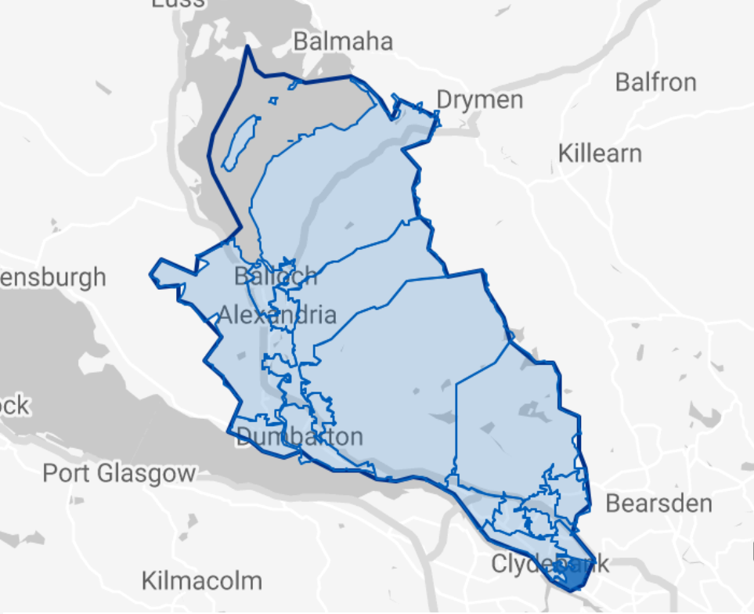

IZ 01 - Clydebank East inc. Whitecrook (part)

APPENDIX 1
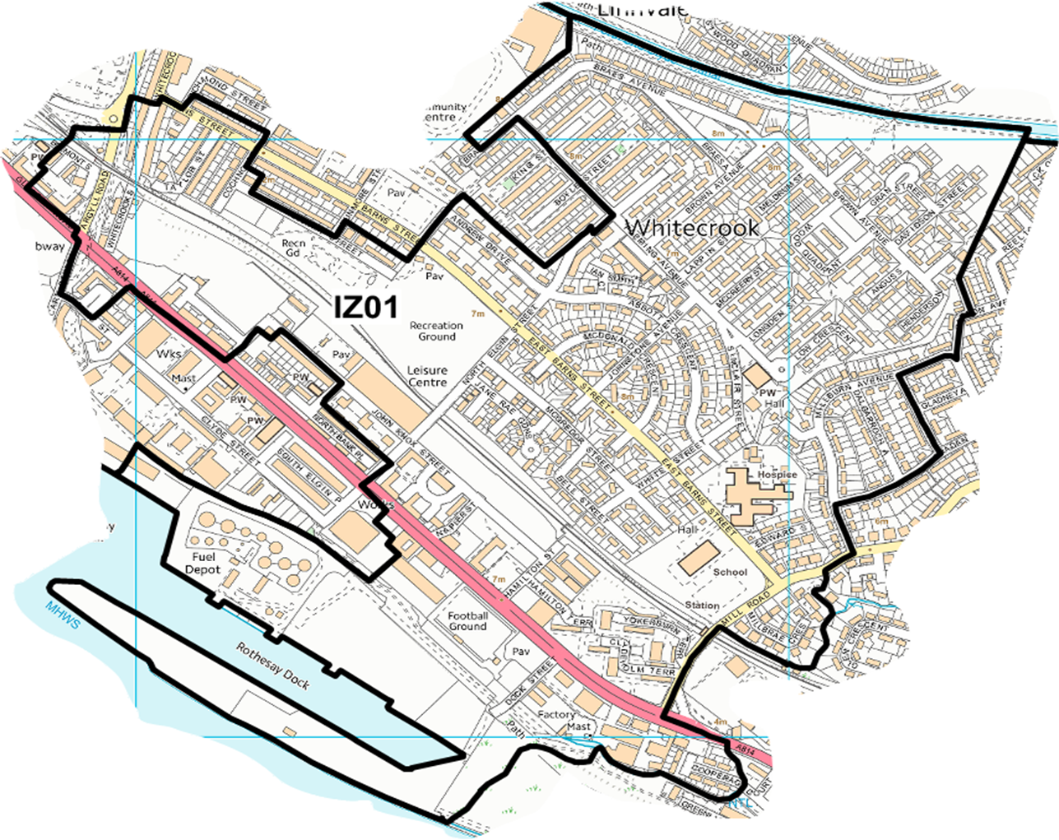

IZ 02 – Clydebank Central inc. Dalmuir (part) & Whitecrook (part)
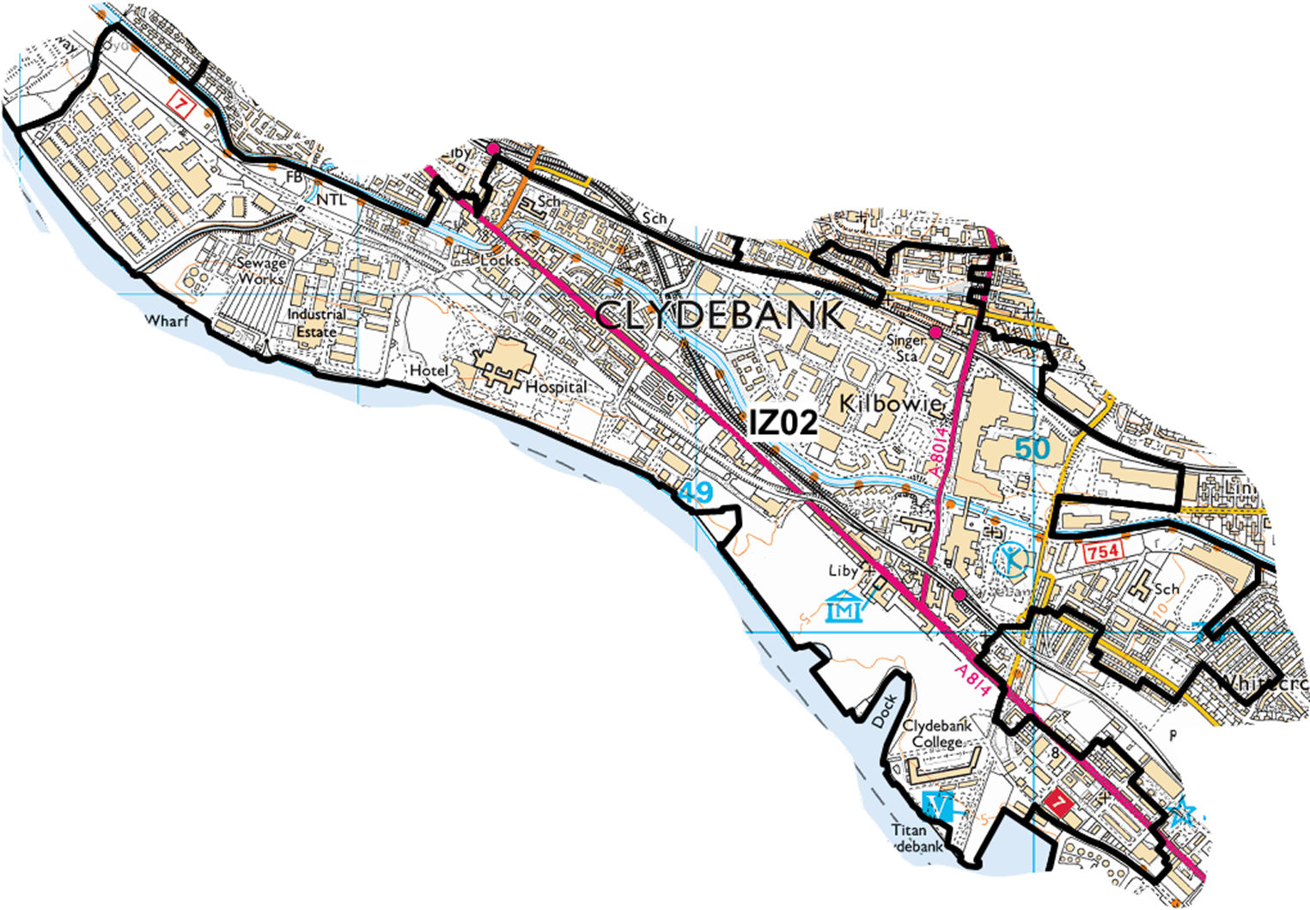

IZ 03 – Drumry & Linnvale

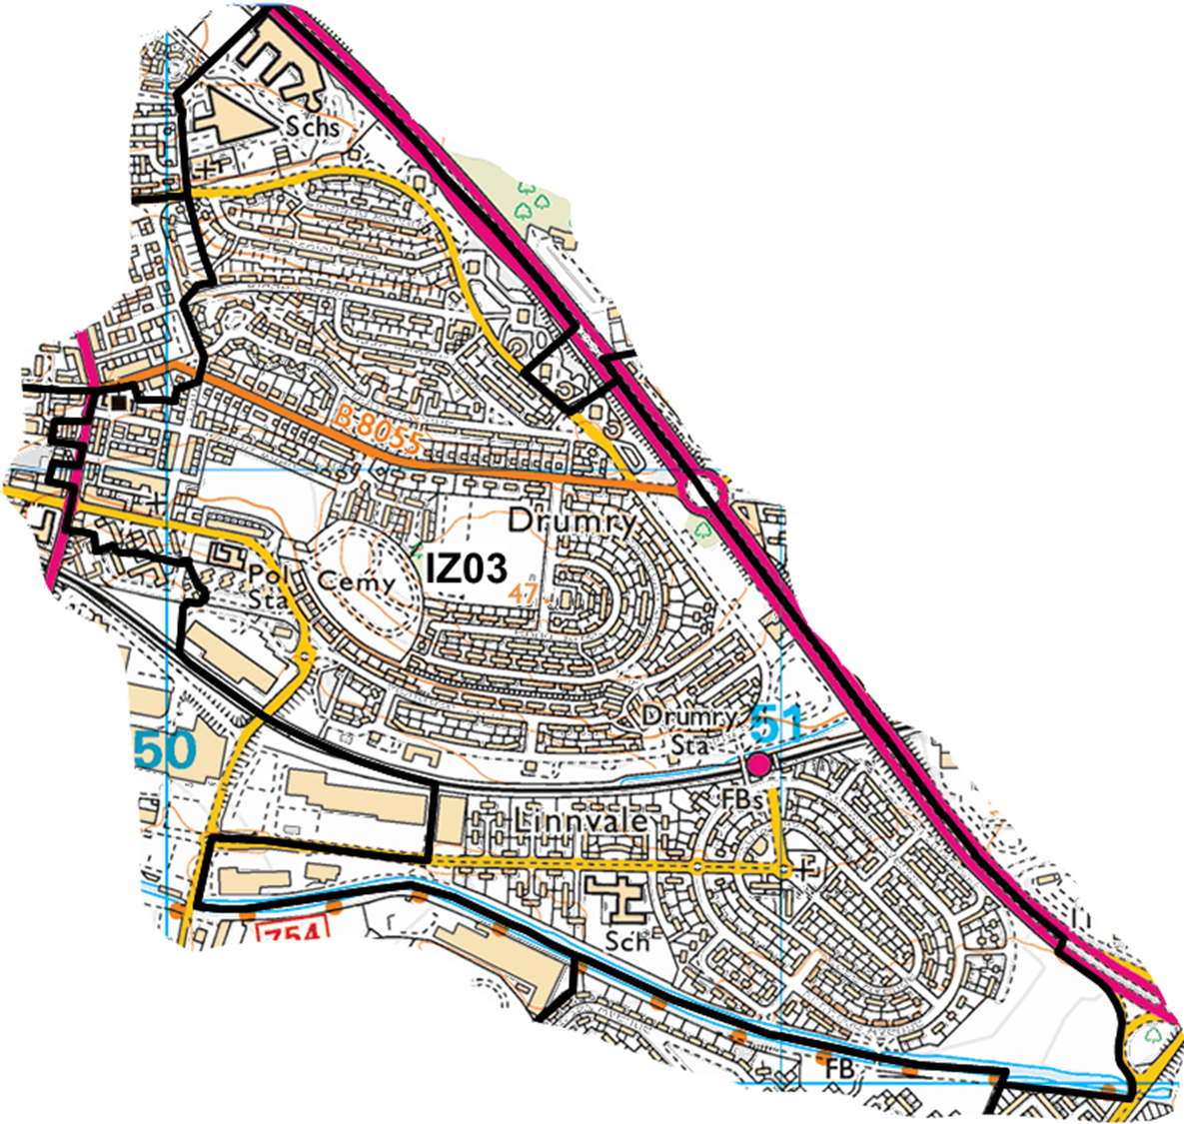

IZ 04 – Parkhall South, Radnor Park and North Kilbowie

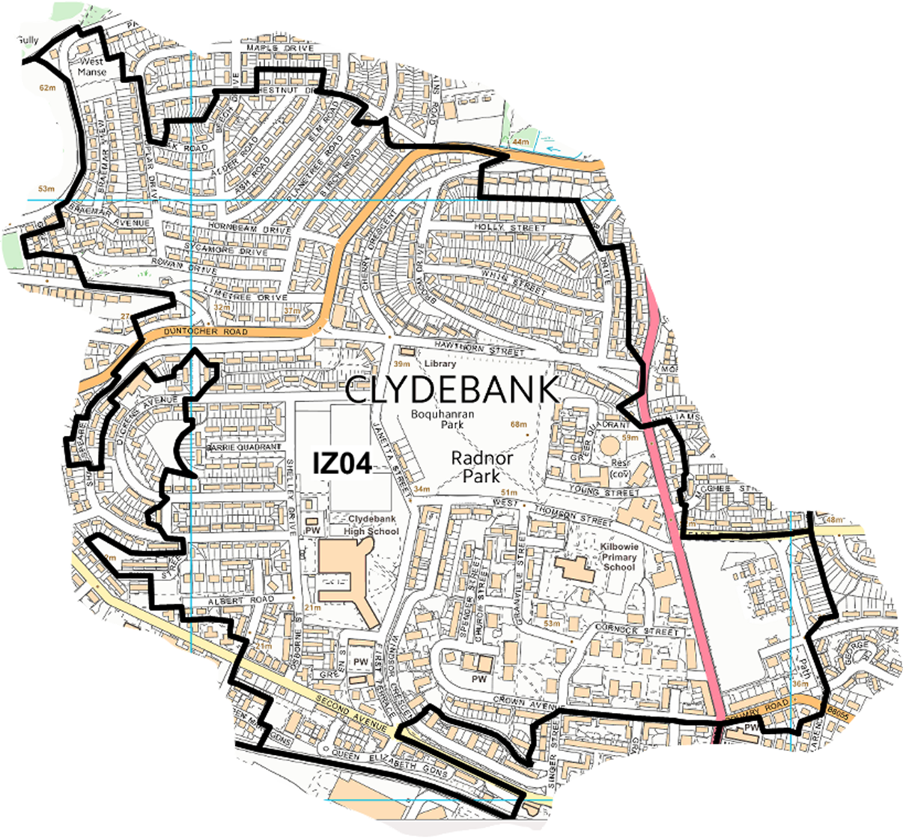

IZ 05 – Goldenhill, Parkhall North, East Kilbowie & Hardgate Central

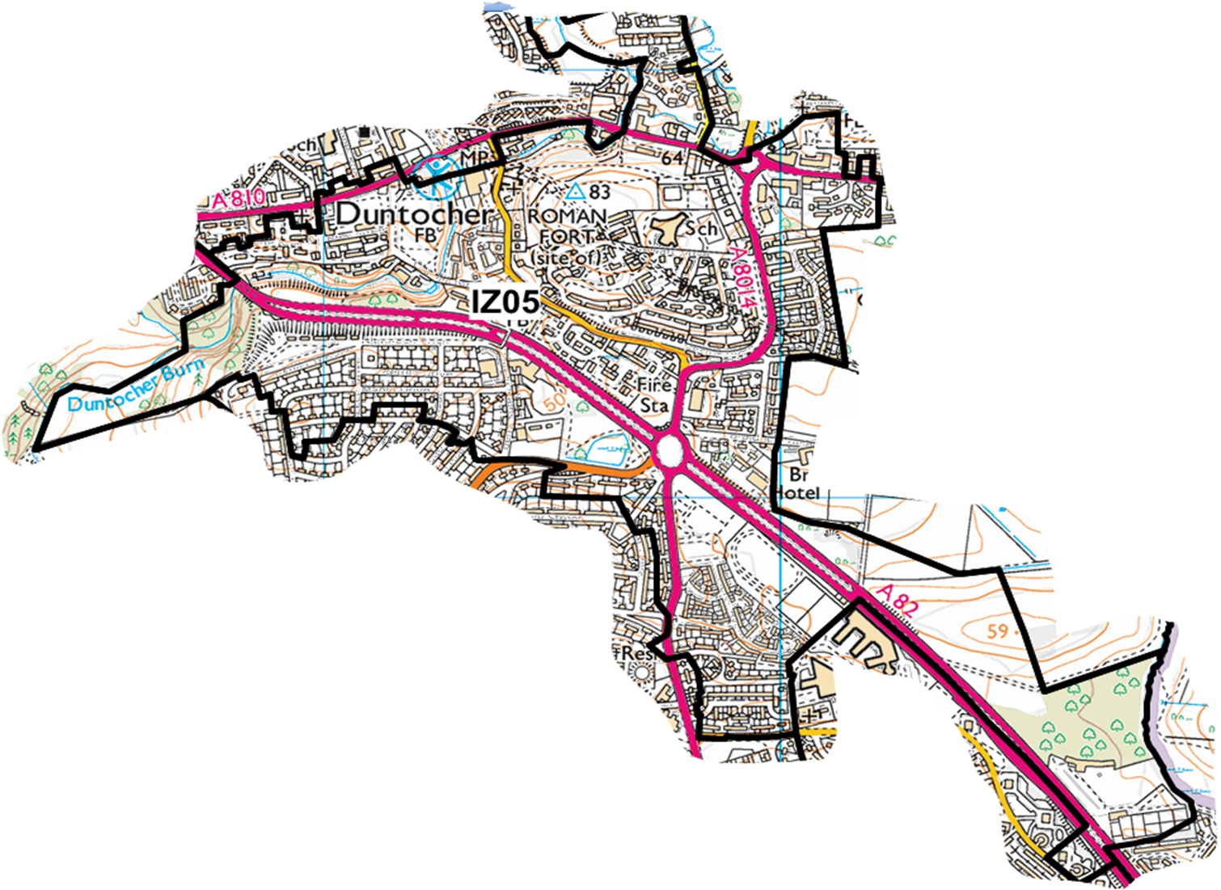

IZ 06 – Faifley& Hardgate East

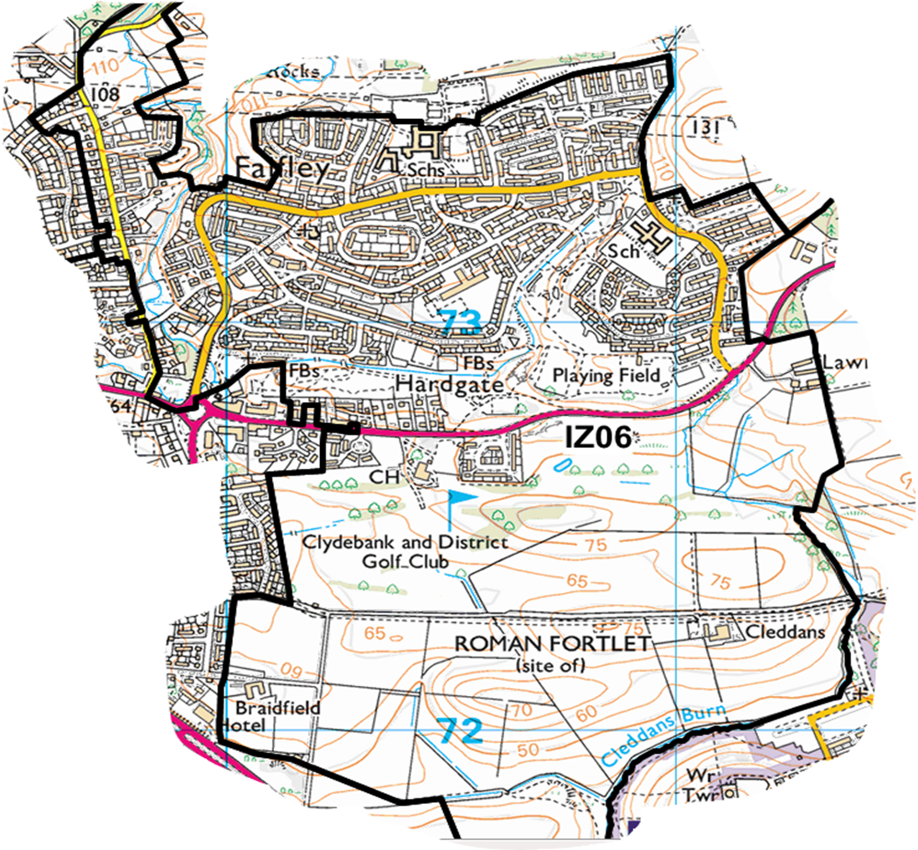

IZ 07 – Duntocher & Cochno

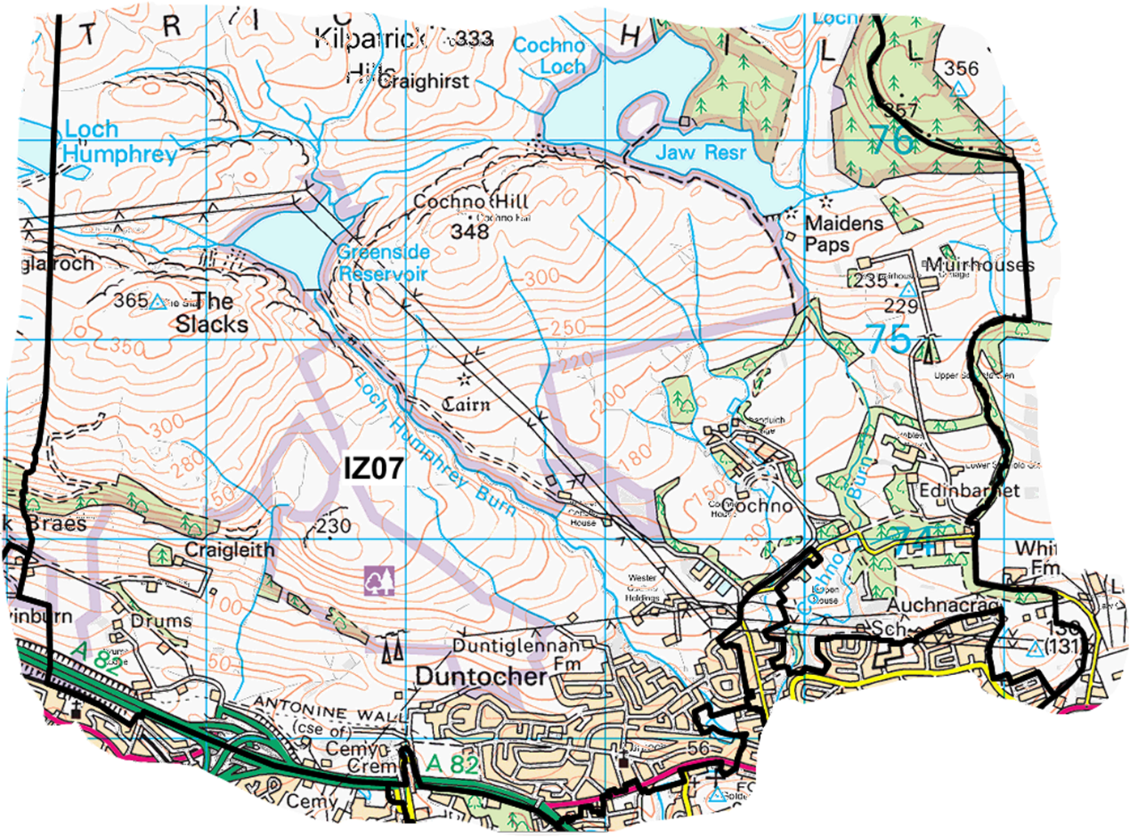

IZ 08 – Mountblow, Parkhall West and Dalmuir Central

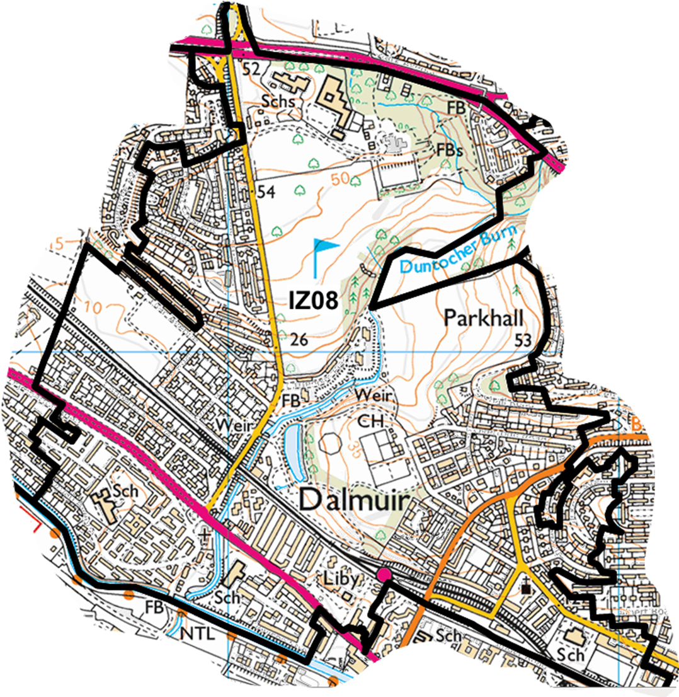

IZ 09 – Old Kilpatrick

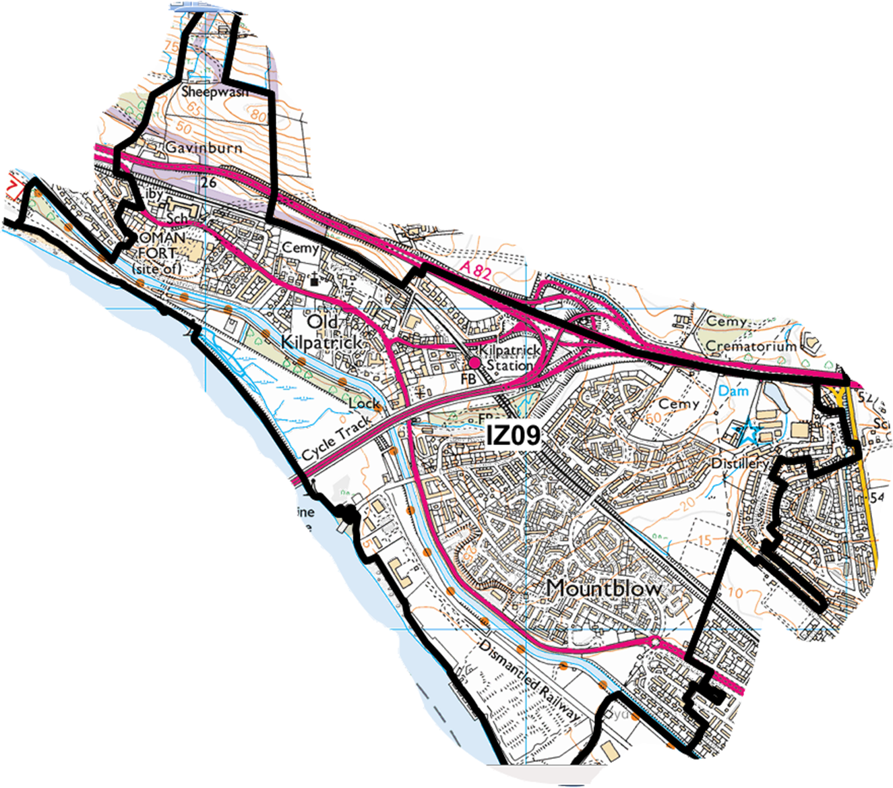

IZ 10 – Barnhill, High Overtoun, Milton & Bowling

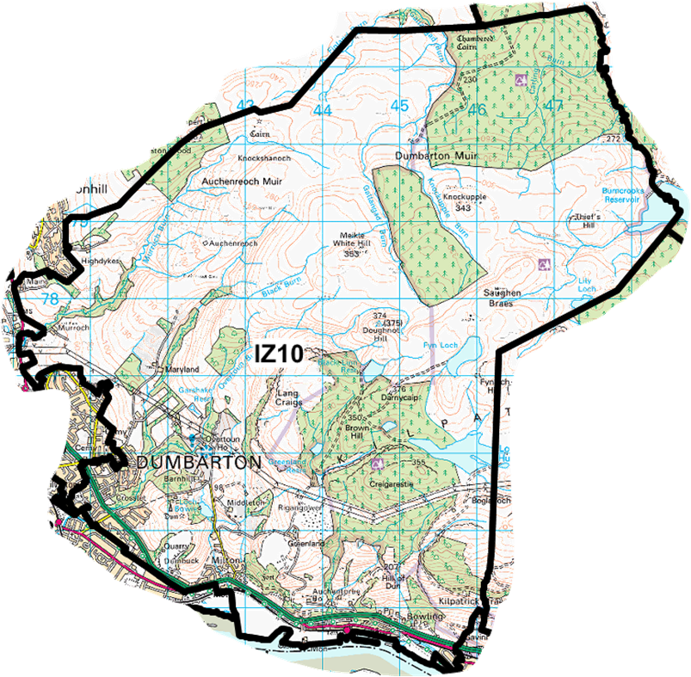

IZ 11 - Dumbarton North East – Bellsmyre & Silverton East

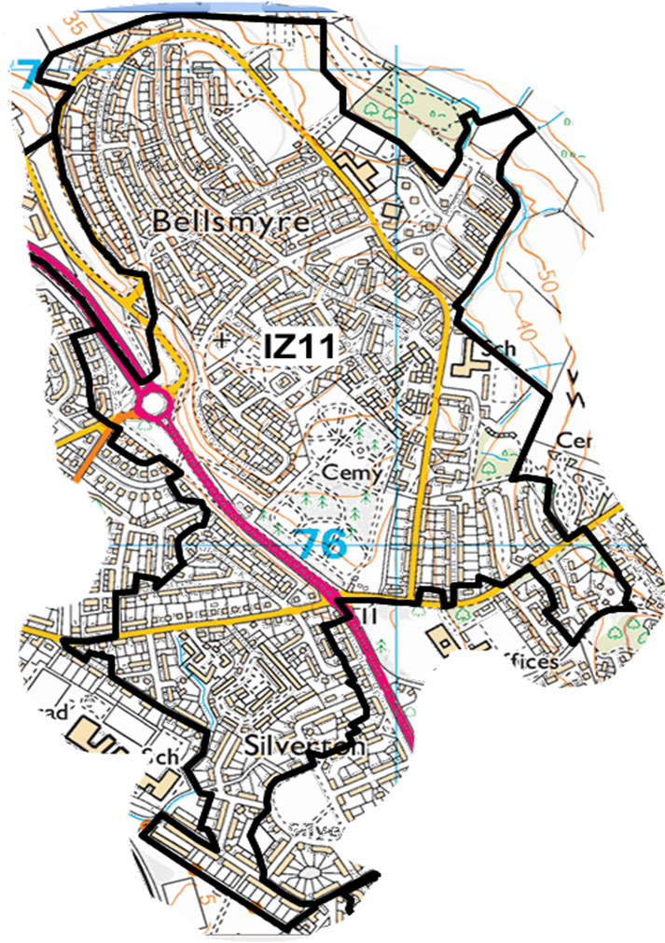

IZ 12 – Dumbarton Central, Dumbarton East & Townend

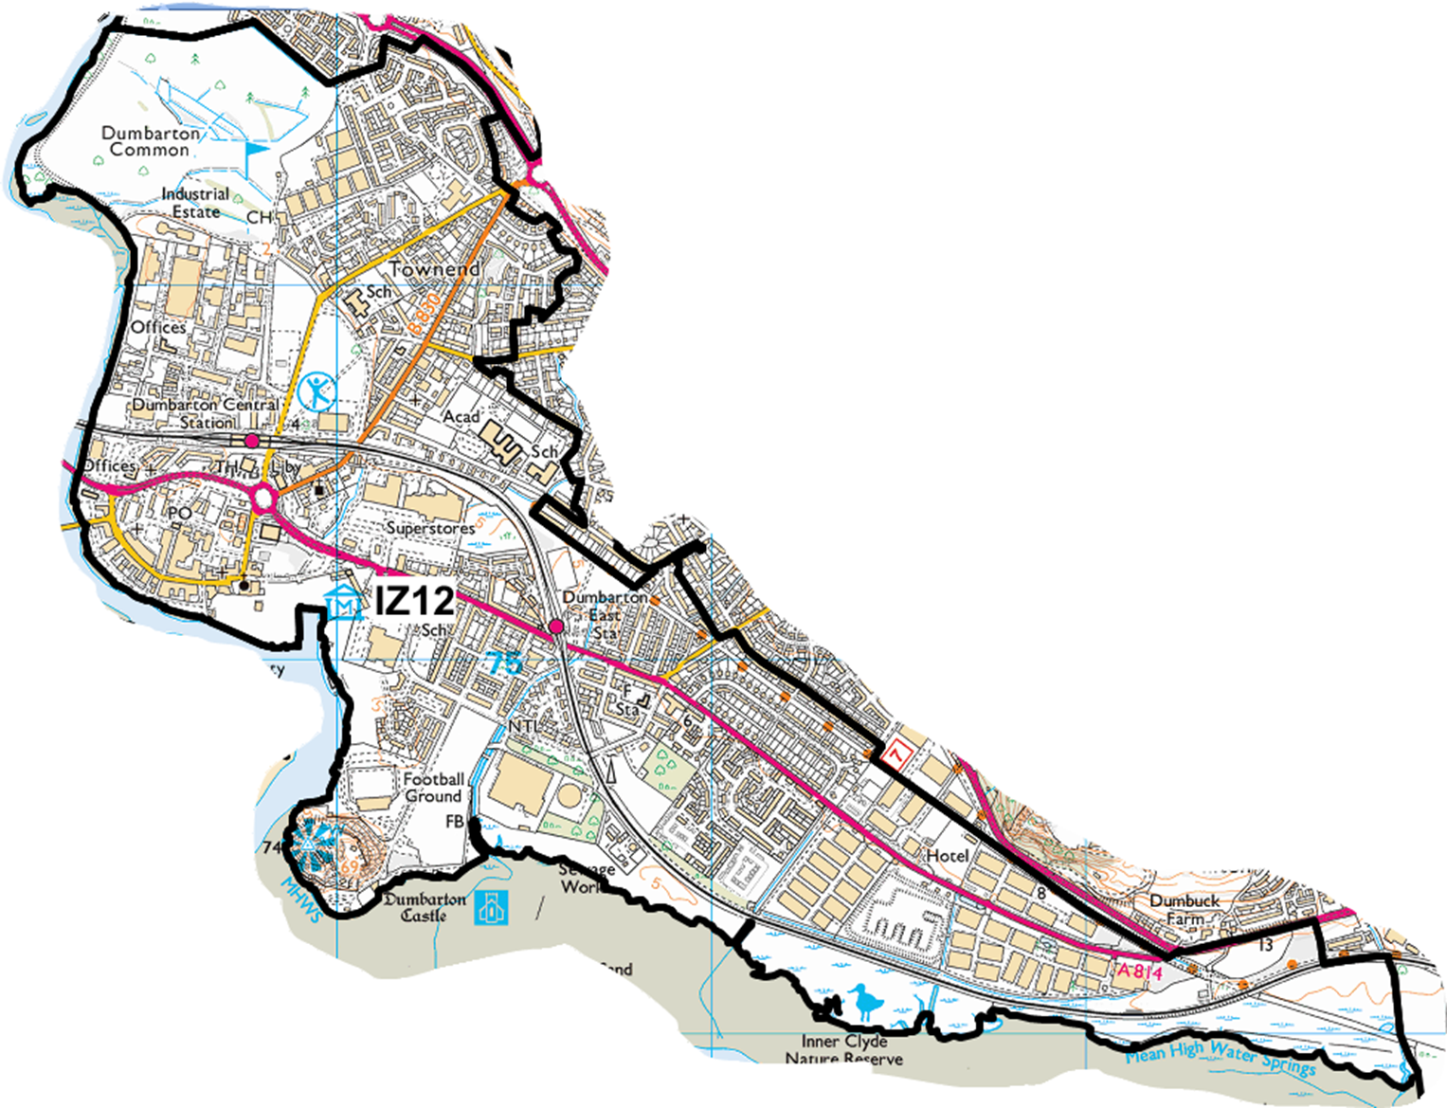

IZ 13 – Dumbarton West

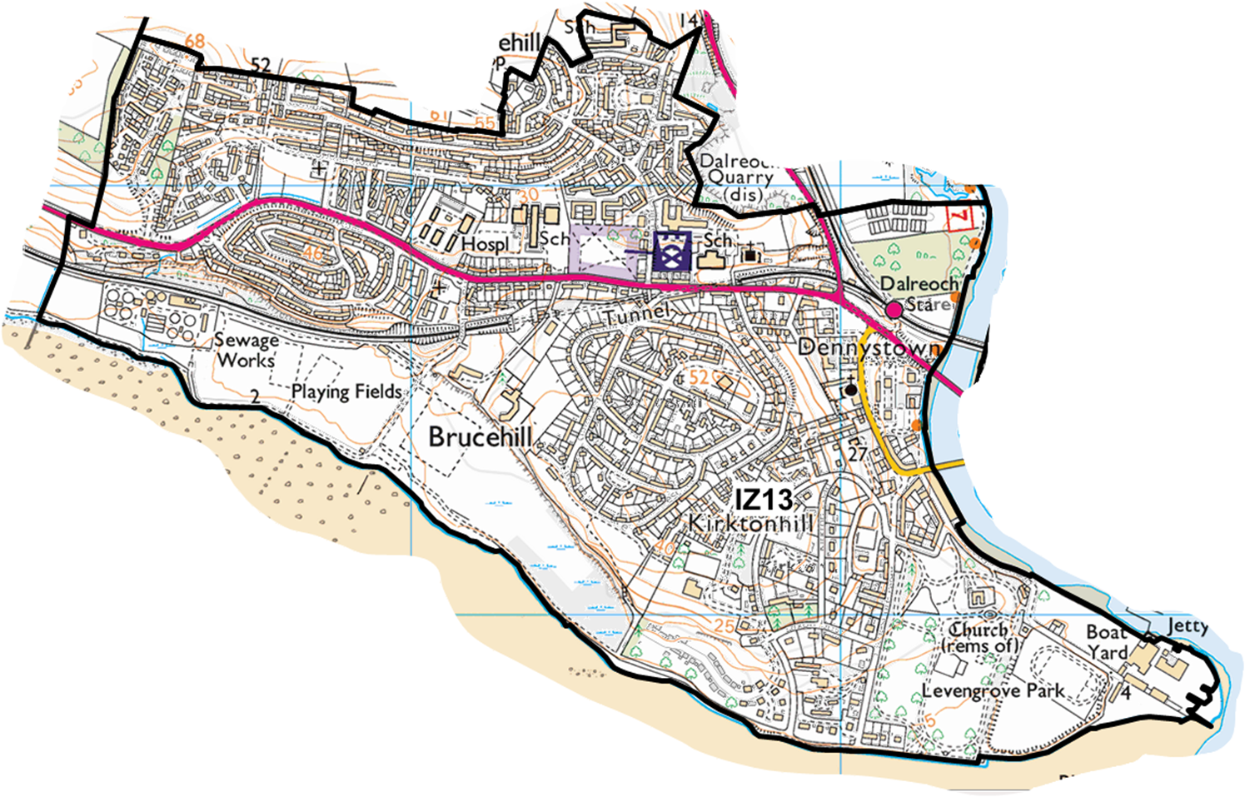

IZ 14 – Renton, Old Bonhill & Loch Lomond West.

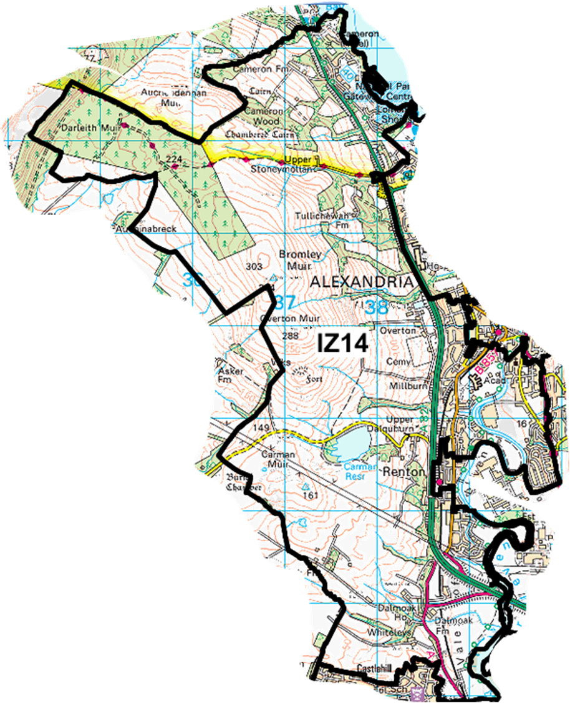

IZ 15 – Bonhill, Lomondgate & Renton North

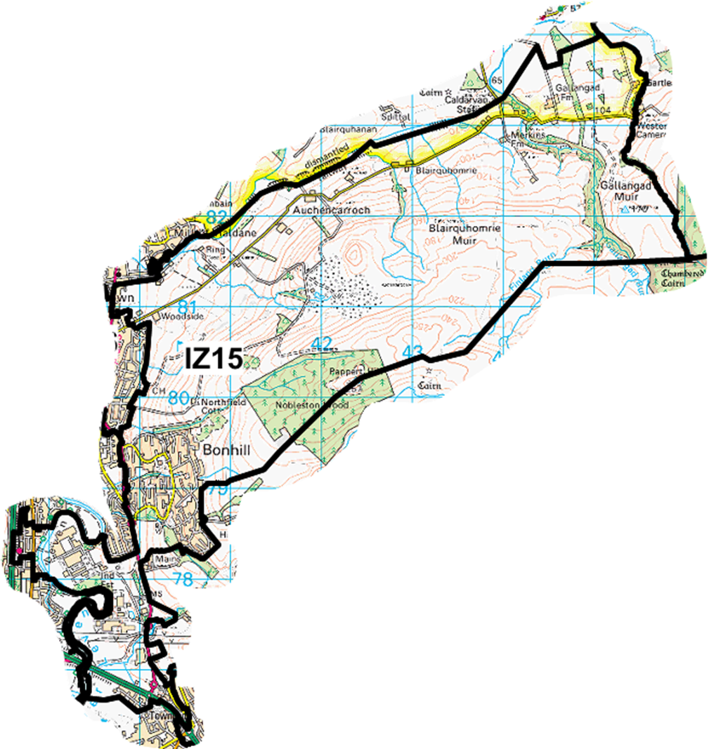

IZ 16 – Alexandria Central, Rosshead & Dalmonach

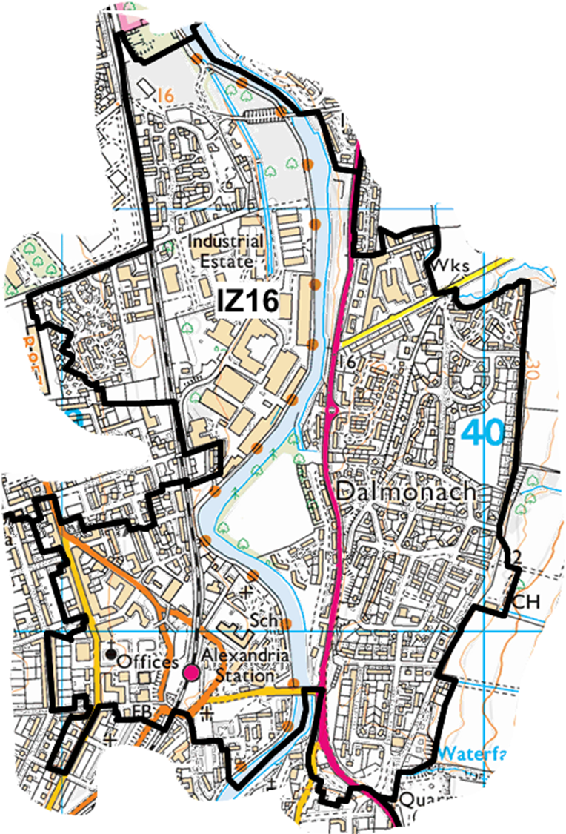

IZ 17 – Balloch & Alexandria North

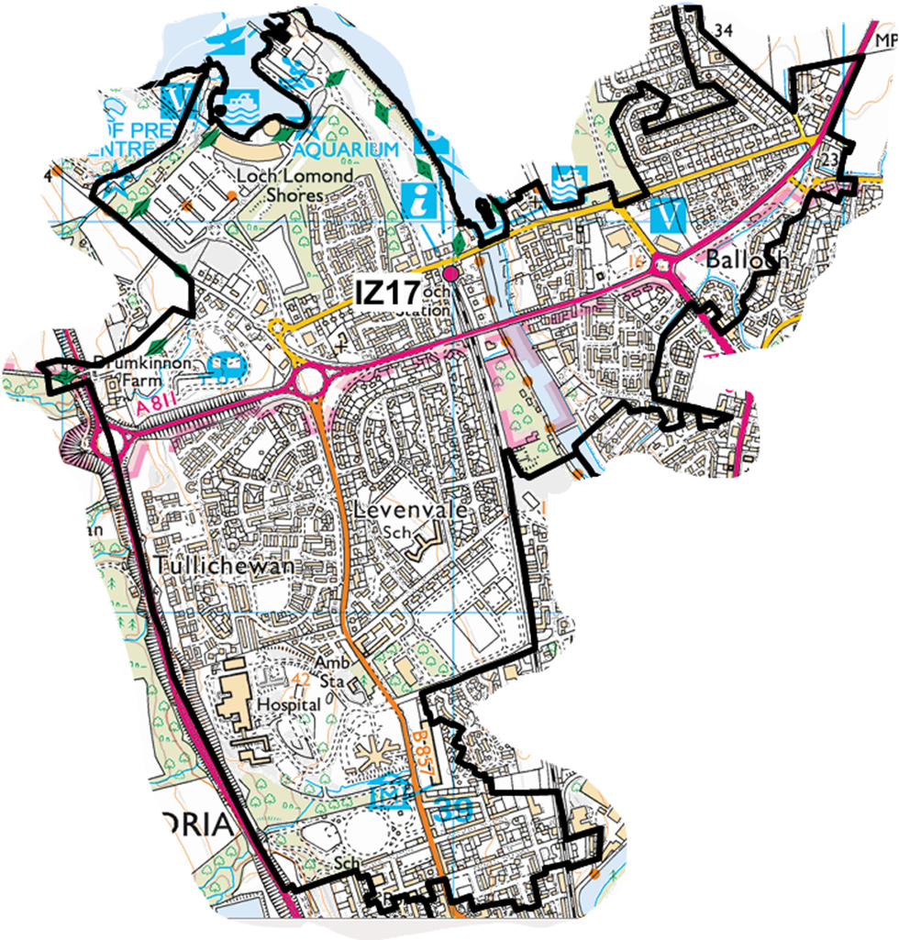

IZ 18 – Jamestown, Balloch North East, Haldane & Gartocharn

