West Dunbartonshire Council
Benefit and Debt Information and Advice Service
Three-Year Plan April 2025 – March 2028

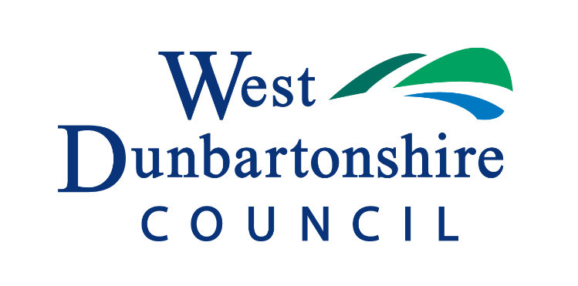

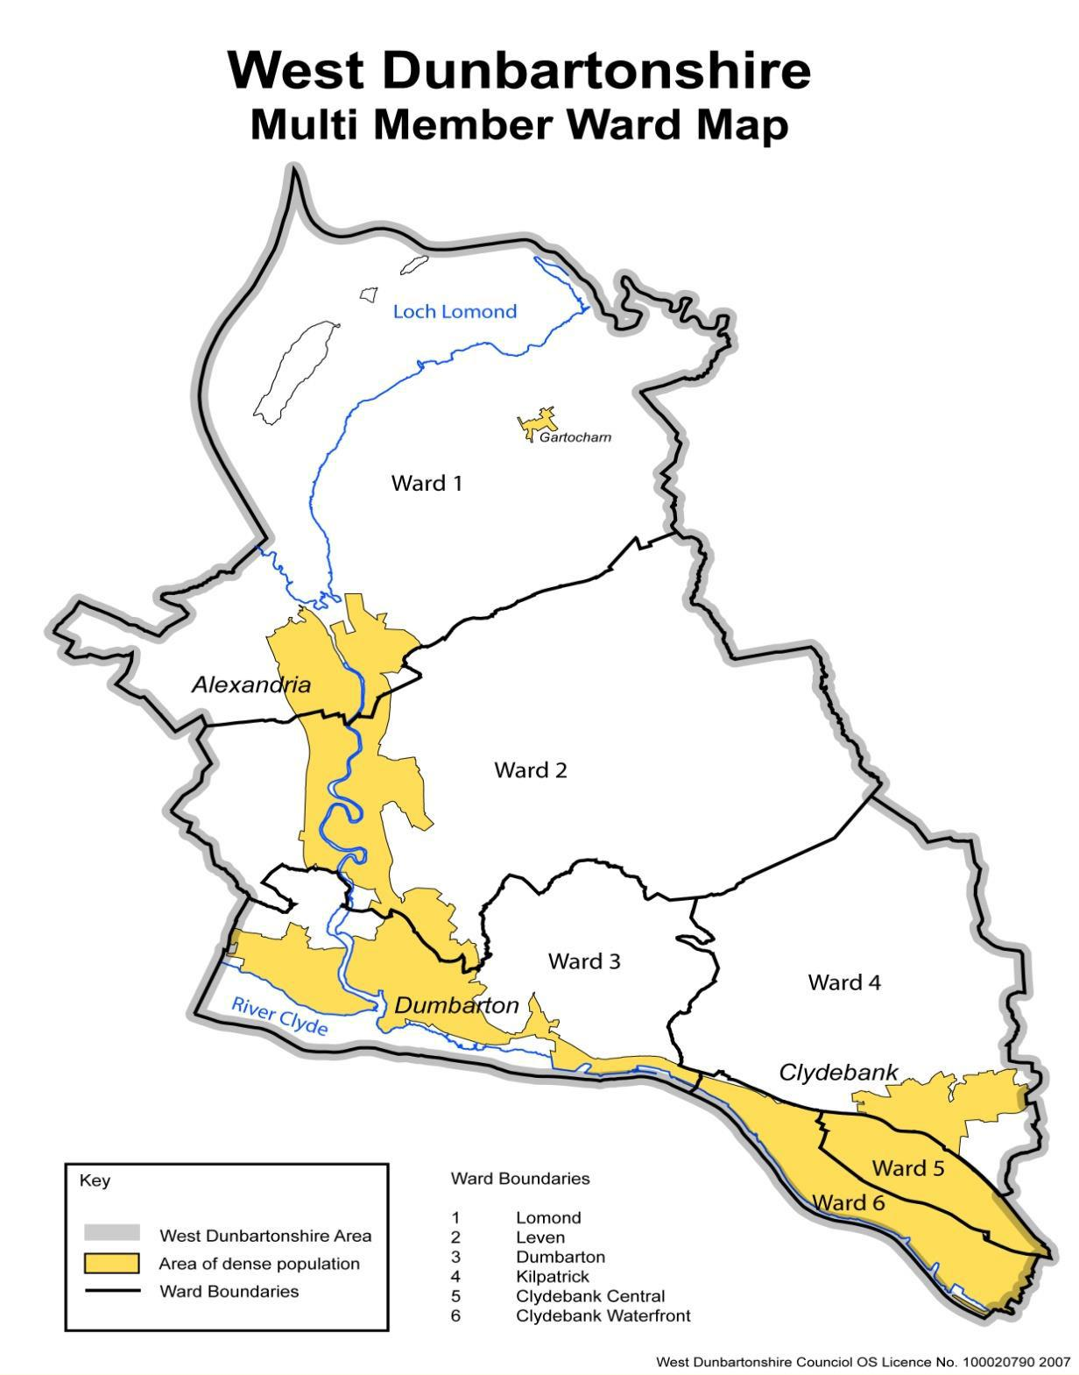

Table of Contents
1. Debt and Benefits Advice Services Three Year Plan Key Points 1
2. Introduction 2
Drivers of Disadvantage 4
3. Defining Information and Advice Services 5
4. West Dunbartonshire Debt and Benefits Advice Services 6
Resources 7
5. Working4U Money - Debt and Benefit Advice 8
Accessing the Service 9
Cancer Support in West Dunbartonshire 10
Workforce Development 11
Measuring Progress and Impact. 12
6. Anticipating future demand 12
7. Resources to meet demand 13
8. Measuring Success 14
Continuous Improvement Actions - Standards for Planning 16
3 Accessibility and Customer Care 16
4 Providing the Service 16
5 Competences 17
6 Resourcing review and move to future demands 17
Appendix 1 - West Dunbartonshire Demographics 18
Appendix 2: Summarised Staff Job Profiles 19
Working4U Co-ordinator Job Purpose 19
Working4U Team Leader 19
Working4U Welfare Rights Macmillan Service/Working4U Welfare Rights Officer 19
Key Performance Areas: 20
Appendix 3: Connected Stakeholders/Partners 21

List of Tables
Table 1: Reasons for Unclaimed Benefits 2
Table 2: Key Performance Indicator Planning Estimates (2025 - 2028) 13
Table 3 - Households in West Dunbartonshire…………………………………………18
Table 4: Benefit rates in West Dunbartonshire compared to Glasgow City region and Scotland……………………………………………………………………………………18
Table 5 - Child Poverty Indicators in West Dunbartonshire and Scotland…………18

Debt and Benefits Advice Services Three Year Plan Key Points
A Debt and Benefits Advice Service within a local authority plays a vital role in reducing poverty and inequality by helping residents access the benefits they are entitled to. It increases financial stability for individuals and families, improves mental and physical wellbeing, and supports early intervention by preventing crises such as homelessness or debt escalation. By supporting the most vulnerable, it contributes to the strategic goal around child poverty reduction. The service enhances local economic resilience by increasing household income and supports better decision-making through expert advice and advocacy in navigating a complex welfare system.
Access to debt and welfare benefits advice is essential due to the complexity of the welfare system, which can lead to errors and low uptake—particularly harming disadvantaged individuals and families. In West Dunbartonshire, where many households face significant hardship driven by low income, limited opportunity, and high benefit dependency, these issues are more pronounced. Life transitions—such as having children, starting school, entering work, or retiring—can further strain vulnerable households. Targeting support effectively requires identifying the households most likely to be impacted.
This three-year Welfare Rights and Debt Advice Plan sets out the local authority’s commitment to reducing poverty, maximising income, and supporting financial resilience. It aims to ensure all residents can access free, high-quality advice through a blend of face-to-face, phone, and digital channels, with targeted outreach to vulnerable groups. The plan prioritises partnership working, and integration with health, housing, and community services. Demand projections and resource planning will guide service capacity, while robust monitoring will track outcomes such as income gains, debt managed, and client satisfaction. Funding sustainability will underpin the ability to adapt to future challenges.
Information and Advice services are defined in ‘Section 3: Defining Information and Advice Services’ outlining the basic aims and approaches of an information and advice service and the three main types of service: sign posting; case management; and advocacy.
In ‘Section 5, West Dunbartonshire Debt and Benefits Advice Services’ we provide an overview of how the service is resourced and managed. In ‘Section 6 Working4U Debt and Benefit Advice’ we provide information about: accessing the service: the type of service available; and how we support our staff to maintain their levels of expertise.
In ‘Section 7 Measuring Progress and Impact’ we outline our approach to a common advice management and performance framework reporting that establishes the type of information we collect and use to demonstrate our effectiveness. In ‘Section 8 Measuring Success’ we provide details of the effect our service is having.
In ‘Section 9 Partnerships Working’ we acknowledge the importance of partnership working and set out our approach to how this will be delivered in West Dunbartonshire. We are committed to collaborating with others to better coordinate existing services and to identify and implement effective and efficient ways of working.
West Dunbartonshire Debt and Benefit Advice Service (Working4U Money) is accredited by the Scottish Government Quality Assurance Framework: Scottish National Standards for Information and Advice Providers (SNSIAP). In ‘Section 10 Continuous Improvement Actions’ we commit to actions that will maintain that standard and give service users confidence.

Introduction
Benefits are vital to the wellbeing of the most vulnerable in society. However, because of the complexity of the system, claimants do not always secure the benefits they are entitled to.
Table 1: Reasons for Unclaimed Benefits
Reasons
Take-up. People don’t always claim what they are entitled to because of lack of knowledge of entitlement and/or stigma with claiming. Unclaimed benefits remain a concern with 45% of people never having checked what benefits they are eligible for, and more than 7.1 million people are missing out on £15.1bn of benefits, Turn2us (2021). Policy In Practice April 2024 Report_Missing-Out-2024_23bn.pdf UC take up rate 77%, PC take up rate 63%, 22.7 billion unclaimed benefits and social tarrifs - 19.5 billion in DWP/HMRC/Locally administered benefits
Complexity. The benefit system can be difficult to understand and rules for accessing benefits often change.
Claim Errors. The claiming process can involve both official and claimant error.
Appeals: Without help, people are unsure when it’s right to appeal and how to go about it.
These factors are part of the rationale for the provision of welfare and debt management services within West Dunbartonshire.
Living in West Dunbartonshire
To plan services effectively we must understand the profile of our community and any special needs that may exist. In this section we will provide information on the profile of West Dunbartonshire.
West Dunbartonshire includes the towns of Clydebank, Dumbarton and Alexandria and has a population estimate of 88,750 residents.
- Lomond.  - Leven.  - Dumbarton.  - Kilpatrick.  - Clydebank Central.  - Clydebank Waterfront. | 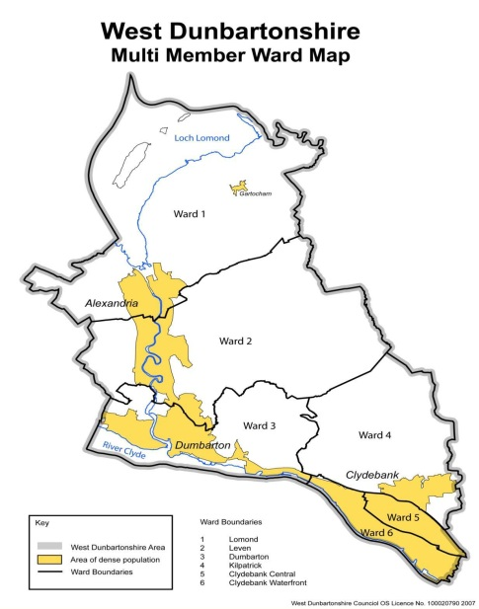
The local authority consists of 121 of Scotland’s 6,978 Scottish Index of Multiple Deprivation data zones and 17 Community Council areas. Diagram 1 -shows the six ‘multi-member’ wards, illustrated in the Map:
The need for access to debt and welfare services will be determined, to some extent by the factors that contribute to disadvantage and poverty.
Who Needs Support (Target Groups)?
SNSIAP standards state that all service providers must be committed to providing equity of access to services for all. We provide a service that is open to all; however, given the socio/economic circumstances we prioritise people who are most vulnerable to disadvantage. When considering the needs within our communities we must understand the characteristics of the population and the barriers to opportunity they are likely to face. Analysis of the data sets demonstrates the following:
- Areas of Multiple Deprivation: West Dunbartonshire consists of 121 of Scotland’s 6,978 Scottish Index of Multiple Deprivation data zones. All multi-member wards in West Dunbartonshire have areas with comparatively high incidences of multiple deprivation. Approximately 35,000 (37%) of the resident population have first-hand experience of multiple deprivation. Showing significant socio-economic gaps, with 30% of the population residing in Quintile 1, the most deprived areas. These areas face higher levels of unemployment, lower educational attainment, and limited opportunities compared to more affluent areas.
- Fuel poverty is defined by the Scottish Government as any household spending more than 10% of their income on energy - after housing costs have been deducted. The indication from the 2019 Scottish House Condition Survey is that 29% of West Dunbartonshire residents are in fuel poverty compared to the Scottish average of 24%. sna-aop-june-2022.pdf
- Health Conditions: In the 2022 Census, in West Dunbartonshire 8.7% of people reported their health as being ‘bad or very bad’ this compares to the Scotland figure of 6.8%. Statistics suggest that a significant portion of the population in West Dunbartonshire live with long-term health conditions (33.4%), including mental health issues and physical disabilities. The Scottish Burden of Disease 2019 report (most recently published study September 2021) assessed how ill-health and premature death contributed to disease burden across local areas. The results for West Dunbartonshire show the three leading group causes of ill-health and early death are cancers, cardiovascular diseases and neurological disorders. Overall, the rate of health loss in West Dunbartonshire is 15% higher than the Scottish rate.
Cancer - The prevalence rate of cancer in West Dunbartonshire (39.48) is higher than NHS Greater Glasgow City (35.6) and Scotland (37.9) as a whole. There is a projected 23.5% increase in males and 9.1% increase in females by 2030. sna-aop-june-2022.pdf
- Families facing Poverty: Low-Income families living below the poverty line often struggle to meet basic needs. In West Dunbartonshire, (28%) of children are living in poverty, higher than the Scottish average (24.5%).
- Carers - Reported adult carers’ needs include support to access services, financial and health and wellbeing support. During 2020/21, Carers of West Dunbartonshire supported 1,250 different carers and identified 263 new carers. Source https://www.gov.scot/publications/carers-census-scotland-2019-20-2020-21/documents/

Drivers of Disadvantage
The key drivers of poverty identified in the Scottish Government legislation on child poverty include income levels and the cost of living. Income is determined, to an extent, by levels of economic activity, employment and the level of uptake of benefits.
Life stage transitions, such as having a child, a child starting primary or secondary school, or transitions to adulthood and work for young people and people moving into retirement can all have implications for access to benefits.
Other kinds of transitions in personal circumstances which are often less easy to predict include: relationship break-down; losing a job; falling ill; having your tenancy ended unexpectedly; imprisonment or release from prison all have the potential to generate debt as well as the need to access benefits.
It is therefore not sufficient to focus on groups without understanding circumstances, transitions and barriers that affect families and individuals daily and provide support that is customised to their specific circumstances.
Given these socio-economic circumstances and associated challenges there is a clear rationale for the provision of debt and money advice in West Dunbartonshire. West Dunbartonshire Council has established such a service to:
Deliver advice and information services in West Dunbartonshire where anyone can obtain the information and advice and support, they need, when they need it and obtain access in the way they need it.

Defining Information and Advice Services
When considering the provision of advice, it is important to stress that when people contact a service provider the product, they seek is not the service, but the outcome. That is, if they require welfare benefits advice the product, they want is the benefit.
It is important to be able to manage these expectations and to be clear about the broader outcomes from receiving advice. This outcome will include providing service users with a better understanding of their options; rights and responsibilities; and the available assistance to support them when taking action to resolve their problem.
Advice is likely to comprise of:
- Listening to clients.
- Diagnosing the problem.
- Giving information.
- Advising on the options available.
- Acting on behalf of clients.
- Negotiating on their behalf.
- Representing clients’ cases at tribunals and courts.
- Referral where appropriate; and
- Enabling or empowering the individual to take informed action on their own behalf.
These activities are subdivided into three types of intervention:
Type I – Active Information, Signposting and Explanation
This work refers to activities such as providing information or referring the service user to other available resources or services and the explanation of technical terms or clarifying an official document.
Type II – Casework
This includes a diagnostic interview where the problem and all relevant issues are identified and making a judgement as to whether the individual has a case that can be pursued.
Once it has been established that the individual has a case that can be pursued, activities may include:
- Setting out an individual’s options or courses of action
- Encouraging the user to act on their own behalf
- Providing practical aid with letters or forms
- Negotiating with third parties on the user’s behalf
- Introducing the enquirer by referral to another source of help; and
- Support to users in making their own case.
Type III – Advocacy, Representation and Mediation at Tribunal
This work includes a range of further actions arising from the casework undertaken above and includes, for example: Advocacy and Representation and Mediation.
In addition, information and advice providers are likely to undertake ‘social policy’ work at some level. This means collecting information generated by individual casework activities and aggregating this to identify trends and emerging issues. This allows service providers to gather local intelligence that will be of use when planning for services.

West Dunbartonshire Debt and Benefits Advice Services
SNSIAP state that all service providers must have clear management structures that identify the roles and responsibilities of all post-holders involved in the planning, management and delivery of the service. In this section of the plan, we identify management structures and resources for the delivery of debt and benefit advice.
West Dunbartonshire Council Working4U service is set within the Roads and Neighbourhood Department.
Working4U is an integrated service that supports residents in West Dunbartonshire to improve their skills, learning and financial situations. The specialist components of Working 4U’s services are:
Working4U – Learning
Community Learning and Development primarily supports disadvantaged or vulnerable groups and individuals of all ages to engage in learning, with a focus on bringing about change in their lives and communities.
Working4U - Employability
Employability encompasses all the things that enable people to increase their chances of overcoming barriers to opportunity, getting a job, staying in a job, and progressing in work.
Working4U – Money
Information and Advice is set within the policy context designed to support a flourishing Scottish economy and help people to lead productive lives in safe and secure communities. Working 4U will achieve this through the provision of debt counselling, income maximisation support, money advice and welfare benefit advice services.
Working4U employs 74 people in a mixture of full and part time posts. The organisation has a manager supported by two Coordinators. Each Coordinator is supported by 4 Team Leaders. Two of the Team Leaders have responsibility for leading on debt and benefits information and advice services.
Diagram 2 provides an illustration of the Working4U structure and demonstrates where debt and benefit advice services are located.

Resources
The Working4U Money - Debt and Benefits Advice Service has 17 members of staff, consisting of two Team Leaders (1.2 Full Time equivalent (FTE)) who between them, are responsibility for 15 Working4U Officers. 10.5 FTE Officers are offering welfare rights advice, 1.5 FTE officers are delivering the Improving the Cancer Journey Service and 3 FTE Officers offer debt advice. The Working4U Officers provide information and advice support and debt advice to the residents of West Dunbartonshire.
The Team Leaders are suitably qualified to provide supervision and support to staff delivering the service. Staff have the appropriate skills, expertise and experience required to deliver an effective and reliable service.
Appendix 3 provides summary job profiles for the Working4U Co-ordinators, Team Leaders and Working4U Officers (frontline debt and benefit advice staff).
Staff costs are approximately £760,000 a year for the delivery of the service. This consists of West Dunbartonshire Council investment of approximately £260,000 each year. Funding provided by West Dunbartonshire Council for the service is reviewed annually as part of the West Dunbartonshire Council budget setting process. Approximately £220,000 of funding a year is from Macmillan Cancer. The annual budget is subject to negotiation with Macmillan Cancer Support as part of their grant award review process.
The Improvement Service offers funding of approximately £13,000 to support the work within GP practices in West Dunbartonshire in 25/26. Funding from the Improvement service is reducing over the coming 2 years when all funding will cease in March 2027.
The Housing department offer funding for 2 Welfare Rights Advisors supporting residents to maximise their income and sustain their tenancy. This funding is in place for 25/26.
HSCP fund 1 Welfare Rights Advisor to support unpaid carers maximise their income and access grants as available. This funding is in place for the 3 years- 25/26, 26/26 and 27/28.

Working4U Money - Debt and Benefit Advice
All service providers must be clear about the remit of their service and the boundaries of their service.
In delivering our services we will adhere to a set of guiding principles to ensure we are:
- Empathetic. Our services are client orientated, private and confidential.
- Insightful. We will work with clients to understand their circumstances, diagnose the issues and provide them with options including onward referral and follow-up actions; and
- Trustworthy. Our advisers will have sufficient experience and expertise to provide service users with options that will address their circumstances.
We will know that we have achieved our aims if people in West Dunbartonshire who need our services are able to say they:
- Can easily find, gain access to, and use the information, advice and advocacy they need to improve or maintain their independence, wellbeing and resilience, both day to day and in times of crisis.
- Are confident the information provided is relevant, easy-to-understand, consistent, accurate and up to date and they feel able to make informed decisions about the options available to them and their families.
- Understand the factors affecting their circumstances and feel more confident about dealing with them and improving their quality of life because of the advice, information and advocacy support they have received.
Service Types
Working 4U Money - Debt and Benefit Information Service provides access to Type 1, Type 2 and Type 3 Information and Advice. The service is free and offers confidential and impartial advice and advocacy for residents on the following matters:
Benefits and Tax Credits
- Benefit checks to ensure claimants are receiving their full entitlement
- Help in completing benefits forms
- Supporting residents to challenge decisions
- Representing residents at benefit appeal tribunals.
Debts
- Preparing financial statements and offering budgeting advice
- Negotiating repayment arrangements with creditors
- Supporting tenants and homeowners with arrears
- Helping with court forms
- Advice and help with insolvency.
Type 1 supporting information about benefits and advice can be found at: Benefits and Eligibility | West Dunbartonshire Council
Following the link will provide access to a benefits calculator and information about the range of benefits available to people dependent on their circumstances.

Accessing the Service
We annually review our service to ensure accessibility and effective use of resources. Residents are offered face to face appointments including home visits if required, telephone and on-line appointments offering advice, guidance and case management.
Service Locations Opening Hours and Contact Details:
Location | Address, Opening Hours, Contact Details
Dumbarton | Council Offices, 16 Church Street, Dumbarton, G82 1QL.  Monday to Thursday: 08:45am to 4:30pm. Friday: 08:45am to 3:55pm.  By appointment only. Telephone: 01389 776929
As a result of our aim to focus on priority groups we provide access to information and advice by appointment in the following outreach centres:
Outreach Locations and Contact Details:
Location | Address and Contact Number
Vale of Leven Hospital  Improving the Cancer Journey, Macmillan Benefits | Main Street, Alexandria, G83 0UA  Telephone: 01389 828599  Thursday – pm
Old Kilpatrick Food Parcels (OKFP)  All benefits | OKFP Hub, Napier Hall, 312 Dumbarton Road  Old Kilpatrick, G60 5JH  Tel. 01389 717792  Wednesday – pm

Advice in GP Practices (Locations)
Practice | Address
Oakview | Main Street, Renton, Dumbarton, G82 4PR
Red Wing | Clydebank Health and Care Centre  Queens Quay, Main Avenue, Clydebank, G81 1BS
Green Wing | Clydebank Health and Care Centre  Queens Quay, Main Avenue, Clydebank, G81 1BS
Orange Wing | Clydebank Health and Care Centre  Queens Quay, Main Avenue, Clydebank, G81 1BS
More information about our service can be found at: Money | West Dunbartonshire Council



Cancer Support in West Dunbartonshire
In addition to the Information and Advice services outlined we also specialise in supporting those affected by cancer and other long term health conditions. This includes two services: the Macmillan Benefits Team and Improving the Cancer Journey through which we can support residents to access other grant aid and social care services.

Improving the Cancer Journey
Those affected by cancer often don’t know where to find financial, emotional or practical support. Improving the Cancer Journey (ICJ) was established to fill that gap. Service users are linked to a Macmillan ICJ Officer who will work with the service user to complete a needs assessment to identify and agree a personalised care plan. Needs assessments can be carried out in a convenient location including in a hospital setting.
The team can be contacted by telephone at: 0800 980 9070 or by email at:
improving.cancerjourney@west-dunbarton.gov.uk

Macmillan Benefits Team
In conjunction with Macmillan Cancer Support, we provide services to all patients at the Beatson West of Scotland Cancer Centre.
Referral pathways have been established for those affected by cancer who are using Health Services at: the Vale of Leven Hospital; Gartnavel General Respiratory services; and GP practices.
Macmillan Benefit Team Location
Location | Address and Contact Details
Beatson West of Scotland Cancer Centre | 1053 Great Western Road, Glasgow, G12 0YN  0141 301 7374  Macmillan Benefits Team  Mon-Thurs  Email: Beatson.MoneyAdviceService@ggc.scot.nhs.uk

Workforce Development
Our recruitment and development practices have been established to ensure that we adhere to equal opportunities legislation and staff have the relevant experience and competences required to advise the public.
In addition, West Dunbartonshire Council has a comprehensive set of resources to support workforce development including the Skills Passports that set out the required and optional learning for all employees and managers to help in planning their development. Each passport is dated and valid for three years to encourage and refresh a cycle of support for continuous learning and development and topics include among others:
- Equality, Diversity and Human Rights.
- Child and Adult Protection.
- Equality Impact Assessment.
- Data protection and GDPR.
- Information Security.
Our commitment is to provide staff with the flexible use of 35 hours of worktime to pursue learning that is consistent with the Information and Advice competences. This can include:
- Encouraging staff to access information and training through Money Advice Scotland - MATRICS learn | Money Advice Scotland;
- Encouraging and enabling staff to participate in various networks, regional and local partnerships and practice sharing forums, for example National Association of Welfare Rights Association and Rights Advice Scotland events;
- Encouraging participation on Macmillan Learn zone development. These are learning resources, online courses, and professional development tools provided by Macmillan Cancer Support.
- Partners who can share practice and upskill staff are invited to give advice at team meetings, and this can include guidance on equalities and awareness raising for residents with specific needs.
We provide staff with the required reference materials and journals to ensure they are aware of developments in the sector with specific reference to benefit changes and benefit reform.
On an annual basis we purchase and disseminate a range of reference material for use by the advisers including:
- Disability Rights Handbook
- Children's Handbook Scotland
- Debt Advice Handbook
- Fuel Rights Handbook
These activities and resources will be reviewed on an annual basis to ensure the service remains relevant and up to date. Advisers access online information also.

Measuring Progress and Impact.
In West Dunbartonshire we regularly review our work against our aims and objectives for the service and we make the results of these reviews available in a publicly accessible format. The service achieves this primarily as part of the ‘Common Advice and Performance Management Reporting Framework’ (CAPMRF). For more information please visit - Advice Insights Framework | Improvement Service
The purpose of the Common Advice Performance Management Reporting Framework is to report and analyse the investment made by local authorities in advice services (covering both internal delivery and external commissioning) and to assess the outputs and impacts achieved for this investment. In doing so, the report aims to provide a mechanism for councils to benchmark their performance and identify scope to further improve the impact and value for money of these services.

Anticipating future demand
The local Authority anticipates future demand, future resources and service patterns to support effective planning.
The UK benefits system is undergoing major changes in 2025, affecting millions of claimants and includes the expansion of Universal Credit and phasing out of Legacy Benefits. Universal Credit continues to replace older benefits, with all remaining claimants transitioning by December 2025. Residents affected typically need support with the process and application to ensure it is done timeously to avoid any break in claim and loss of any transitional protection. The migration has led to an increase in referrals recently relating to rent arrears due to the misunderstanding of the question around housing costs resulting in the housing element not being included.
In November 2025, Scotland will introduce the Pension Age Winter Heating Payment, replacing the existing Winter Fuel Payment. The team are receiving enquiries already.
On 22 April 2025 the Pension Age Disability Payment benefit extended to 14 more areas – one of which was West Dunbartonshire. The Pension Age Disability Payment is for disabled people or those with a long-term health condition that means they need help looking after themselves or supervision to stay safe. It is the fifteenth benefit to be delivered by the Scottish Government and it is replacing the UK Government’s Attendance Allowance, delivered by the Department for Work and Pensions.
Targeted campaigns in partnership with social work for kinship carers to highlight the availability of welfare rights advice and guidance to ensure they are accessing benefits and there is support through employability services for families and young people transitioning from education into employment should result in more kinship carers accessing the service.
A service review has been taking place in partnership with Housing, Corporate Debt, Homeless and W4U Debt service to look at referral process and communications between service areas. A new referral form has been created that will improve the flow of information required when referring between services. Referral stages have been agreed which should ensure consistency in referrals and that all pre-action requirements have been completed correctly. It is anticipated that this will lead to an increase in referrals and tenants being referred timeously for support with their debts. This will also tie in with the new proposed Housing Bill ‘Ask and Act’ which shifts the focus from reacting to homelessness to preventing it with referrals made at an earlier stage, as well as WDC’s Housing/Homeless Service redesign.
The number of people supported with debt issues has decreased slightly in the last year, however referral numbers are only just increasing to pre covid rates with eviction bans being lifted. There has been a reduction in the number of people choosing to actively engage with the service when compared to previous years. Of those who engaged, cases are becoming much more complex and often involve benefit issues too.
The Fair Repayment Rate for Universal Credit came into force in May 2025 which reduces maximum rate of deductions from 25 to 15 per cent of the universal credit standard allowance. Whilst this means more households will be better off, this is likely to have an impact on those with housing debts and deductions for child support maintenance (predominately single men), as the child support maintenance will move from 7th position in the priority structure to 1st position taking precedence over other deductions.
Local authority staff and teams need to keep up to date with national changes within welfare rights and local circumstances which can affect demand on services.

Resources to meet demand
West Dunbartonshire Council is facing financial challenges and savings are likely to impact some non-statutory services which could include the Working4U Money service. Decisions on funding from the council are taken in March of each year and any reduction would have an impact on the staffing resources available to deliver Advice and Guidance in West Dunbartonshire for the following financial year. Working4U Advice and Benefits service will need to balance increasing service demands and associated costs, driven by both the demography of the local population and against rising inflation and short-term funding settlements from the Scottish Government. As West Dunbartonshire’s older population increases overall population growth is lower than many other local authority areas which is likely to generate continued reductions in Scottish Government funding.
Macmillan are currently reviewing their funding model in Scotland and as a result there are likely to be implications for the benefits staff funded through Macmillan from May 2026. We are involved in national discussions about future funding models and safeguarding services in West Dunbartonshire for residents and staff.
HSCP commit funding for one welfare rights worker to support unpaid carers – this 3-year commitment is in place until March 2028.
There are substantial challenges planning for a 3-year period with uncertainty about funding streams – both council funding and Macmillan funding likely to consider reducing budgets.
The total local authority investment in money and welfare rights advice services in 2023/24 was £680K. The ratio of individual financial gain to the level of local authority investment in 2023/24 suggests that there was just over £12 of financial gain for individuals for every £1 invested.

Measuring Success
Table 2: Key Performance Indicator Planning Estimates (2025 - 2028)
Key Performance Indicators Estimates | 2025/26  Target | 2026/27  Estimate | 2027/28  Estimate
Total Number of Cases supported by Working4U Money | 4800 | 4800 | 4800
Number supported with Type 1 support | 3200 | 3200 | 3200
Number supported with Type 2 support | 2400 | 2400 | 2400
Number supported with Type 3 support | 22 | 22 | 22
Total Value (£) of Income Generated | £7,000,000 | £7,000,000 | £7,000,000
Value (£) of new debt managed | £1,500,000 | £1,500,000 | £1,500,000

Achievement of these forecast indicators is based on securing the level of funding we currently receive.
Partnership Working in West Dunbartonshire
Working4U maintains regular contact with other providers in West Dunbartonshire. Referral agreements are established between agencies to ensure that service users receive a consistent and seamless service.
To pursue these aims Working4U chairs the West Dunbartonshire Information and Advice Partnership. The partnership brings together organisations that have:
- a specific core function for the provision of benefits/debt information and advice services.
- a central of benefits/debt advice function, but provide advice on a range of advice issues,
- have multiple functions, one of which is provision of benefits/debt advice or information and have dedicated staff for this task; and
- multiple functions, and that have staff with generic roles, for example, housing or homelessness teams, or voluntary sector services that provide support to a particular client group across a range of issues and have a close interest in the provision of benefits/debt and other advice for their service users.
The partnership consists of:
- Working4U Money
- West Dunbartonshire Citizens Advice Bureau
- Clydebank Asbestos Group
- Department of Work and Pensions and
- Scottish Social Security
Several national and local organisations have a significant interest in the effective delivery of advice and information services. Working4U will maintain strong and proactive relationships with other agencies operating within our geographical area. We will undertake regular mapping of the locality to identify existing advice provision, specialist services, and emerging resources. This will include identifying any gaps in provision as well as identifying new services and relevant strategies as they become available. We will work collaboratively to avoid duplication and develop coordinated referral pathways. Our approach will ensure that residents receive timely, accurate, and holistic support from the most appropriate service.
Several national and local organisations have a significant interest in the effective delivery of advice and information services. Appendix 3 provides a list of examples of local and national stakeholders. Working4U will maintain strong and proactive relationships with other agencies operating within our geographical area. We will undertake regular mapping of the locality to identify existing advice provision, specialist services, and emerging resources. This will include identifying any gaps in provision as well as identifying new services and relevant strategies as they become available. We will work collaboratively to avoid duplication and develop coordinated referral pathways. Our approach will ensure that residents receive timely, accurate, and holistic support from the most appropriate service.
The Rationale for the Partnership is to:
- co-ordinate existing services to identify and pursue more effective and efficient services.
- collaborate on the delivery of information and advice services.
- promote diversity and innovation in service provision.
- lead on collaborative projects across the voluntary and public sector.
- conduct and contribute to research and policy analysis.
- conduct media activity and campaigns to raise awareness of services.
- liaise with and lobby government at all levels in the promotion of welfare issues; and
- explore opportunities for maximising access to external resources.

Partnership Actions
The Partnership will commit to effective communication; consultation; cooperation and collaboration by:
- Communicating on an ongoing basis on any matters pertaining to the day-to-day delivery of services where mutual support is required.
- Consult with each other on proposed changes to practice where this may impact on the delivery of services.
- Collaborate through sharing ideas for innovation and improvement within overall service delivery.
- Commit to periodical meetings to review strategic and operational issues.
The partnership terms of reference and membership will be reviewed on an annual basis.

Continuous Improvement Actions - Standards for Planning
The planning of services is a key component of developing a quality service.
- We will publish a West Dunbartonshire Three-year plan identifying all those involved in the planning, management and delivery of the service. This will include details of anticipated future demand, availability of resources and make provision for changes in advice patterns
- We will review the service annually and publish an on-line report that demonstrates progress against our aims and objectives.
- Working4U Compliance team will gather information; including performance information and service user satisfaction surveys that will contribute to an annual independent review and evaluation.
- We will gather and review the views of service users annually and incorporate these views into our service provision.

3 Accessibility and Customer Care
To ensure services are accessible to all members of the community and operate with the highest standards of customer care:
- We will work with service departments and partners to obtain the views about the effectiveness of our delivery.
- We will ensure that we carry out satisfaction surveys in a systematic way and use service user input to test the results.

4 Providing the Service
To ensure an effective and efficient service for their users we will:
- Review all referral processes to ensure there are clear grounds for acceptance/rejection with information about responsibilities of the referring agency.
- Ensure that we gather all required information to complete the required returns for the common advice performance management reporting framework.
- Conduct case load reviews with staff, consistent with policy guidelines.

5 Competences
To ensure that all staff gain, maintain and develop the skills and knowledge necessary to meet the needs of their service users. We will:
- Review findings of the Scottish National Standards Information Advice Providers Peer Review with clear actions implemented to address case management recommendations and minimum recording requirements.
- Ensure records of participation in development and learning are maintained and up to date.

Resourcing review and move to future demands
To ensure the resources necessary to underpin the delivery of the service we will:
- Conduct an annual review of the service and resources.
- Review trend analysis of previous service usage (e.g. volume of referrals, volume of cases, caseload data, people supported.
- Use local socioeconomic data (poverty rates, employment figures, health inequalities, housing pressures) to forecast areas of rising need.
- Use Predictive modelling based on policy changes (e.g. migration to Universal Credit, cost-of-living impact).
- Review consultation findings from communities and partner organisations identifying emerging issues.
- Review premises and methods for access to services on an annual basis, more frequently if response to external events required.

Appendix 1 - West Dunbartonshire Demographics
Total population at the 2022 Census was 88,399 showing a steady decline in population.
Ethnicity - 96.8% of the population are from White ethnic groups and 3.2% of the population are from Black minority ethnic (BME) groups.
Age range: 0-15 years - 17%
16-64 years - 63%
65 years plus - 20%
Table 3 - Households in West Dunbartonshire
Indicator | West Dunbartonshire
Number of households on Universal Credit | 11,279
The number of households in private rented accommodation on UC | 943
the number of households in social housing on UC | 7,632
the number of single households | 10680

Table 4: Benefit rates in West Dunbartonshire compared to Glasgow City region and Scotland
Indicator | West Dunbartonshire | Glasgow City Region | Scotland
Household on Universal Credit (%) | 24.7 | 21.9 | 18.7
Claimant Count Rate (%) | 4.1 | 3.9 | 3.2
% of Household that are workless | 17.2 | 19.3 | 17.8
Number of Incapacity Based Benefits (per 1,000 16 - 64 population) | 69.0 | 57.5 | 46.2
Economic Inactive: Long-term Sick/Disabled Rate (%) | 33.4 | 31.3 | 31.6
Economic Inactivity Rate (%) | 25.9 | 24.7 | 22.5
Unemployment Rate (%) | 3 | 3.2 | 3.6

Indicator | West Dunbartonshire | Scotland
% of Children in Child Poverty | 28.0 | 24.5
% of Children in Low Income Families | 25.6 | 21.3
% of children in relative poverty living in lone-parent households | 64.5 | 56.9
% of single adults with children on universal credit | 35 | 32
% of Families with Dependent Children eligible for Child Benefit | 95.4 | 90.8
Table 5 - Child Poverty Indicators in West Dunbartonshire and Scotland

Appendix 2: Summarised Staff Job Profiles

Working4U Co-ordinator Job Purpose
The job holder will be a key member of the Working4U Management team with direct line management responsibilities and a key role in shaping the Working4U strategy of the Council ensuring delivery of high quality integrated and specialist customer service in the areas of
- Employability including Modern Apprenticeships and wider externally funded employment and training initiatives
- Community Learning and Development including adult learning and community literacies, digital literacies, and youth services
- Advice Service including welfare benefits advice and assistance, money advice and financial education and effective responses to welfare reform
The job holder will be the key liaison officer between the Council’s transformation of Adult and Youth services and the operational delivery of Working4U Services.
The Adult Services Coordinator is broadly responsible for Community Learning and Development – Adult Learning and Community Literacies, European funded employability services and other externally funded initiatives. Also, Advice Services including welfare benefits advice, money advice and financial education for adults.

Working4U Team Leader
Job Purpose
The job holder will be a key member of the Working4U Management team with direct line management responsibilities and a key role in shaping the Working4U strategy of the Council ensuring delivery of high quality integrated and specialist customer service in the areas of
- Advice Service including welfare benefits advice and assistance, money advice and financial education and effective responses to welfare reform
The job holder will be a key liaison officer between the Council’s transformation of Adult/ Youth services and the day-to-day management and operational delivery of Working4U Services.
The Adult Services Senior Worker post is broadly responsible for the day-to-day management and operational delivery of designated elements of Community Learning and Development – Adult Learning and Community Literacies, Adult Employability and Advice Services.

Working4U Welfare Rights Macmillan Service/Working4U Welfare Rights Officer
Job Purpose
The post holder will be expected to deliver services in line with the Council’s Corporate Objectives. Providing an integrated, comprehensive and effective welfare rights & money advice service from Housing Operations, and other locations, throughout West Dunbartonshire, as required.
This will include maximising income including in and out-of-work benefits up to and including appeal representation and assisting with debt management. Holistic assessment will also include access to training/education/employment through the Working 4U initiative, Social Care services and with other issues relating to financial and social exclusion.
The post holder will also be expected to deliver training and contribute to personal/service improvement and development.
Key Accountabilities:
- Provide welfare rights and money advice service within the Housing Operations Team, One Stop Shops, CHCP offices, and in locations throughout West Dunbartonshire, as appropriate. To undertake home visits as required.
- Maximise income in relation to in and out-of-work benefits, up to and including Appeal Representation, and provide money advice support to people accessing the service.
- Ensure that holistic assessment identifies additional needs, i.e. employability, learning, housing, social care, etc.
- Develop and deliver training in welfare rights and money advice.
- Provide information to support colleagues and partner agencies on issues of welfare rights & money advice.
- Maintain & update such records as required and maintain relevant processes and paperwork

Key Performance Areas:
- To provide a welfare rights and money advice service in locations across West Dunbartonshire
- To assist in the completion of benefit claim forms including online claims.
- To progress benefit claims and money advice to conclusion on behalf of people accessing the service to ensuring effective income maximisation and debt management including representation at Appeals Tribunals
- To refer and support residents to access appropriate specialist services, where required.
- To deliver effective working relationships with internal and external partners including Working 4U, CHCP, Housing, JCP, DWP, etc.
- To contribute to the planning development and evaluation of the Advice Service
- Prepare and deliver relevant Welfare Benefits & Money Advice training/information sessions to internal colleagues, external agencies/partners/voluntary groups, where required
- Establish & maintain integrated effective working relationships with team members, internal & external colleagues
- To promote financial and social inclusion
- To commit to continuous professional development
- Commitment to personal development

Appendix 3: Connected Stakeholders/Partners
The strategic partners are committed to working with organisations that provide support to individuals that have barriers to social inclusion. This includes, but is not restricted to:
Connected Stakeholders (Local)
- West Dunbartonshire Council’s Housing and Homeless Service.
- West Dunbartonshire Council’s Revenues and Benefits Service.
- West Dunbartonshire Council’s Education Service.
- Health and Social Care Partnership
- Community Planning Partnership and associated Delivery Improvement Groups
- Community and voluntary organisations, including for example -Food banks

Connected Stakeholders (National)
There are several agencies and organisations that have significant interest in the individual and collective efforts of the members of the West Dunbartonshire Advice Partnership. These include:
- DWP and West Dunbartonshire Jobcentreplus services.
- Scottish Social Security Agency
- Scotland Improvement Service – establishing a national framework for service delivery and reporting.
- Scottish Legal Aid Board (Scottish National Standards for Advice and Information Service Providers).
- Macmillan Cancer Support – Transforming Care after Treatment (TCAT) and Improving the Cancer Journey (ICJ).
- Poverty Alliance.
- Citizen’s Advice Scotland and its network of Partners.

End of Document

