

Dumbarton Ward Locality Plan November 2024

Contents Page

|  |  |
| --- | --- |
| Introduction | Page. 3 |
| Community Planning Partners | Page. 3 |
| What is a Locality Plan | Page. 4 |
| The Dumbarton Locality Plan | Page. 5 |
| Local Priorities and Engagement | Page. 7 |
| Next Steps | Page. 9 |
| Community Action Plan Template | Page. 10 |

I**ntroduction**

Community Planning in West Dunbartonshire is focused on supporting communities to have more of a say in decisions that affect them. This is informed and influenced by the Community Empowerment (Scotland) Act 2015 (the Act). The Act was passed to support and promote more active community life.

West Dunbartonshire’s Community Planning Partnership (CPP) is committed to working together with communities. All 32 CPPs across Scotland have a legal duty to produce two key documents to address inequality within their area.

1. A Local Outcome Improvement Plan (LOIP) – in West Dunbartonshire the current LOIP is called the Plan for Place 2017 -27. It sets out how outcomes will be improved and inequalities will be reduced in the area. It focuses on 5 priority local outcomes:
   * Our local economy is flourishing
   * Our adults and older residents are supported to remain independent
   * Our children and young people are nurtured
   * Our residents are empowered
   * Our communities are safe
2. Locality Plans – these are focused on tackling those inequalities that are concentrated within a specific geographical community. Localities in West Dunbartonshire are defined by ward boundaries and each includes several communities.

**Community Planning Partners**

Community Planning West Dunbartonshire (CPWD) is made up of partners from across the authority area and include:

* West Dunbartonshire Council
* West Dunbartonshire Community and Volunteering Service (CVS)
* West Dunbartonshire HSCP
* West Dunbartonshire Leisure Trust
* Police Scotland
* Scottish Fire and Rescue Service
* West College Scotland
* Dunbartonshire Chamber of Commerce
* Loch Lomond and the Trossachs National Park
* NHS Golden Jubilee
* Department of Works and Pensions

These partners and more work together to address the inequalities that exist across West Dunbartonshire by focussing on the priority outcomes set out in the LOIP.

Community planning also allows partners and communities to focus on inequalities that are identified in specific communities through the development of Locality Plans.

**What is a Locality Plan**

Localities in West Dunbartonshire are defined by ward boundaries, Leven, Lomond, Dumbarton, Kilpatrick, Clydebank Central and Waterfront. Every locality in West Dunbartonshire experiences the challenges of multiple deprivation. Therefore, it is difficult to choose one locality over the other in terms of poorer outcomes which result from socio-economic disadvantage.

Within each locality there are several communities, some of which experience greater levels of deprivation than others. These communities will be supported to detail the challenges they face and to develop a Community Action Plan (see template below) that would include:

* local outcomes to be addressed
* detail the proposed improvement
* a timescale for delivery

Each Community Action Plan prepared will be read with the relevant Locality Plan and shared with Community Planning Partners. This will allow all involved in community planning to contribute to delivering improvements and reducing inequalities and to monitor progress through annual reporting.

**The Dumbarton Locality Plan**

The Dumbarton Locality Plan (DLP) was developed to help improve the quality of life for people living in the Dumbarton Ward. This could focus on different things such as health and wellbeing, community safety, education, employment, housing, the local environment or access to services. At the centre of it is a desire to see local people more involved in what matters in their local area.

This locality plan sets out statistical data from a range of different sources, this helps us all understand some of the local issues. The second part of the report has been developed based on the wealth of information and feedback from communities over recent years. We have used this to avoid consultation fatigue, we don’t want to ask the same questions again. Instead, we’ve reviewed all the findings and pulled out the priorities that came up most often. It’s now over to you to review our findings and confirm if feels right.

**Here’s the facts and statistics**

Life in Dumbarton:

The Dumbarton Locality covers the following Community Council areas:

* Milton & Bowling
* Dumbarton East & Central
* Silverton & Overton
* Dumbarton West

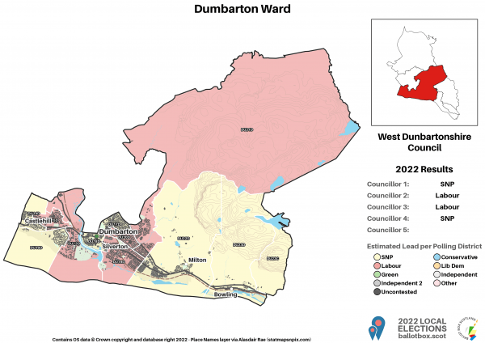

Dumbarton is one of the six wards used to elect members of the West Dunbartonshire Council. It elects four Councillors. The ward covers most of the town of Dumbarton, including the outlying villages of Milton and Bowling on the Firth of Clyde, but excepting northern parts of Dumbarton such as Bellsmyre, Broadmeadow and Lomondgate which are assigned to the Leven ward.

Around 17,000 people live in Dumbarton locality, and projections show this number will remain relatively stable over the next 10 years.

Table outlining Dumbarton Locality Demographics 2024. 
Population of Dumbarton Locality 16,979
Gender Split Female 52% Male 48%
Age 0-17 17.3%, 18-64 61.1%, 65+ 21.5%
Life expectancy. Female 79 years, Male 73 years.

Number of Households 7650
Age  


Populations in Dumbarton's Neighbourhoods:
Milton and Bowling 2727
Silverton and Overtoun 4096
Dumbarton East 4403
Dumbarton West 5446
West Dunbartonshire consists of 121 data zones reported in the Scottish Index of Multiple Deprivation (SIMD, 2020). Dumbarton Locality has 23 data zones. Although Dumbarton Locality has the lowest local share (WDC area) of most deprived areas, 3 of are in the 10% most deprived in Scotland data set. These are located in Dumbarton West Community Council area where 2 of the 3 data zones fall within the 5% most deprived in Scotland data set.

6 data zones in Dumbarton fall within the 20% most deprived data set in Scotland. All but one of these is in Dumbarton West, Bellsmyre has the remaining data zone.

**Local Priorities and Engagement**

Local engagement in prioritising plans for the area is an ongoing process undertaken by community groups and community planning partners working together. Work has been underway in the Dumbarton locality for a number of years, generating a range of findings.

The aim is to better work with residents to coordinate local service delivery in a joined-up way to meet the needs of local communities. It is also an opportunity to empower local people where they want to do more for their own local community.

In the Dumbarton Locality residents have made their voice heard in a range of ways including:

1. Dumbarton West Local Place Plan 2023
2. School Transport - Social Media comments
3. The Artizan Centre redevelopment Community Consultation responses 2023
4. Communications Plan - Survey Results CE 2022
5. Connecting Dumbarton Upgrading the Link to Dumbarton Central Station Final Report January 2021
6. Local Outcome Improvement Plan 2017-27
7. ‘Seeing Things Differently’ Dumbarton Rock & Castle Charrette: Final Report 2015
8. The Report Panel Sitting – 20th June 2018 Dumbarton Town Centre Conservation Area
9. Schools engagement activities February 2020
10. WDC Dumbarton Consultation Event – 29/8/19
11. WDC Facebook - <https://www.facebook.com/WDCouncil>
12. Tenant participation walkabouts
13. Local resident & Citizen Panel surveys
14. Local community walk-a-bouts
15. Through organised community organisations such as Community Councils or Tenant and Resident Organisations

These conversations informed the following priorities for the Dumbarton Locality.

* Economic & retail regeneration of the town centre / conservation area
* Cultural and Historical Heritage: preserving and showcasing the town's heritage.
* Tourism: to make Dumbarton more appealing to tourists
* Access to Green Spaces: access to green spaces, parks, and recreational areas
* Environment: dog fouling enforcement, redevelopment of vacant ground, feeling safe, CCTV, lighting, fly-tipping, pest control, potholes, parking
* Safety - Safe spaces for teens / kids to access, community hub, ASB, fire-raising, park & street lighting, community policing.
* Employability and economic development.
* Health & wellbeing - Sports development, active travel improvements, improved signage, cycle paths, outdoor gyms, playpark upgrades. Access to mental health services
* Community facilities and activities- community hubs, gala days, sense of identity and community ownership.

**Our Commitment**

As set out in the Community Planning Local Outcome Improvement Plan, all partners are committed to tacking inequalities. We will do this by working in partnership with communities to help make neighbourhoods better. CPWD and the community will commit to addressing inequalities in the Dumbarton Locality by focussing on the themes that have been raised by local people through recent years:

* Improved economic regeneration
* Heritage preservation / tourism
* Access to greenspace
* A safe and attractive environment
* Health & wellbeing

**Next Steps**

This locality plan represents community influence within Community Planning. This report will be shared with the Community Planning Partnership to ensure the priorities that have emerged are understood by all partners.

The next step is for the communities within the Dumbarton Locality area to develop their own, unique community action plan (see template below) for local delivery. This could be a Local Place Plan or a community Action Plan and will include community engagement to help identify where partners may contribute or help to remove barriers to increased community participation and / or action.

Local Place Plans were introduced by the Planning (Scotland) Act 2019, giving communities the new power to produce their own plans to inform the preparation of the Local Development Plan.

Local Place Plans offer the opportunity for a community-led, collaborative approach to achieve community aspirations and create great places.

Read more about Local Place Plans here:

[Local Place Plans | West Dunbartonshire Council (west-dunbarton.gov.uk)](https://www.west-dunbarton.gov.uk/council/key-council-documents/local-development-planning/local-place-plans/)

The Economic Development and Regeneration Team will be able to support the development of community-led action plans.

**Community Action Plan Template**

This template Community Action Plan has been prepared for consideration by the neighbourhoods that make up the Leven Locality. This can be used for each individual community or developed for the full locality. To focus on key deliverable projects, it is recommended to limit the number of actions.

This action plan will detail:

* local outcomes to be addressed
* detail the proposed improvement
* a timescale for delivery

|  |  |  |  |  |
| --- | --- | --- | --- | --- |
| Local Priority | CPWD Strategic Priority | Proposed Improvement | Timescale | Lead Organisation |
| Economic & retail regeneration of the town centre and conservation area | Flourishing West Dunbartonshire:  Our economy is diverse and dynamic creating opportunities for everyone | Community to identify actions to be progressed locally. | To be agreed | To be agreed |
| Cultural and Historical Heritage | Flourishing West Dunbartonshire: Our local communities are sustainable and attractive. |  |  |  |
| Tourism | Flourishing West Dunbartonshire:  Our economy is diverse and dynamic creating opportunities for everyone |  |  |  |
| Access to green spaces | Flourishing West Dunbartonshire: Our local communities are sustainable and attractive |  |  |  |
| Environment | Flourishing West Dunbartonshire: Our local communities are sustainable and attractive |  |  |  |
| Safety | Safe West Dunbartonshire: Residents live in a safe and positive community. |  |  |  |
| Employability and economic development | Flourishing West Dunbartonshire:  Our economy is diverse and dynamic creating opportunities for everyone |  |  |  |

Comments from the community

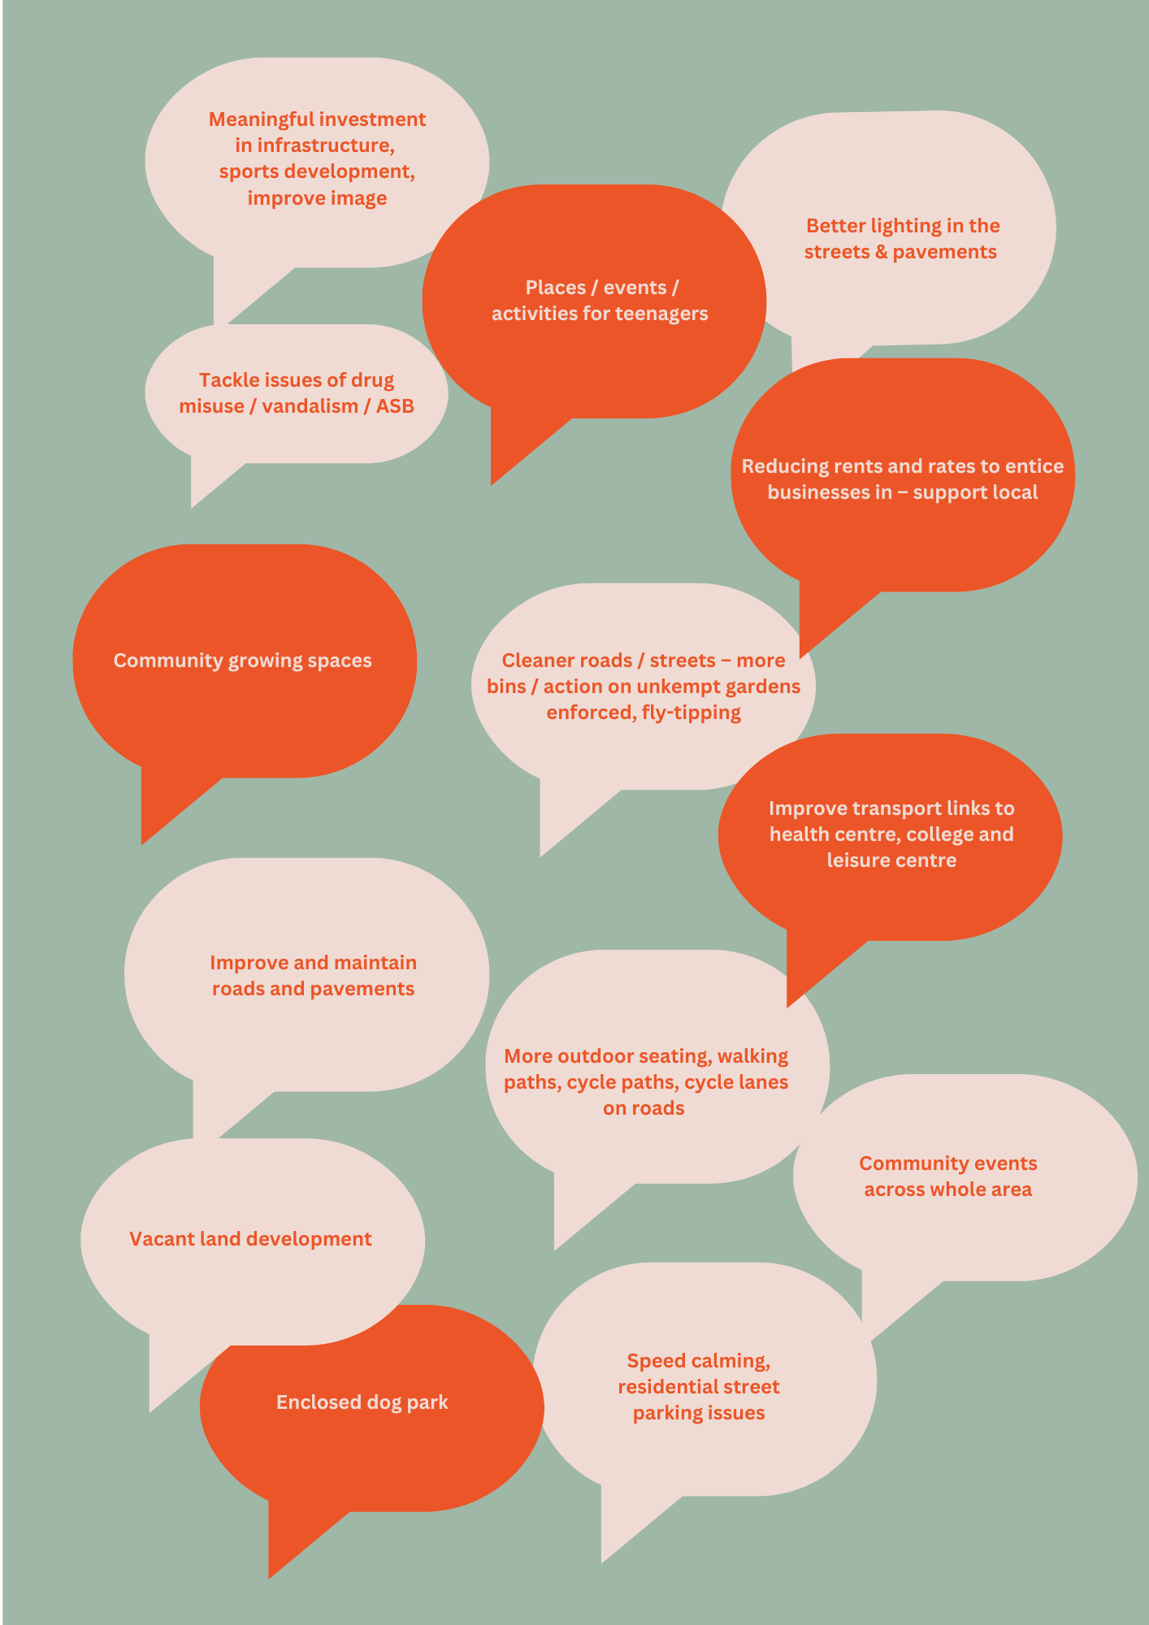

References

* 1. NHS Greater Glasgow and Clyde 2022/23 Adult Health and Wellbeing

Survey West Dunbartonshire Report February 2024

* 1. ELECTED MEMBERS’ MONTHLY BULLETIN April 2024
  2. West Dunbartonshire Citizens Panel Spring 2023 Survey Report
  3. West Dunbartonshire Social and Economic Profile 2017
  4. [Dumbarton (Ward, United Kingdom) - Population Statistics, Charts, Map and Location (citypopulation.de)](https://citypopulation.de/en/uk/scotland/wards/west_dunbartonshire/S13003124__dumbarton/)
  5. West Dunbartonshire CPP Locality Plans: Your Community Area Evidence Sheets
  6. West Dunbartonshire Community Council Profiles
  7. West Dunbartonshire Local Development Plan (Proposed Plan)