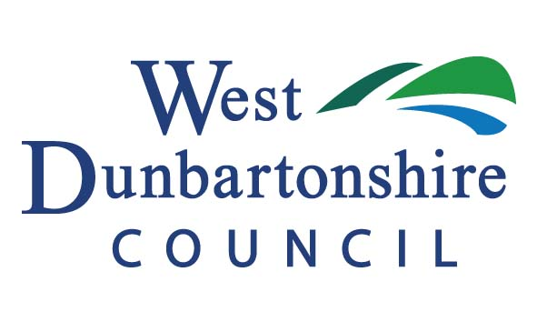
Social Enterprise Growth Grant
Application Form

The aim of this programme is to assist established social enterprise businesses to develop through growth and become more sustainable in the long term. The Social Enterprise Growth Grant will provide up to 50% of project expenditure up to a maximum grant of £2,000 to registered enterprises located within West Dunbartonshire. This grant aims to provide a financial contribution towards business growth projects which will safeguard or create local jobs.

1. | Company Name
1. | Trading Address
1. | Postcode
1. | Telephone Number
1. | Email Address
1. | Company Number
1. | Contact
 |  | Designation

2. | Type of Business  (please tick) | Sole Trader | CIC
2. | Type of Business  (please tick) | Ltd Company | SCIO

3. | Date Commenced Trading

4. | Current Employment Numbers
5. | Forecast Employment Numbers (for the next 6-12 months)

6. | Current Turnover | £
7. | Forecast Turnover (1 year after completion of project) | £

8. | Who owns/manages the social enterprise business?
Owner:
Manager:

9. Please provide a brief description of your social enterprise business activity and what its objectives are:

Project details:

10. | Please describe the project for which you are seeking assistance?

11. | What benefits will this project bring to the social enterprise business?

12. | How will this support help to make the social enterprise business become more sustainable?

13. | Please detail how this project will safeguard current jobs and/or create new local job opportunities – please include how many jobs will be safeguarded or created and what type of jobs.

14. Please give a breakdown of your estimated project expenditure for which this grant will be used:
 | £
 | £
 | £
 | £
TOTAL | £

15. Please tell us about any other public funding you have applied for as part of this overall project: (Please note - the social enterprise growth grant cannot be used to fund the same expenditure as other public funding)

Source of funding | Reason for funding | Date approved/received | Funding
 |  |  | £
 |  |  | £
 |  |  | £
 |  |  | £

Subsidy Control – Minimal Financial Assistance (MFA)

The Social Enterprise Growth Grant being applied for by your Enterprise is classified as a Minimal Financial Assistance (MFA) subsidy under the Subsidy Control Act (2022).

To be eligible for the support, you must not have already exceeded receipt of £315,000 in MFA subsidies over this and the previous two financial years.

Note: Minimal Financial Assistance (MFA) is a relatively new term which you may have previously seen referred to as “De Minimis” or “Special Drawing Rights” (SDR).

Before making any payment, written confirmation that receipt of the payment will not exceed your company’s MFA threshold of £315,000 cumulated over this and the previous two financial years, as specified in section 36(1) of the Subsidy Control Act (2022), is required.

This means you must confirm you have not received more than £315,000 minus the value of this grant in MFA subsidies or comparable types of subsidy (see section 42(8) of the Subsidy Control Act (2022)) in the current or previous 2 financial years.

We take this opportunity to remind you that you are required to keep a written record of the amount of MFA you have received and the date/s when it was received. The written record must be kept for at least three years beginning with the date on which the MFA was given. If your application is successful at the point of claiming the grant, we will issue you with an email which you can use as your written confirmation. This will enable you to respond to future requests from public authorities on how much MFA you have received and whether you have reached the cumulative threshold

Source of Funding | Reason for Funding | Date Approved/Received | Funding
Click or tap here to enter text. | Click or tap here to enter text. | Click or tap here to enter text. | £ Click or tap here to enter text.
Click or tap here to enter text. | Click or tap here to enter text. | Click or tap here to enter text. | £ Click or tap here to enter text.
Click or tap here to enter text. | Click or tap here to enter text. | Click or tap here to enter text. | £ Click or tap here to enter text.
Click or tap here to enter text. | Click or tap here to enter text. | Click or tap here to enter text. | £ Click or tap here to enter text.
Click or tap here to enter text. | Click or tap here to enter text. | Click or tap here to enter text. | £ Click or tap here to enter text.
Click or tap here to enter text. | Click or tap here to enter text. | Click or tap here to enter text. | £ Click or tap here to enter text.

Please note: Each application should be submitted with the following information:

- Up to date financial accounts (Profit & Loss and Balance Sheet) or most recent Management Accounts
- A Project Proposal (if relevant)
- Written quotes/estimates

DECLARATION BY APPLICANT COMPANY

I confirm that I have read the guidelines and conditions pertaining to this scheme and confirm that my company will adhere to all the conditions detailed therein.

I also confirm that all the information contained on this application is correct and understand that if this is found not to be so at any later stage, any grant award will be cancelled and my company will immediately repay any monies that may have been paid with regard to this application.

To be eligible for this grant support, you must not have already exceeded receipt of £315,000 in MFA subsidies over this and the previous two financial years. I confirm that the MFA threshold of £315,000 will not be exceeded by receiving this grant if my application is successful.

Data Protection

All information supplied by the applicant will be used in accordance with the EU General Data Protection Regulation (GDPR) 2016/679. It will be held by West Dunbartonshire Council’s Economic Development Section for audit purposes, to promote and evaluate the business support services offered by the Council, our approved contractors and other public economic development agencies.

It may also be shared with other Council Services and relevant agencies including but not limited to Business Gateway, Scottish Enterprise, Jobcentre Plus, Scottish Government, HMRC, SEPA and Police Scotland to help prevent or detect fraud or crime and to verify consents and licences and compliance with legislation.

Please confirm if you would like to receive information e-mails from the WDC Business Support/Business Gateway section which includes information on business grants & funding, advice and support, local workshops and events to help grow your business.

Yes ☐ No ☐

Signed | Click or tap here to enter text. | Position | Click or tap here to enter text.
Print Name | Click or tap here to enter text. | Date | Click or tap here to enter text.

Please complete this form and return with required evidence to:
business.support@west-dunbarton.gov.uk

