West Dunbartonshire Local Employability Partnership (LEP)
Terms of Reference 2026 - 2027

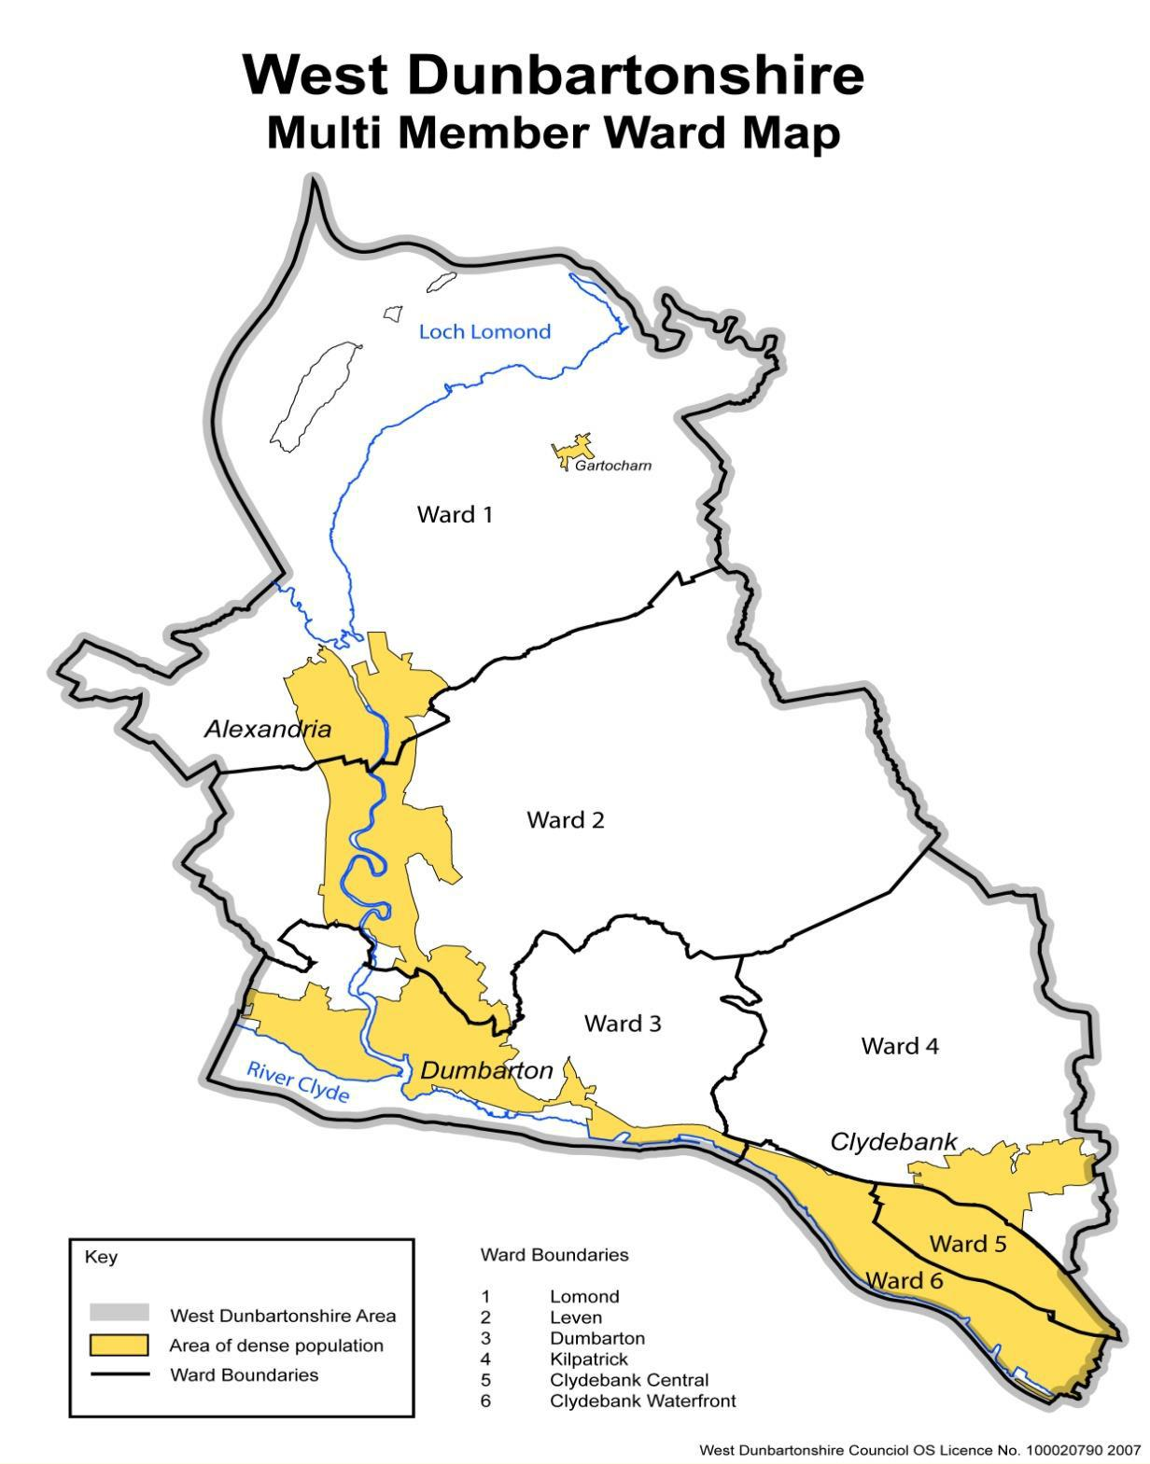
The Challenge
Supporting people into fair, sustainable jobs is central to delivering the ambitions for an inclusive, sustainable economy with well-being at its core, and employability services are pivotal to avoiding the widening of social and economic inequalities.
By supporting those seeking employment and careers, including those who are most vulnerable, we recognise the vital role that organisations across the employability landscape play. Our challenge is to ensure that the right type, amount, and quality of support is in place to meet the needs of service users.
Purpose
To enable collective leadership and shared commitment across partners to address the employability challenges faced by our residents.
The Partnership will function as a strong network committed to working with all relevant key partner organisations. Where appropriate, partners will strive to share resources and information to improve co-ordinated delivery of services for West Dunbartonshire residents and employers.
The Partnership will also build on the strengths of existing national and local services, to align funding and improve the integration of employability services with other support. This will ensure that services are designed and delivered around the needs and aspirations of those that require our services.
Core Membership:
The operation of the Partnership is a shared responsibility between partners delivering and managing employability services in West Dunbartonshire.
The West Dunbartonshire Local Employability Partnership will include subgroups, where appropriate. These subgroups will further the aims of the partnership and their membership will be determined by the LEP:
- Creative Design Group - to act as a joint design collaborative.
- Community of practice – sharing professional learning and solutions for frontline workers
- Lived experience user groups - evaluate our services and help shape design
- Data group - local data informs priorities and service design.
- Employer Engagement Group – Employers Voice
- NHS/LEP subgroup to support NHS pathways
- Short-term working groups – where necessary.

Each group will be led by a member of the partnership and will have its own terms of reference and operating methods clearly outlined.

The LEP membership will consist of representatives from:
- West Dunbartonshire Council Working4U.
- Skills Development Scotland.
- Department of Working Pensions
- West College Scotland.
- West Dunbartonshire HSCP
- West Dunbartonshire Education Services.
- Developing Scotland’s Young Workforce (DSYW).
- West Dunbartonshire CVS.
- Qualification Scotland
- Rep from Creative Design group.
- NHS.
Membership will be reviewed on an annual basis to ensure that the partnership purpose and membership remain valid.
The partnership will be coordinated by West Dunbartonshire Council. The council will also provide administrative support to the various groups that are established to pursue the partnership aims.
The overall purpose of the West Dunbartonshire Local Employability Partnership is:
- To drive forward and implement the shared ambitions and actions of No One Left Behind, to ensure the right support is available in the right way at the right time.
- To use the Scottish Approach to Service Design to co-produce an all-age employability support service that is person centered, more joined up, flexible and responsive to individual needs.
- To co-ordinate improved service delivery to West Dunbartonshire residents accessing local employability services through an agreed agenda.
- To utilise labour market statistics and information to inform good decisions, identify priorities and support improvement of services.
- To identify priority geographical areas and generic issues and to co-ordinate multi-agency initiatives to respond effectively.
- To improve opportunities for residents to gain access to appropriate learning, education, volunteering, training and employment.
- To coordinate existing resources to offer more effective and efficient services.
- To identify common themes, challenges and changes to the landscape of employability delivery and respond appropriately.
- To capitalise on emerging opportunities for joint working where appropriate.
- To provide Community planning with information on emerging priorities and action.
- To coordinate information sharing and action between West Dunbartonshire Community Planning Partnership, strategic partners, private and third-sector employers.
Partnership working:
- The LEP will operate on consensus and in the spirit of sound partnership.
- There is a group commitment, within the constraints of partners’ duties and responsibilities, to take every opportunity to promote and support the achievement of agreed plans and outcomes.
- An annual calendar of meetings will be agreed and circulated. Within this calendar of meetings, partners make every effort to attend and, where possible, send an appropriate substitute when they are unable to attend. Partners will share updates to the LEP as and when necessary.
- Formal reporting on the progress of the LEP will be in line with requirements of the Scottish and UK Governments, Community Planning West Dunbartonshire Delivery and Improvement Groups.
- Members will inform the Chairperson of any changes in contact details or relevant staff for changes, as appropriate.
Ways of Working:
- The partnership groups will meet at a frequency determined by each group; however, there will be a minimum of four meetings a year of the LEP.
- Meetings will last no longer than 2 hours.
- Meetings will take place either on-line or in-person.
- The Agenda, Action Points and papers will be circulated in advance of the meeting.
- Additional meetings may be called as agreed.
- Papers will not be shared beyond group members unless agreed.








